5 & 6

Association Analysis
Contents
True or False and Short Answer Questions 2
Basics of Association Analysis 7
Drawing an Itemset Lattice 16
Candidate Itemset Generation 27
Basics of Closed Itemsets 35
Compact Itemsets in Market Basket Tables 39
Comparing Compact Itemsets across Market Basket Tables 46
Evaluation of Association Patterns 66
Simpson’s Paradox 83
Effect of Skewed Support (H-confidence and Hypercliques) 84
Handling Categorical and Continuous Attributes 87
Handling a Concept Hierarchy 97
Sequential Patterns 98
Subgraph Patterns 133

True or False and Short Answer Questions

- True or False with one sentence explanation.
- Given that {a,b,c,d} is a frequent itemset, {a,b} is always a frequent itemset.

True. Any subset of a frequent itemset is frequent.

- Confidence generally does not have an anti-monotone property.
False. For example, Conf({AB} => {CD}) can be greater than or less than Conf({A} => {CD})

- Given that {a,b}, {b,c} and {a,c} are frequent itemsets, {a,b,c} is always frequent.

False. It is possible that you have a dataset such that the support of {a,b,c} is zero, but all its subsets are frequent.

- Given that the support of {a,b} is 20 and the support of {b,c} is 30, the support of {b} is larger than 20 but smaller than 30.
False. The support of an itemset must be equal or larger than any of its superset.

- Given that the support of {b,c} is 30 and {b} is a maximal frequent itemset, the count of minsup is equal to 30.
False. Since {b} is a maximal frequent itemset, {b,c} cannot be frequent. Hence, the count of minsup for this problem must be greater than 30.

- Given that the support of {a,b,c} is 20 and the support of {b,c} is 30, {b,c} is a closed itemset.

False. If the dataset contains itemset {b,c,d} of which the support is 30. {b,c} will not be closed.
- A maximal frequent itemset is always a closed itemset.
True. By definition, a maximal itemset is frequent, but no superset of it is. Thus, any superset of it must have different support than the maximal itemset itself.
- If an itemset is not closed, then all of its supersets are not closed.
False. Any subset of a closed itemset is a counterexample.
- If an itemset is maximal frequent, then its supersets must be maximal frequent.
False. By definition, none of its supersets are maximal frequent.
- If an itemset is closed then, then its subsets must be closed.
False. They may be either closed or not closed.
- Given the supports of all closed itemsets in a market-basket transaction dataset, you can estimate the support of any itemset in the dataset.
True. Itemsets are either closed or belong to an itemset with the same support that is closed.
- In a dataset that has 5 items, the maximum number of size-2 frequent itemsets that can be extracted (assuming minsup > 0) is 20.
False. 5 choose 2 is 10
- Given that the support count of {x,y,z} is 20, and {x} is a closed itemset, the support count of {x,y} cannot be equal to 20.
False. {x,y} may not be a closed itemset.
- Given that the support count of {x,y,z} is 20, the support count of {x,y} is 21, and minsup is 21, {x,y} will always be a maximal itemset.
False. If there is an itemset {x,y,w} whose support is 21, {x,y} will not be a maximal itemset.
- Given that the support count of {p,r,s} is 10, and {p} is a closed itemset, the support count of {p,r} cannot be equal to 10.
False. {p,r} may not be a closed itemset.

- {x,y} has support of 30 and {x,z} has support of 20, so the support of {x} is greater than 20 and less than 30.
False. The support of an itemset must be equal or larger than any of its superset.

- For a given dataset and a support threshold, the number of frequent closed itemsets is always larger than or equal to the number of maximal itemsets.
True. Maximal itemsets are closed, but frequent closed itemsets need not be maximal.

- If an itemset is maximal frequent, then none of its supersets can be maximal frequent.
True. All of its supersets are infrequent.

- Given that the support count of {p,r,s} is 10, and {p} is a closed itemset, the support count of {p,r} cannot be equal to 10.
False. {p,r} may not be a closed itemset.

- The anti-monotone property of support says that support cannot increase as additional items are added to an itemset.
True. Support must stay the same or decrease.
- The confidence of an association rule cannot be greater than the support of the rule.
False. Consider the counterexample where {A, B} is a closed itemset with support 10% and the association rule, A → B, which will have a confidence of 1 and support of 10%.
- If conf(A→ B) = 1, then the items in A and B always occur together.
False. Consider the case where B occurs in every transaction of A but also occurs in some transactions where A does not.
- With a minimum support threshold of 1 transaction, closed itemsets and maximal itemsets are always equivalent. (No explanation needed)
False. Maximal itemsets are closed but closed itemsets need not be maximal.

- For a given dataset and a support threshold, the number of closed itemsets is always larger than or equal to the number of maximal itemsets.
True. Maximal itemsets are closed but closed itemsets need not be maximal.

- For a given dataset and a support threshold, the number of frequent closed itemsets is always larger than or equal to the number of maximal itemsets.
True. Maximal itemsets are closed, but frequent closed itemsets need not be maximal.

- Apriori based association analysis techniques cannot be used for data sets that have categorical data.
False. Association analysis can be used after converting the categorical variables using one-hot encoding.

- For association analysis using continuous attributes, finer discretization is always better than coarser discretization since coarser discretization may lead to a reduction in the confidence of a resulting rule.
False, support can be too low for finer discretization, thus missing the rule entirely.

- If an itemset is maximal frequent, then all its supersets must be maximal frequent.
False. All of its supersets are infrequent.

- Given 4 items i1, i2, i3, i4 with support counts s1,s2, s3, s4 respectively. If s1 > s2 >s3> s4, then the itemset of size 2 with largest support count is {i1,i2}.
False. A high support count of items i₁ and i₂ does not imply that items i₁ and i₂ would have occurred together simultaneously. There can be even situations where i₁ and i₂ are not found together at all in any transaction.

- More complicated True or False.
- Given items A,B,C,D,E. If A is the most frequent item among all the items, then the h-confidence of the itemset {A,B,C,D,E} would be the confidence of the rule {A} -> {B,C,D,E}.
True. By definition, the h-confidence of an itemset is equal to the lowest confidence attainable from that itemset. The confidence of a rule {X} → {Y} = supp{X,Y}/{X}. To attain the lowest confidence, the numerator should be minimized and the denominator should be maximized. By apriori principle, supp{A,B,C,D,E} would be lowest and supp{A} would be highest. Therefore, h-confidence should be equal to supp{A,B,C,D,E}/supp{A}, which is equal to the confidence of the rule {A} --> {B,C,D,E}.

- For some market-basket transaction data, the number of frequent itemsets of size 3 was found out to be three. Is it safe to assume that there cannot be any frequent itemset of size 4? If no, come up with an example. If yes, justify your answer.
Yes. Using the Apriori principle, all the subsets of a frequent itemset should be frequent. Therefore, in a frequent itemset of size 4, there should be four frequent itemsets of size 3, all of which should be frequent. However, we got only three frequent itemsets of size 3.

- Given 3 items i1, i2, i3 with support as s1=0.7,s2=0.5, and s3 = 0.15. The support of {i1.i2} is necessarily greater than support of {i1,i3}.

True. It is given that item i₃ is only present in 15 % of the transactions. Therefore, by apriori principle, supp{i₁,i₃}<=0.15. On the contrary, item supp{i₁} = 0.7 and supp{i₂} = 0.5. Even if item i₂ is present in all the remaining 30 % transactions where i₁ is absent, there would be at least 20 % transactions that contain both i₁ and i₂. Therefore, supp{i₁,i₂} >= 0.2.

- A survey was conducted to study the preferences of two beverages, namely tea and coffee, among the students of a university. It was found out that 80 % of coffee drinkers do not drink tea, suggesting that tea was highly unpopular among those who drink coffee. Does this imply that tea would be more popular among those who do not drink coffee? If yes, provide an explanation, otherwise provide a counterexample.
False. It could be possible that tea is highly unpopular among students in general. As a counterexample, consider Table 5.7 in the textbook.

- The market basket data contains A,B,C,D,E as items. Given that conf ( {C,D}->{A,B}) < minconf, then conf({C} → {A,B,D,E} )< minconf ?
True. The denominator of conf({C} → {A,B,D,E} ) increases, since support({C}) ≥ support(C,D} and the numerator decreases since support({A,B,D,E} ≤ support({A,B}). Thus, conf({C} → {A,B,D,E} ) ≤ conf ( {C,D}->{A,B}) < minconf.

- Decide if the following inequality is true or false, and justify your answer. conf({P,Q} →{R,S,T}) ≤ conf({P,Q,R}→{S})
True.
Conf({P,Q} ->{R,S,T}) = σ({P,Q,R,S,T}) / σ({P,Q}) whereas
Conf({P,Q,R}->{S}) = σ ({P,Q,R,S)}) / σ({P,Q,R})
By Apriori principle, σ({P,Q,R,S,T}) < = σ({P,Q,R,S}) and σ({P,Q}) > = σ({P,Q,R})
Therefore, σ({P,Q,R,S,T}) / σ({P,Q}) < = σ({P,Q,R,S}) / σ({P,Q,R})

- The number of maximal frequent itemsets decreases monotonically with an increase in support threshold. True or false. Justify your answer.
False.
Maximal frequent itemsets can also increase with an increase in support threshold. For example, consider an example of market basket transaction data in which σ{A,B,C,D} = 25 % and
σ{A,B,C,} = σ{A,B,D} = σ{,B,C,D} = σ{A,C,D} = 30 %.
When support threshold = 24 %, the only maximal frequent itemset = {A,B,C,D}. However, if support threshold is increased to 26 %, all the itemsets {A,B,C} , {B,C,D} , {A,C,D} and {A,B,D} would be maximal frequent. Thus, the number of maximal frequent itemsets increases from 1 to 4 as support threshold is increased from 24 % to 26 %.

- conf({A} ->{B,C,D,E}) < = conf({A,B}->{C,D})

True
Conf({A} ->{B,C,D,E}) = supp({A,B,C,D,E}) / supp({A}) whereas
conf({A,B}->{C,D}) = supp ({A,B,C,D)}) / supp({A,B})
By Apriori principle, supp({A,B,C,D,E}) < = supp({A,B,C,D}) and supp({A,B}) < = supp({A})
Therefore, conf({A} ->{B,C,D,E}) < = conf({A,B}->{C,D})

- Association short answer.
- In a market-basket transaction data, if it is known that itemsets {A, B} and {B, C} are closed, then would {B} be necessarily a closed itemset? If yes, provide a proof else provide a counterexample.
True.

Suppose {B} is not closed. Then there exists an item X such that supp{B,X} = supp{B}.
Case 1: if X is neither A nor C.
supp{B, X} = supp{B} implies that X is found in all the transactions where B has been found.
Therefore, X is found in all the transactions of {A,B} and {B,C}.
This implies that {A,B} and {B,C} are not closed. Contradiction!

Case 2: if X is A.
Then, supp{B,X} = supp{A,B} = supp{B}.
This implies that A is present in all the transactions where B is present.
Therefore, A is present in all the transactions where {B, C} is present.
This implies that {B, C} is not closed. Contradiction!

Case 3: if X is C. Similar argument can be made for X = C.

- Prove that h-confidence is an anti-monotonic measure, i.e., the h-confidence of an itemset is always greater than all of its supersets.
Consider two itemsets s1 and s2 such that s2 is a superset of s1. Then,
h-confidence(s1) = supp(s1) / supp(i1), where i1 is the most frequent item in s1
h-confidence(s2) = supp(s2) / supp(i2), where i2 is the most frequent item in s2
By apriori principle, supp(s1) >= supp(s2). Since i2 is the most frequent item in s2 and s2 is the superset of s1, therefore supp(i1) <=supp(i2).
Therefore, h-confidence(s1) >= h-confidence(s2).

- Suppose {p,q,r} and {p,q,s} are two itemsets with support counts 10 and 18, respectively. If {p,q} is not closed and {p,q,r} and {p,q,s}are the only itemsets of size 3 or more containing {p,q} that have support count 10 or above, determine a lower bound for the support count of {p,q}. Briefly explain your answer.

The lower bound is 18 because {p,q} is not closed. Therefore, its support must be equal to the maximum support of its supersets.

- The association rules are to be generated from the market basket data that contains A, B, C, D as items.

Given that
confidence({B} → {A,C,D}) > minconf and
confidence( {C,D} → {A,B}) < minconf

Answer whether the following inequality would always hold with a brief explanation:

Conf({A,B} → {D}) > minconf

conf({A,B} → {D}) = supp{A,B,D}/supp{A,B} >= supp{A,B,C,D}/supp{A,B}
>= supp{A,B,C,D}/supp{B} = conf({B} → {A,C,D}) > minconf
Therefore, conf({A,B} → {D}) > minconf.

Basics of Association Analysis

- Suppose ABC is a frequent itemset and BCDE is NOT a frequent itemset. Given this information, we can be sure that certain other itemsets are frequent and sure that certain itemsets are NOT frequent. Other itemsets may be either frequent or not. Which of the following is a correct classification of an itemset?
- BC is frequent.
T
- ABCDE is not frequent.
T
- ABCD can be either frequent or not frequent.
T
- ABCD is frequent.
F (The apriori principle says that if an itemset is frequent, then its subsets are also frequent. It does not imply that its supersets are frequent.)
- AB can be either frequent or not frequent.
F (the apriori principle says that if an itemset is frequent, then its subsets are also frequent.)
- BCDEF can be either frequent or not frequent.
F (the converse of the apriori principle says that if an itemset is not frequent, then its supersets are not frequent either.)

- Suppose ACD is a frequent itemset and AB is NOT a frequent itemset. Given this information, we can be sure that certain other itemsets are frequent and sure that certain itemsets are NOT frequent. Other itemsets may be either frequent or not. Which of the following is a correct classification of an itemset?

- A is frequent.
T
- CD can be either frequent or not frequent.
F (the apriori principle says that if an itemset is frequent, then its subsets are also frequent.)
- ACDE can be either frequent or not frequent.
T
- ABCD is frequent.
F (The apriori principle says that if an itemset is frequent, then its subsets are also frequent. It does not imply that its supersets are frequent. AB is not a frequent itemset)
- ABCDE can be either frequent or not frequent.
F (the converse of the apriori principle says that if an itemset is not frequent, then its supersets are not frequent either.)

- Suppose {A,B,D,E} is a frequent itemset and {B,C,D} is NOT a frequent itemset.
Given this information, we can be sure that certain other itemsets are frequent and
sure that certain itemsets are NOT frequent. Other itemsets may be either frequent or not.
Which of the following statements are correct?

Give a one sentence explanation if you believe any statement is incorrect.
- {A, E} can be either frequent or not frequent.
F (the apriori principle says that if an itemset is frequent,
then its subsets are also frequent.)
- {A,B,D,E,F} can be either frequent or not frequent.
T
- {A,B,C,D,E,F} can be either frequent or not frequent.
F (the converse of the apriori principle says that if an itemset is not frequent,
then its supersets are not frequent either.)

- Suppose {P,S,T} is a frequent itemset and {Q,S} is NOT a frequent itemset.
Given this information, we can be sure that certain other itemsets are frequent and
sure that certain itemsets are NOT frequent. Other itemsets may be either frequent or not.
Which of the following statements is/are correct?
Give a one sentence explanation if you believe any statement is incorrect.
- {P, T} can be either frequent or not frequent.
F (the apriori principle says that if an itemset is frequent,
then its subsets are also frequent.)
- {P, S, T, W} can be either frequent or not frequent.
T
- {P,Q,R,S,T} can be either frequent or not frequent.
F (the converse of the apriori principle says that if an itemset is not frequent,
then its supersets are not frequent either.)

- Suppose PRS is a frequent itemset and PQ is NOT a frequent itemset. Given this information, we can be sure that certain other itemsets are frequent and sure that certain itemsets are NOT frequent. Other itemsets may be either frequent or not. Which of the following is a correct classification of an itemset?

- PQS can be frequent or not frequent.
F (the converse of the apriori principle says that if an itemset is not frequent, then its supersets are not frequent either.)
- PS can be either frequent or not frequent.
F (the apriori principle says that if an itemset is frequent, then its subsets are also frequent.)
- PQRS can be either frequent or not frequent.
F (the converse of the apriori principle says that if an itemset is not frequent, then its supersets are not frequent either.)
- P is frequent.
T
- PQRST is not frequent.
T

- Imagine there are 100 transactions, numbered 1,2,...,100, and 100 items, similarly numbered. Item i is in transaction j if and only if i divides j evenly. For example, transaction 24 is the set of items {1,2,3,4,6,8,12,24}.
- Describe all the association rules that have 100% confidence.
For the confidence to be 100%, every transaction that contains all the items on the left must contain every item from the itemset on the right. Since membership in transactions is defined by divisibility, what we are looking for is that every integer b that is divisible by all the numbers on the left is also divisible by the number on the right. For example, the rule {4,6} → 12 has 100% confidence, because if b is divisible by 4 and 6, it has at least two factors 2 and at least one factor 3. That means it is divisible by 2*2*3 = 12. A rule such as {2} -> {6,12} does not have 100% confidence since {2} is supported by all even-numbered transactions, including 2 and 4, while {2, 6, 12} is not supported by transactions 2 and 4.
- List all itemsets that have a support of 15% or more. Use the apriori algorithm to filter candidate itemsets. You need not show the computation of the algorithm. Just the final answer is required.
Size 0 - {}
Size 1 - {1}, {2}, {3}, {4}, {5}, {6}
Size 2 - {1,2}, {1,3}, {1,4}, {1,5}, {1,6}, {2,3}, {2,4}, {2,6}, {3,6}
Size 3 - {1,2,3}, {1,2,4}, {1,2,6}, {1,3,6}, {2,3 6}
Size 4 - {1,2, 3, 6}
- Which of the following association rules meet a 100% confidence threshold and a 15% support threshold? Give a one-line explanation for each.
  - {3} ->{1,6}
No, 6 does not divide 9, but 3 does. Not 100% confident.
  - {1,2,6}->{3}
Yes, {1,2,6} is frequent and 3 will divide a number if 1,2,6 do.
  - {} ->{1}
Yes, {1} and {} are subsets of every transaction itemset in this data.
  - {1,4,6} -> {1,2,3,4}
No, Itemset {1,4,6} does not meet the support threshold
  - {1,2,3,6} -> {3,4}
No, 6 is divisible by each of 1,2,3,6 but not by 4. Not 100% confident
  - {3,4} -> {1,2,3,6}
No, Itemset {3,4} does not meet the support threshold

- In the following, 1 through 7 are items. Which of the following association rules has a confidence that is certain to be at least as great as the confidence of 12=>34567 and no greater than the confidence of 1234=>5?

123=>456 True
124=>356 True
134=>567 False (Suppose the only baskets are {1,3,4,5,6,7} and {1,2,3,4}. Then the confidence of 1234=>5 is 0%, while the confidence of 134=>567 is 50%.)
234=>567 False (Suppose the only baskets are {2,3,4,5,6,7} and {1,2,3,4}. Then the confidence of 1234=>5 is 0%, while the confidence of 234=>567 is 50%)

- In the following, 1 through 7 are items. For each of the following association rules in the center column, compare its confidence with the confidence of the 2 rules in the columns to the left or right of it. You may use any of the operators >, <, >=, <=, = to state your answer. If nothing can be said, write NA.
Given Rule 1 |  | Rule in question |  | Given Rule 2
12=>34567 | <= | 123=>456 | <= | 1234=>5
12=>34567 | NA | 234=>567 | NA | 1234=>5
12=>34567 | >= | 2=>134567 | <= | 1234=>5
12=>34567 | <= | 12345=> | >= | 1234=>5

- Consider the market basket transactions shown in Table 1.

Table 1: Market basket transactions.

Transaction ID | Item Bought
1 | {Beer, Diapers}
2 | {Milk, Diapers, Bread, Butter}
3 | {Milk, Diapers, Cookies}
4 | {Bread, Butter, Cookies}
5 | {Milk, Beer, Diapers, Eggs}
6 | {Beer, Cookies, Diapers}
7 | {Milk, Diapers, Bread, Butter}
8 | {Bread, Butter, Diapers}
9 | {Bread, Butter, Milk}
10 | {Beer, Butter, Cookies}

(a) What is the maximum number of association rules that can be extracted from this data (including rules that have zero support)?

There are d=7 items in the data set. Therefore the total number of rules is
$R=3^{d}-2^{d+1}+1=1932$.

(b) What is the maximum size of frequent itemsets that can be extracted (assuming minsup >0)?

Because the longest transaction contains 4 items, the maximum size of a frequent itemset is 4.

(c) Given that this dataset has 7 distinct items, write an expression for the maximum number of size-3 itemsets that can be derived.

$\left(\begin{matrix}7 \\ 3\end{matrix}\right)=35$

(d) What is the support count for {Bread}, {Milk}, {Bread, Milk}?
σ({Bread}) = 5, σ({Milk}) = 5, σ({Bread,Milk}) = 3

e) What is the confidence of the rule {Bread} -> {Milk} and {Milk}->{Bread}?
$c\left(\left\{Bread\right\}-> \left\{Milk\right\}\right)=\frac{σ(\{Bread,Milk\}) }{σ(\{Bread\})}=\frac{3}{5}=0.6$
$c\left(\left\{Milk\right\}→\left\{Bread\right\}\right)=\frac{σ\left(\left\{Bread, Milk\right\}\right)}{σ\left(\left\{Milk\right\}\right)}=\frac{3}{5}=0.6$
f) Comment on the situation where the rules {a} −> {b} and {b} −> {a} have the same confidence
Since $c\left(\left\{a\right\}-> \left\{b\right\}\right)=\frac{σ(\{a,b\})}{σ(\{a\})}=\frac{σ(\{a,b\})}{σ(\{b\})}=c\left(\left\{b\right\}-> \left\{a\right\}\right)$, we have σ({a})= σ({b})

- Consider the market basket transactions shown in the table below:
TID | Items
1 | Bread, Butter
2 | Bread, Milk, Beer
3 | Milk, Apple, Beer, Coke
4 | Bread, Apple, Beer, Butter
5 | Bread, Milk, Apple, Coke
a) What is the maximum number of association rules that can be extracted from this data (including rules that have zero support)?
b) What is the maximum size of frequent itemsets that can be extracted (assuming minsup > 0)?
c) Write an expression for the maximum number of size-3 itemsets that can be derived from this data set.
d) What is the support of {Bread}, {Milk}, {Bread, Milk}?
e) What is the confidence of the rule {Bread} -> {Milk} and {Milk}->{Bread}?
f) Comment on the situation where the rules {a} −> {b} and {b} −> {a} have the same confidence and the situation where the rules {a} −> {b} and {b} −> {a} have the different confidence.
Solution:
a) There are 6 items in the data set. Therefore, the total number of rules is 3⁶ – 2⁷ +1 = 602.
b) Because the longest transaction contains 4 items, the maximum size of a frequent itemset is 4.
c) $\left(\begin{matrix}6 \\ 3\end{matrix}\right)$=20
d) {Bread}: 0.8, {Milk}: 0.6.{Bread, Milk}: 0.4.
e) i) Confidence of {Bread} -> {Milk} = 2/4 ii) Confidence of {Milk}->{Bread} = ⅔
f) If support(a) = support(b), then the rules {a} −> {b} and {b} −> {a} would have the same confidence. Otherwise, they will be different

- Rules are to be generated from market basket data that contains A,B,C,D as items. Given that
Confidence({B}->{A,C,D}) > minconf
and
Confidence( {C,D}->{A,B}) < minconf
Answer whether the following inequalities would always hold with a brief explanation :
- Conf({A,B,C} ->{D}) > minconf
Answer: LHS = $\frac{σ(A,B,C,D)}{σ(A,B,C)}$ > = $\frac{σ(A,B,C,D)}{σ(B)}$ > minconf . Thus, this inequality would always hold.

- Conf({C} ->{A,B,D} ) < minconf
Answer:
LHS = $\frac{σ(A,B,C,D)}{σ(C)}$ < = $\frac{σ(A,B,C,D)}{σ(C,D)}$ < minconf . Thus, this inequality would always hold true.

- Consider the market basket transactions shown in Table 1.

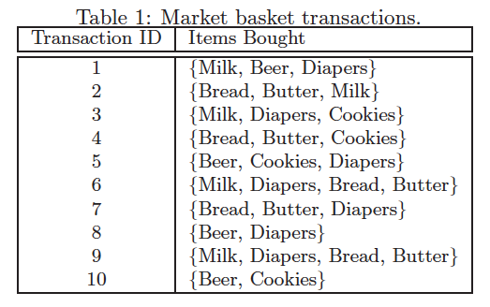

a. What is the maximum number of association rules that can be extracted from this data (including rules that have zero support)?
Answer: There are six items in the data set. Therefore the total number of rules is 602.
b. What is the maximum size of frequent itemsets that can be extracted (assuming minsup > 0)?
Answer: Because the longest transaction contains 4 items, the maximum size of a frequent itemset is 4.
c. Write an expression for the maximum number of size-3 itemsets that can be derived from this data set.
Answer: $\left(\begin{matrix}6 \\ 3\end{matrix}\right)$=20
d. Find an itemset (of size 2 or larger) that has the largest support.
Answer: {Bread, Butter}.
e. Find a pair of items, a and b, such that the rules {a} −> {b} and {b} −> {a} have the same confidence.
Answer: (Bread, Butter) is one example. In general, if support(a) = support(b), then the rules
{a} −> {b} and {b} −> {a} would have the same confidence.

- Consider the market basket transactions shown in Table 1.

Transaction ID | Items Bought
1 | {Beer, Diapers}
2 | {Milk, Diapers, Bread, Butter}
3 | {Milk, Diapers, Cookies}
4 | {Bread, Butter, Cookies}
5 | {Milk, Beer, Diapers, Eggs}
6 | {Beer, Cookies, Diapers}
7 | {Milk, Diapers, Bread, Butter}
8 | {Bread, Butter, Diapers}
9 | {Bread, Butter, Milk}
10 | {Beer, Milk, Cookies}

Table 1: Market basket transactions.
(a) What is the maximum number of association rules that can be extracted from this data (including rules that have zero support)?
Answer: There are seven items in the data set. Therefore the total number of rules is 1932.
(b) What is the maximum size of frequent itemsets that can be extracted (assuming minsup > 0)?
Answer: Because the longest transaction contains 4 items, the maximum size of a frequent itemset is 4.
(c) Write an expression for the maximum number of size-3 itemsets that can be derived from this data set.
Answer: $\left(\begin{matrix}7 \\ 3\end{matrix}\right)$=35
(d) Find an itemset (of size 2 or larger) that has the largest support.
Answer: {Bread, Butter}.
(e) Find a pair of items, a and b, such that the rules {a} → {b} and {b} → {a} have the same confidence.
Answer: (Bread, Butter).

- Consider the market basket transactions shown in the table below:

TID | Items
1 | Bread, Milk, Butter
2 | Bread, Milk, Beer, Eggs
3 | Milk, Diaper, Beer, Coke
4 | Bread, Milk, Diaper, Beer
5 | Bread, Milk, Diaper, Coke

a) What is the maximum number of association rules that can be extracted from this data (including rules that have zero support)?
b) What is the maximum size of frequent itemsets that can be extracted (assuming minsup > 0)?
c) Write an expression for the maximum number of size-3 itemsets that can be derived from this data set.
d) What is the support of {Bread},{Milk},{Bread, Milk}?
e) What is the confidence of the rule {Bread} -> {Milk} and {Milk}->{Bread}?
f) Comment on the situation where the rules {a} −> {b} and {b} −> {a} have the same confidence and the situation where the rules {a} −> {b} and {b} −> {a} have the different confidence.

Solution:
a) There are 7 items in the data set. Therefore the total number of rules is 3⁷ – 2⁸ +1=1932 .
b) Because the longest transaction contains 4 items, the maximum size of a frequent itemset is 4.
c) $\left({7 \atop 3}\right)$=35
d) {Bread}: 0.8,{Milk}: 1.{Bread, Milk}: 0.8.
e) i) Confidence of {Bread} -> {Milk} = 4/4 = 1
ii) Confidence of {Milk}->{Bread} = 4/5 = 0.8
f) If support(a) = support(b), then the rules {a} −> {b} and {b} −> {a} would have the same confidence. Otherwise, they will be different.

- Write an expression for each of the counting problems below. You do not have to simplify the expression.

(a) Consider a database that contains 12 items {a, b, . . . k, l} and 10000 transactions. How many unique association rules with rule consequent {a, b} can we obtain?
Answer: 1024 if you allow the left-hand side to include the empty itemset. 1023, if not.
(b) Suppose there are 100 rules generated by an association rule mining algorithm. How many unique rule orderings can we obtain?
Answer: 100!

- Let {Bread,Milk,Diaper,Butter,Coke,Cookies} be the set of items.
Consider the following set of candidate itemsets: {Bread,Butter,Coke} , {Milk,Diaper,Coke}, {Bread,Diaper,Butter}, {Coke,Diaper,Bread}, {Milk,Butter,Coke}
Suppose you need to count the support of the candidate itemsets for different transactions using a hash tree. Is there any pre-processing required before you begin constructing a hash tree? Construct a trinary-hash tree to enable fast support-counting.

You would need to first assign a serial number to the items. Then sort the items in every candidate itemset in the increasing order of serial numbers. Then the first branch is hashed on {1,4}, the second is hashed on {2,5}, and the third is hashed on {3,6}.

- {A,B,C,D} a frequent itemset. Given that {B}->{A,C,D} and {C,D}->{A,B} fails min-confidence requirement. Generate all the candidate rules for the itemset {A,B,C,D}.

Answer: {A}->{B,C,D}, {A, C}->{B, D}, {A,D}->{B,C}.

- For every question, there are two statements given, STATEMENT-1 and STATEMENT-2. Write your answer as
(a) If both statements are correct and STATEMENT-2 is the correct explanation of STATEMENT-1
(b) If both statements are correct, but STATEMENT-2 is not the correct explanation of STATEMENT-1
(c) If STATEMENT-1 is true, STATEMENT-2 is false
(d) If STATEMENT-1 is false,STATEMENT-2 is true
(e) If both statements are false
Also, explain your answer, if you claim any statement to be wrong.

(i) STATEMENT-1: conf({A}->{B,C,D}) <= conf({B}->{C,D})
STATEMENT-2: Confidence of rules is anti-monotone with respect to the number of items on the RHS of the rule.

Answer-(e). STATEMENT-2 is not complete by itself, and it is important to mention that the rules must have the same LHS. Clearly, STATEMENT-1 is false

(ii) STATEMENT-1: conf({A,E} ->{B,C,D}) < = conf({E}->{B,C})
STATEMENT-2: Confidence of the rules generated from the same itemset has an anti-monotone property.

Answer-(d). Easy counter-example for STATEMENT-1. STATEMENT-2 is correct.

(iii) STATEMENT-1: conf({A,E} ->{B,C,D}) < = conf({A}->{B,C,D})
STATEMENT-2: Confidence of the rules generated from the same itemset has an anti-monotone property.

Answer-(a)

(iv) STATEMENT-1 : conf({A,E}->{B,C}) > = conf({A,E}->{B,C,D})
STATEMENT-2 : conf({A,E} ->{B,C}) > = conf({A}->{B,C,D}) >=conf({A,E}->{B,C,D})

Answer – (c) STATEMENT-1 is true because of the anti-monotone property of confidence of rules having the same LHS. STATEMENT-2 is false because of the first inequality, second inequality is correct.

- For each measure or type of pattern defined below, determine whether it is monotone, anti-monotone, or non-monotone (i.e., neither monotone nor anti-monotone) with respect to increasing itemset size.

i. Itemsets that contain both positive and negative items such as {A,B,C,D}. Is the support measure monotone, anti-monotone, or non-monotone when applied to such patterns? Ignore the case where $\overline{X}$ (or X) is added to a transaction that contains X (or $\overline{X}$).
Answer: Anti-monotone.
ii. Boolean logical patterns such as { (Pepsi ∨ Coke ∨ Sprite), Chips, Cookies}, which may contain both disjunctions and conjunctions of items. Is the support measure monotone, anti-monotone, or non-monotone when applied to such patterns?
Answer: Non-monotone.
iii. Given an itemset X = {i₁, i₂, . . . , i_{k}}, let bond(X) = σ(X) / σ(i₁ ∨ i₂ ∨…∨ i_{k} ),
where σ(.) is support count and σ(i_{p} ∨ i_{q} ∨ i_{r} ) is the number of transactions that contain i_{p}, i_{q} or i_{r}. Is bond monotone, antimonotone, or non-monotone?
Answer: Anti-monotone.
- For a given itemset of size k, the number of itemsets of size k-1 that one can obtain from it is always
- >k
- <k
- = k
- ≤ k
Answer: (iii). Given an itemset, one can always obtain k itemsets of size k-1 by eliminating every of the k items, one at a time. Since all the items are distinct in an itemset, therefore, each k-1 itemset obtained would also be distinct from others. Therefore, exactly k itemsets of size k-1 are formed.
- Answer the following two questions.
(a) What are two key differences and two key similarities between clustering and association analysis?
Solution:
Similarities:
Clustering and classification are both unsupervised methods.
Both produce groupings of objects. (The items that support a frequent itemset.)
Differences:
The main focus of association analysis is on rules.
For clustering, grouping of objects is based on similarity, which typically considers all attributes. In contrast, objects (transactions) are grouped into frequent itemsets based on a relatively small number of attributes. Thus, clustering finds global patterns, while association analysis finds local patterns.
(b) True or False. A frequent itemset of size 5 will generate 5 frequent itemsets of size 4 and five frequent itemsets of size 1.

Solution: True

Drawing an Itemset Lattice

- The Apriori algorithm uses a generate-and-count strategy for deriving frequent itemsets. Candidate itemsets of size k + 1 are created by joining a pair of frequent itemsets of size k (this is known as the candidate generation step). For example, the candidate {P,Q,R} is generated by merging the frequent itemsets {P,Q} and {P,R}. A candidate is pruned if any one of its subsets is found to be infrequent. For example, the candidate {P,Q,R} is pruned if {Q,R} is infrequent. (Such kind of pruning is performed during the candidate pruning step.)

Suppose you apply the Apriori algorithm to the data set shown in Table 1. Assume the minimum support threshold is equal to 30%, i.e., any itemset occurring less than 3 transactions is considered to be infrequent.
(a) Draw a lattice structure representing all possible itemsets that can be generated from the data set given in Table 1. In your diagram, label each node using the following letter(s):
• N: If the itemset is not considered to be a candidate itemset by the Apriori algorithm. There are two reasons for an itemset not to be considered as a candidate itemset: (1) It is not generated at all during the candidate generation step, or (2) It is generated during the candidate generation step but is subsequently removed during the candidate pruning step because one of its subsets is found to be infrequent.
• F: If the candidate itemset is found to be frequent by the Apriori algorithm.
• I: If the candidate itemset is found to be infrequent after support counting.
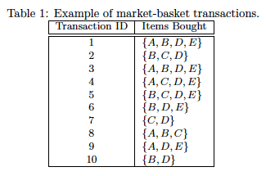
The solution lattice structure is shown below.
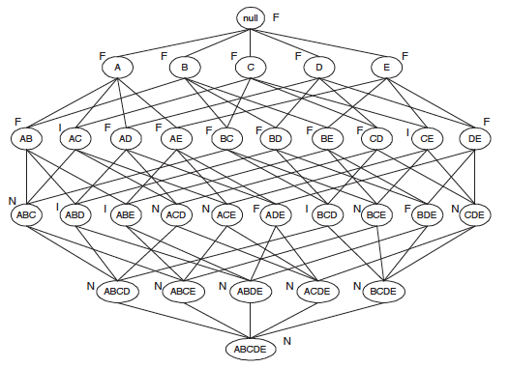
(b) What is the percentage of frequent itemsets (with respect to all itemsets in the lattice) found by the Apriori algorithm?
Percentage of frequent itemsets = 16/32 = 50.0% (including the null set).
(c) What is the pruning ratio of the Apriori algorithm on this data set? (Pruning ratio is defined as the percentage of itemsets not considered to be a candidate because: (1) they are not generated during candidate generation or they are pruned during the candidate pruning step.)
Pruning ratio is the ratio of N to the total number of itemsets. Since the count of N = 11, therefore pruning ratio is 11/32 = 34.4%.
(d) What is the false alarm rate (i.e., percentage of candidate itemsets that are found to be infrequent after performing support counting)?
The false alarm rate is the ratio of I to the total number of itemsets. Since the count of I = 5, the false alarm rate is 5/32 = 15.6%.

- Answer the following questions for the data set in the given table.

Transaction ID | Items bought
1 | {A,B.D.E}
2 | {B,C,D}
3 | {A,B,D,E}
4 | {A,C,D,E}
5 | {B,C,D,E}
6 | {B,D,E}
7 | {C,D}
8 | {A,B,C}
9 | {A,D,E}
10 | {B,D}

- What is the maximum number of association rules that can be extracted from this dataset (including rules that have zero support)?
There are five items in the data set. Therefore, the total number of rules is
3⁵ − 2⁶ + 1 = 180.
- What is the maximum size of frequent itemsets that can be extracted (assuming minsup >0)?
Because the longest transaction contains 4 items, the maximum possible size
of a frequent itemset is 4.
- Calculate the maximum number of size-3 itemsets that can be derived from this dataset.
$\left(\begin{matrix}5 \\ 3\end{matrix}\right)$= 10.
- Find an itemset (of size 2 or larger) that has the largest support.
{D, E}, {B, D}.
- Find a pair of items, say x and y, such that the rules {x} → {y} and {y} → {x} have the same confidence.
Essentially, we want to find two items whose support in the data set is the
same. Since the support of both A and C is 5, {x = A, y = C} is one such pair of items.

- Draw the itemset lattice for the data set above. Now, given this lattice structure and the transactions given in the table of Question 1, above, label each node in the lattice with the following letter(s):

- M if it is a maximal frequent itemset,
- C if it is a closed frequent itemset,
- F if it is frequent but neither maximal nor closed, and
- I if it is infrequent.
Assume that the minimum support threshold is 30%.

Answer

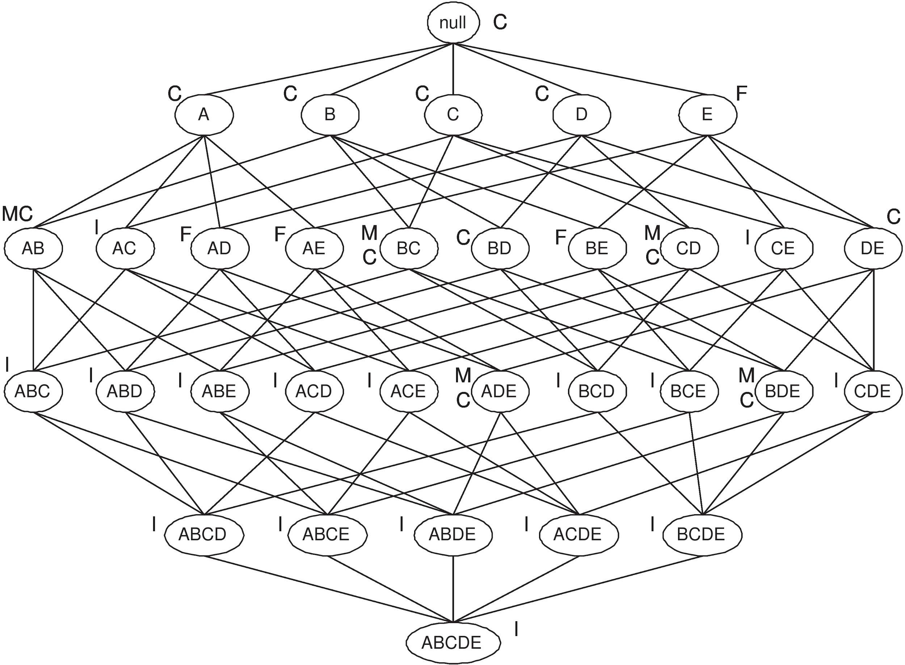

- Answer the following questions for the data set in Table 2.

Transaction ID | Items Bought
1 | { A, B, D, E }
2 | { B, C, D }
3 | { A, B, D, E }
4 | { A, B, C, E }
5 | { A, B, C, D }
6 | { A, B, D}
7 | { B, C }
8 | { C, D, E }
9 | { A, B, E }
10 | { B, D }

(a) What is the maximum number of association rules that can be extracted from this data
set (including rules that have zero support)?
There are five items in the data set. Therefore, the total number of rules is
$3^{5}- 2^{6} + 1 = 180$
(b) What is the maximum size of frequent itemsets that can be extracted (assuming minsup >
0)?
Because the longest transaction contains 4 items, the maximum possible size
of a frequent itemset is 4.
(c) Calculate the maximum number of size-3 itemsets that can be derived from this data
set.

$\left({5 \atop 3}\right)= 10$.

(d) Find an itemset (of size 2 or larger) that has the largest support.
{A, B}, {B, D}.

(e) Find a pair of items, say x and y, such that the rules x → y and y → x have the same confidence.
Essentially, we want to find two items whose support in the data set is the same. Since the
support of both A and C is 5, x = C, y = E is one such pair of items.

(f) Draw the itemset lattice for the data set in Table 2. Dataset of Market-basket transactions. Now, given this lattice structure and the transactions given in Table 2, label each node in the lattice with the following letter(s):
• M if it is a maximal frequent itemset,
• C if it is a closed frequent itemset,
• N if it is frequent but neither maximal nor closed, and
• I if it is infrequent.
Assume that the minimum support threshold is equal to 30%.

The lattice structure is shown below.

- Draw the itemset lattice for the data set in Table 2 (Example of such a lattice is Figure 5.1 in Chapter 5 in the textbook). Now, given this lattice structure and the transactions given in Table 2, answer the following questions (Assume that the minimum support count is 2):

TID | Items
1 | ABC
2 | ABCD
3 | BCD
4 | ACDE
5 | DE
Table 2. Data set of market-basket transactions

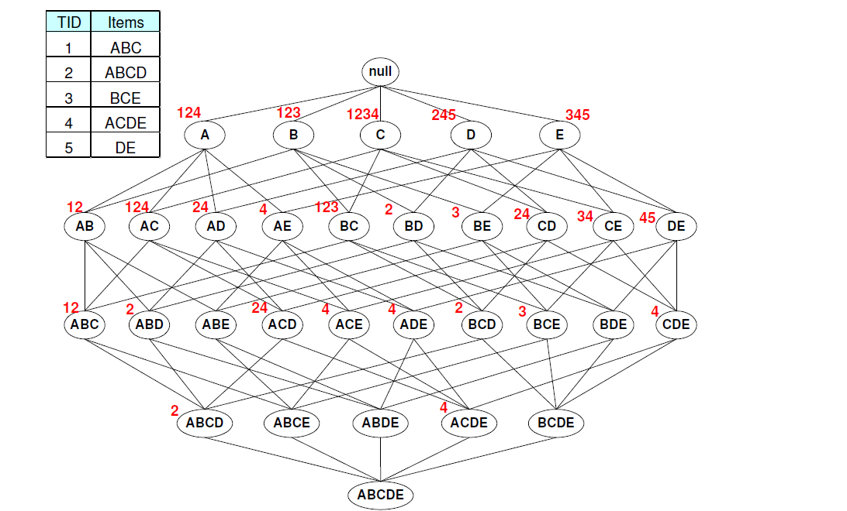

- List the maximal frequent itemsets generated from the data.
ABC, ACD, CE, DE.

- An itemset is closed if none of its supersets has the same support count as itself. List all the frequent closed itemsets generated from the data.
C, D, E, AC, BC, CE, DE, ABC, ACD.

- True or False. If an itemset X is not closed, then all of its supersets are not closed.
False.

- A closed itemset is not necessarily frequent. Answer True or False with a short reason?
True, since the definition of a closed itemset only requires that its supersets have different support.

- An itemset is a generator if none of its subsets has the same support count as itself. List all the frequent generators from the data.
A, B, C, D, E, AB, AD, CD, CE, DE.

- True or False. If an itemset X is not a generator, then all of its supersets are not generators.
False

- Suppose {p, q, r}, {p, q, s}, and {p, q, t} are three closed itemsets with support counts 10, 15, and 8, respectively. If {p, q} is not closed and {p, q, r}, {p, q, s}, and {p, q, t} are the only supersets of {p, q}, determine the support count for {p, q}.

- Consider a transaction data set shown in the table below. The corresponding itemset lattice for this data set is shown in the figure below, where the TID-list associated with each itemset is also shown by its side. For example, node {A} is present in TIDs 1, 2 and 4. Now, answer the questions below, assuming a minimum support count threshold of 2. (You may ignore the null set when listing your answers.)

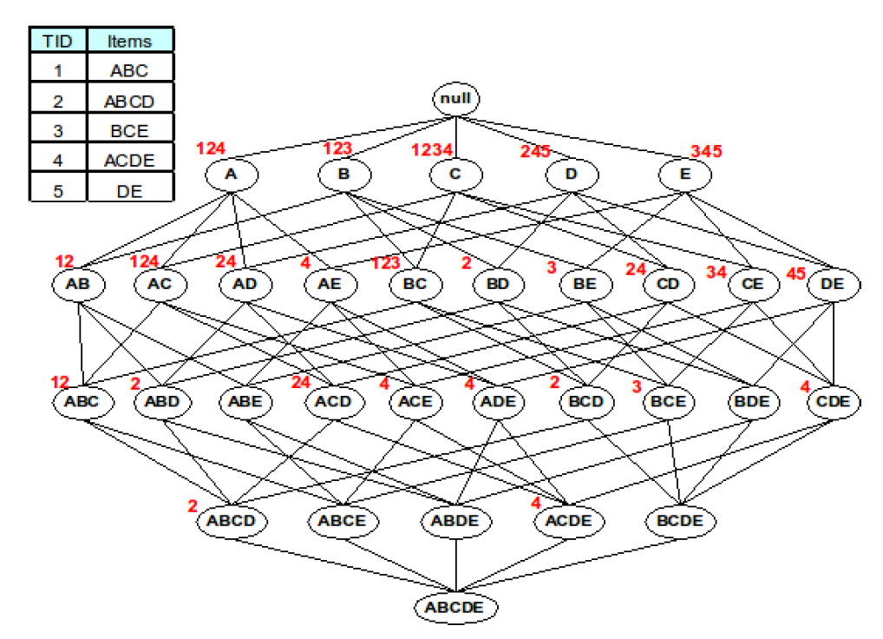

- List size 2 maximal frequent itemsets
- List size 2 frequent itemsets that are closed.
- True or False with a short reason:
- If an itemset is maximal frequent, its supersets must be infrequent.
- A closed itemset is not necessarily frequent.

- {CE} and {DE}
- {AC}, {B,C}, {C,E}, {DE}

- True. Otherwise, the given itemset can not be maximal.
- True, since the definition of a closed itemset only requires that its supersets have different support.

- Drawing an itemset lattice

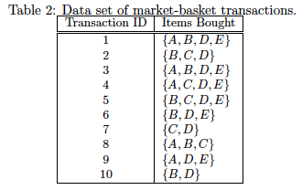
Draw the itemset lattice for the data set in Table 2 (Example of such a lattice is Figure 6.1 in Chapter 6 in the textbook). Now, given this lattice structure and the transactions given in Table 2, label each node in the lattice with the following letter(s):
• M if it is a maximal frequent itemset,
• C if it is a closed frequent itemset,
• N if it is frequent but neither maximal nor closed, and
• I if it is infrequent.
Assume that the minimum support threshold is equal to 30%.

Answer: The lattice structure is shown below.

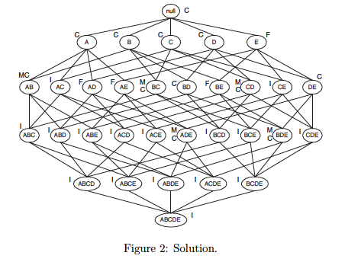

- Consider the following itemset lattice.
    - From the following itemsets, circle the maximal ones.
{ABC}, {AC}, {ACD}
Answer: {ABC}, {ACD}
    - From the following itemsets, circle the ones which are closed.
{ABC}, {CD}, {ABCD}
Answer: {ABC}, {ABCD}
    - If an itemset is maximal frequent, then its supersets must be maximal frequent. True or False?
Answer: False.
    - If an itemset is closed, then its subsets must be closed. True or False?
Answer: False.

- Consider a transaction data set shown in the table below. The corresponding itemset lattice for this data set is shown in the figure below, where the TID-list associated with each itemset is also shown by its side. For example, node {A} is present in TIDs 1, 2 and 4. Now, answer the questions below, assuming a minimum absolute support threshold of 2. (You may ignore the null set when listing your answers.)

  - Which size-3 itemsets are maximal.
Answer: {ABC} and {ACD}
  - Which size-3 itemsets with non-zero support are not closed.
Answer: {ABD}, {ACE}, {ADE}, {BCD}, {CDE}
  - If an itemset is maximal frequent, then its supersets must be infrequent. Answer True or False with a short reason?
Answer: True, otherwise the given itemset can not be maximal.
  - A closed itemset is not necessarily frequent. Answer True or False with a short reason?
Answer: True, since the definition of a closed itemset only requires that its supersets have a different support.

- Consider a transaction data set shown in the table below. The corresponding itemset lattice for this data set is shown in the figure below, where the TID-list associated with each itemset is also shown by its side. For example, node {A} is present in TIDs 1, 2 and 4. Now, answer the questions below, assuming a minimum absolute support threshold of 2. (You may ignore the null set when listing your answers).

(a) Which size-3 items are maximal?
Answer: ABC, ACD.
(b) Which size-3 itemsets with non-zero support are not closed?
Answer: ABD, ACD, ACE, ADE, BCD, CDE
(c) If an itemset is maximal frequent, then its supersets must be infrequent. Answer True or False with a short reason?
Answer: Yes. a maximal itemset is a frequent itemset that has no frequent superset.
(d) A closed itemset is not necessarily frequent. Answer True or False with a short reason?
Answer: True, since the definition of a closed itemset only requires that its supersets have a different support.

- Consider the transactions and itemset lattice shown in the following Figure. The tidlist associated with each itemset is also shown diagram. Assume that the minimum support count is 2. (You may ignore the null set when listing your answers below.)

a) List the maximal frequent itemsets generated from the data.
Answer: ABC, ACD, CE, DE.
b) An itemset is closed if none of its supersets has the same support count as itself. List all the frequent closed itemsets generated from the data.
Answer: C, D, E, AC, BC, CE, DE, ABC, ACD.
c) True or False. If an itemset X is not closed, then all of its supersets are not closed.
Answer: True.

Candidate Itemset Generation

- Following is the list of all frequent itemsets of size 3 in a given dataset:

{a, b, c}, { b, c, d}, {a, c, d}, {a, d, e}, {a,c,e}, {b,c,e}, {c,d,e}

Which of the following 4-itemsets would be generated using the Fk-1 * Fk-1 candidate generation method in which two (k-1) length itemsets are merged if their first (k-2) items are the same. Answer YES/NO. Will the generated itemset be pruned? Answer YES/NO if you think the itemset will be generated and NA (Not Applicable) otherwise.

Itemsets | Candidate Itemset | Pruned (Yes / No/NA)
{a,b,c,d} | NO | NA
{b,c,d,e} | YES | YES
{a,c,d,e} | YES | NO

- The following is the list of all the frequent itemsets of size 3 found for a certain database.

{a, b, c}, {b, c, d}, {a, c, d}, {a, c, e}, {a, b, d}
Which of the following pairs of itemsets should be merged to generate a candidate itemset of size 4 according to the Apriori F_{k-1} × F_{k-1} method?

If the itemset could be generated, list the candidate itemset otherwise write None. Also answer Yes, if the candidate itemset would be pruned in the pruning step and answer No if it would not be pruned. Write NA (Not Applicable) in the Pruned column if you write None in the Candidate Itemset column.
Merging itemsets | Candidate Itemset | Pruned (Yes / No/NA)
{a, b, c}, {b, c, d}

{a, c, d}, {a, c, e}

{a, b, c}, {a, b, d}

Merging itemsets | Candidate Itemset | Pruned (Yes / No/NA)
{a, b, c}, {b, c, d} | None | NA
{a, c, d}, {a, c, e} | {a, c, d, e} | Yes
{a, b, c}, {a, b, d} | {a, b, c, d} | No

- Consider the following frequent 3-itemsets:

{a, b, c}, { b, c, d}, {a, b, d}, {a, c, d}, {a, d, e}, {a,c,e}
The book presents two algorithms for generating candidate 4-itemsets, the Fk−1 x F1 method (Page 369) and Fk−1 x Fk−1 method (Page 371).
- List all the 4-itemsets that will be generated by the Fk−1 x F1 candidate generation method and the 4-itemsets that will be selected after the pruning step of the Apriori algorithm.
- List all the 4-itemsets that will be generated by Fk−1 x Fk−1 candidate generation method and the 4-itemsets that will be selected after the pruning step of the Apriori algorithm.
- Consider a new candidate generation method in which a pair of frequent (k-1)-itemsets are merged only if the last (k-2) items of the first one are identical to the first (k-2) items of the second one. For example, {x,y,z} and {y,z,w} can be merged to generated {x,y,z,w}.
List all the 4-itemsets that will be generated by this method and the 4-itemsets that will be selected after the pruning step of the Apriori algorithm.
- How do the two sets of results (i.e., the candidates generated from candidate generation step and the itemsets after the pruning step) you obtained from part (b) related to the results you obtained from part (c)
- {a,b,c,d}, {a,b,c,e}, {b,c,d,e},{a,b,d,e}, {a,c,d,e} After pruning{a,b,c,d}
- {a,b,c,d}, {a,c,d,e}. After pruning{a,b,c,d}
- {a,b,c,d}. After pruning {a,b,c,d}
- The candidates generated from different algorithms may be different. But the itemsets selected after the pruning step are identical for different algorithms.

- Consider the following frequent 3-itemsets:
{a, b, c}, {p, b, c}, {p, a, b}, {p, a, c}, {p, a, w}
The book presents two algorithms for generating candidate 4-itemsets, the Fk−1 x F1 method (Page 369) and Fk−1 x Fk−1 method (Page 371).
As a pre-processing step, we first sort the items in all the itemsets following the lexicographical ordering.
- List all the 4-itemsets that will be generated by Fk−1 x F1 candidate generation method and the 4-itemsets that will be selected after the pruning step of the Apriori algorithm.
{a,b,c,p}, {a,b,c,w}, {a,b,p,w},{a,c,p,w}, {b,c,p,w} After pruning{a,b,c,p} will survive.

- List all the 4-itemsets that will be generated by Fk−1 x Fk−1 candidate generation method and the 4-itemsets that will be selected after the pruning step of the Apriori algorithm. Make sure you exploit lexicographical ordering.
{a,b,c,p}. After pruning{a,b,c,p} will survive.
Note: If lexicographical ordering is ignored, one may end up generating {p,a,b,w} and {p,a,c,w}.

- Based on the list of candidate 4-itemsets generated above, is it possible to generate a frequent 5-itemset? State your reason clearly.
No. To generate a frequent 5 itemset that can survive after pruning step needs at least 5 frequent 4-itemsets. However, we only have one potential frequent 4-itemsets here.

- Consider the following set of frequent 3-itemsets:

{p, q, r}, {p, q, s}, {p, r, s}, {p, r, t}, {p, s, t}, {p, s, w}, {q, s, t}, {r, s, t}.

Assume that there are only six items in the data set.

a. List all candidate 4-itemsets obtained by a candidate generation procedure using the Fk−1 x F1 merging strategy.

{p, q, r, s} − thrice, {p, q, r, t} − twice, {p, q, r,w} − once, {p, q, s, t} − thrice,
{p, q, s,w} − twice, {p, r, s, t}−4 times, {p, r, s,w}− twice, {p, r, t,w} − once,
{p, s, t, w} − twice, {q, s, t, w} − once, {q, r, s, t} – twice, {r, s, t, w} − once

b. List all candidate 4-itemsets obtained by the candidate generation procedure in Apriori.

{p, q, r, s}, {p, r, s, t}, {p, s, t,w}

c. List all candidate 4-itemsets that survive the candidate pruning step of the Apriori algorithm.
{p, r, s, t}

d. Based on the list of frequent 3-itemsets given above, is it possible to generate a frequent 5-itemset?
State your reason clearly.
No, we would not be able to generate a frequent 5-itemset as there is at most one frequent
4-itemset.

The Following is the list of all frequent itemsets of size 3 in a given dataset:
{x, y, z}, {x, z, w}, {x, z, t}, {x, y, w}, {z, t, y}, {x, w, t}, {z, w, t}
Which of the following itemsets should be merged to generate a candidate itemset of size 4 according to the Apriori F_{k-1} × F_{k-1} method given in the book? Also answer whether the candidate itemset would be pruned in the pruning step or not. If the itemsets could be merged, list the candidate itemset and write down whether it will be pruned or not (Yes/No). If the itemsets could not be merged, write None in the “Candidate Itemset” answer space and NA (Not Applicable) in the “Pruned” answer space. No explanation is needed.
(i) Merging itemsets: {x, z, t} {z, t, y}
Candidate Itemset (None or {item1, item2, item3, item4}): None
Pruned (Yes / No/ NA): NA

(ii) Merging itemsets: {x, z, w}, {x, z, t}
Candidate Itemset (None or {item1, item2, item3, item4}): {x, z, t, w}
Pruned (Yes / No/ NA): No

(iii) Merging itemsets: {x, y, z}, {x, y, w}
Candidate Itemset (None or {item1, item2, item3, item4}): {x, y, w, z}
Pruned (Yes / No/ NA): Yes

- Following is the list of all frequent itemsets of size 3 in a given dataset:
{x, y, z}, { y, z, w}, {x, z, w}, {x, z, t}, {x,y,w}
Which of the following itemsets should be merged to generate a candidate itemset of size 4 according to the apriori F_{k-1} × F_{k-1} method given in the book? Also, answer whether the candidate itemset would be pruned in the pruning step or not. (If the itemsets could be merged, list the candidate itemset and write down whether it will be pruned or not (Yes/No). If the itemsets could not be merged, write a None in the Candidate Itemset column and an NA (Not Applicable) in the Pruned Column.

Merging itemsets | Candidate Itemset | Pruned (Yes / No/NA)
{x, y, z}, { y, z, w} | None | NA
{x, z, w}, {x, z, t} | {x,z,w,t} | Yes
{x,y,z}, {x, y, w} | {x,y,w,z} | No

- Following is the list of all frequent itemsets of size 3 in a given dataset:

{a, b, c}, { b, c, d}, {a, c, d}, {a, d, e}, {a,c,e}, {b,c,e}, {c,d,e}

Which of the following 4-itemsets would be generated using Fk-1 * Fk-1 candidate generation method in which two (k-1) length itemsets are merged if their first (k-2) items are the same. Answer YES/NO. Will the generated itemset be pruned? Answer YES/NO if you think the itemset will be generated and NA (Not Applicable) otherwise.

Itemsets | Candidate Itemset | Pruned (Yes / No/NA)
{a,b,c,d} | NO | NA
{b,c,d,e} | YES | YES
{a,c,d,e} | YES | NO

- Following is the list of all the frequent itemsets of size 3 found for a certain database.

{A,C,D}, {A,C,E}, {A,D,E}, {A,B,D},{D,C,E},{D,C,B}

Which of the following itemsets of size 4 would be generated as candidates for frequent itemsets of size 4 by Apriori F_{k-1} × F_{k-1} method while using lexicographical ordering? If the itemset could be generated, list the candidate itemset otherwise write None. Also, answer whether the candidate itemset would be pruned in the pruning step or not. Write NA (Not Applicable) if you write None in the column of Candidate Itemset.

Merging itemsets | Candidate Itemset | Survives Pruning (Yes / No/NA)
{A,C,D} and {A,C,E} | {A,C,D,E} | Yes
{B,C,D} and {A,B,D} | None | NA
{D,C,E} and {D,C,B} | None (lexicographical ordering would not allow {B,C,D,E} to generate) | NA

- Following is a list of all the frequent itemsets of size 3 found for a certain database.

{A,B,D}, {A,C,D}, {A,C,E}, {A,D,E}, {B,C,D},{B,C,E}, {C,D,E}
Answer whether the given pairs of size 3 itemsets can be merged to create candidates for frequent itemsets of size 4 by Apriori F_{k-1} × F_{k-1} method while using lexicographical ordering (as discussed in class and in the textbook)? If the itemset could be generated, list the candidate itemset otherwise write None. Also, answer whether the candidate itemset would be pruned in the pruning step or not. Write NA (Not Applicable) if you write None in the column of Candidate Itemset.
Merging itemsets | Candidate Itemset | Survives Pruning (Yes / No/NA)
{A,C,D} and {A,C,E} | {A,C,D,E} | Yes
{B,C,D} and {A,B,D} | None | NA
{B,C,D} and {B,C,E} | {B,C,D,E} | No

- Following is a list of all the frequent itemsets of size 3 found for a certain database.
<{P},{Q,R}>{P,Q,S}, {P,R,S}, {P,R,T}, {P,S,T}, {Q,R,S}, {Q,R,T}, {R,S,T}
Which of the following pairs of itemsets of size 3 can be merged to generate candidate frequent itemsets of size 4 by Apriori F_{k-1} × F_{k-1} method while using lexicographical ordering (as discussed in class and in the textbook)? If the itemset could be generated, list the candidate itemset otherwise write None. Also, answer whether the candidate itemset would be pruned in the pruning step or not. Write NA (Not Applicable) if you write None in the column of Candidate Itemset.
Merging itemsets | Candidate Itemset | Survives Pruning (Yes/No/NA)
{P,R,S} and {P,R,T} | {P,R,S,T} | Yes
{Q,R,S} and {P,Q,S} | None | NA
{Q,R,S} and {Q,R,T} | {Q,R,S,T} | No

- Following is the list of all frequent itemsets of size 3 in a given dataset:

{1,2,3}, {1,2,4}, {1,2,5}, {1,3,4}, {2,3,4}, {2,3,5}, {3,4,6}
Which of the following itemsets should be merged to generate a candidate itemset of size 4 according to the apriori F_{k-1} × F_{k-1} method given in the book? Also, answer whether the candidate itemset would be pruned in the pruning step or not. (If the itemsets could be merged, list the candidate itemset and write down whether it will be pruned or not (Yes/No). If the itemsets could not be merged, write a None in the Candidate Itemset column and an NA (Not Applicable) in the Pruned Column.

Merging itemsets | Candidate Itemset | Pruned (Yes / No/NA)
{1, 2, 3}, {1,2,4} | {1,2,3,4} | No
{2,3,4}, {2, 3, 5} | {2,3,4,5} | Yes

- Following is the list of all frequent itemsets of size 3 in a given dataset:
{x, y, z}, { y, z, w}, {x, z, w}, {x, z, t}, {x,y,w}
Which of the following itemsets should be merged to generate a candidate itemset of size 4 according to the apriori F_{k-1} × F_{k-1} method given in the book (Page 341)? Also answer whether the candidate itemset would be pruned in the pruning step or not. (If the itemsets could be merged, list the candidate itemset and write down whether it will be pruned or not (Yes/No). If the itemsets could not be merged, write a None in the Candidate Itemset column and an NA (Not Applicable) in the Pruned Column.

Merging itemsets | Candidate Itemset | Pruned (Yes / No/NA)
{x, y, z}, { y, z, w} | None | NA
{x, z, w}, {x, z, t} | {x,z,w,t} | Yes
{x,y,z}, {x, y, w} | {x,y,w,z} | No

- Consider the following frequent 3-itemsets:
{a, b, c}, {p, b, c}, {p, a, b}, {p, a, c}, {p, a, w}
The book presents two algorithms for generating candidate 4-itemsets, the Fk−1 x F1 method (Page 339) and Fk−1 x Fk−1 method (Page 341).

- List all the 4-itemsets that will be generated by the Fk−1 x F1 candidate generation method and the 4-itemsets that will be selected after the pruning step of the Apriori algorithm.
Answer: {a,b,c,p}, {a,b,c,w}, {a,b,w,p},{a,c,w,p}, {b,c,p,w} After pruning{a,b,c,p}

- List all the 4-itemsets that will be generated by the Fk−1 x Fk−1 candidate generation method and the 4-itemsets that will be selected after the pruning step of the Apriori algorithm.
Answer: {a,b,c,p}. After pruning{a,b,c,p}

- Based on the list of candidate 4-itemsets generated above, is it possible to generate a frequent 5-itemset? State your reason clearly.
Answer: No. To generate a frequent 5 itemset that can survive after the pruning step needs at least 5 frequent 4-itemsets. However, we only have one potential frequent 4-itemsets here.

- Following is the list of all the frequent itemsets of size 4 found for a certain database.

{A,C,D,E}, {A,D,E,F}, {C,D,E,F}, {A,B,D,E}, {A,C,E,F}, {A,C,D,F}, {A,B,D,F}

Which of the following should be merged to generate a candidate itemset of size 5 according to the Apriori F_{k-1} × F_{k-1} method? If the itemset could be generated, list the candidate itemset otherwise write None. Also, answer whether the candidate itemset would be pruned in the pruning step or not. Write NA (Not Applicable) if you write None in the column of Candidate Itemset.

Merging itemsets | Candidate Itemset | Pruned (Yes / No/NA)
{A,C,D,E} & {C,D,E,F}

{A,C,D,E} & {A,D,E,F}

{A,C,D,E} & {A,C,D,F}

Answer:
Merging itemsets | Candidate Itemset | Pruned (Yes / No/NA)
{A,C,D,E} & {C,D,E,F} | None | NA
{A,C,D,E} & {A,D,E,F} | None | NA
{A,C,D,E} & {A,C,D,F} | {A,C,D,E,F} | No

- Consider the following set of frequent 3-itemsets:
{1,2,3}, {1,2,4}, {1,2,5}, {1,3,4}, {2,3,4}, {2,3,5}, {3,4,6}
Assume that there are only six items in the data set.
(a) List all candidate 4-itemsets obtained by candidate generation procedure using the F_{k−1} x F₁ merging strategy.
Solution: {1, 2, 3, 4},{1, 2, 3, 5},{1, 2, 3, 6}.{1, 2, 4, 5},{1, 2, 4, 6},{1, 2, 5, 6}.
{1, 3, 4, 5},{1, 3, 4, 6},{2, 3, 4, 5}. {2, 3, 4, 6},{2, 3, 5, 6},{3, 4, 5, 6}.
(b) List all candidate 4-itemsets obtained by candidate generation procedure in Apriori.
Solution: {1, 2, 3, 4}, {1, 2, 3, 5}, {1, 2, 4, 5}, {2, 3, 4, 5}.
(c) List all candidate 4-itemsets that survive the candidate pruning step of the Apriori algorithm.
Solution: {1, 2, 3, 4}

- Consider the following frequent 3-itemsets:
{r, s, t}, {p, s, t}, {p, r, s}, {p, r, t}, {p, r, w}
The book presents two algorithms for generating candidate 4-itemsets, the F_{k−1} x F₁ method and the F_{k−1} x F_{k−1} method. Answer the following questions by placing either a Y (Yes), N (No), or NA (Not Applicable) at appropriate places in the tables.
- Will the following 4-itemsets be generated by the F_{k−1} x F₁ candidate generation method?

 | Candidate Generated
{p, r, s, t} | Y
{p, r, s, w} | Y
{r, s, t, w} | Y

- Will the following 4-itemsets be generated by the F_{k−1} x F_{k−1} candidate generation method? If the answer is yes, will it survive the candidate pruning step of the Apriori algorithm?

 | Candidate Generated | Candidate Pruned
{p, r, s, t} | Y | N
{p, r, s, w} | Y | Y
{r, s, t, w} | N | NA

- The frequent itemsets of size 2 from a transaction matrix is given above. Apriori algorithm generates 4 items sets of size 3 after the candidate generation step. Write all the size 3 itemsets that remain after the candidate pruning step in the box with the ‘?’ shown below.

{A,D}
{A,C}
{A,F}
{B,D}
{B,F}
{C,D}

{A,C,D}
{A,C,F}
{A,D,F}
{B,D,F}

Candidate size 3 itemsets after the candidate generation step
Frequent size 2 itemsets

?

Candidate size 3 itemsets after the candidate pruning step

Solution: {A,C,D}

- Consider the following set of frequent 3-itemsets:
{a, b, c}, {a, b, d}, {a, b, e}, {a, c, d}, {a, d, e}, {a, e, f}, {c, d, e}, {c, e, f}, {d, e, f}.
Assume that there are only six items in the data set.
(a) List all candidate 4-itemsets obtained by a candidate generation procedure using the F_{k−1} X F₁ merging strategy.
Answer:
{a,b,c,d }, {a,b,c,e }, {a,b,c,f }, {a,b,d,e }, {a,b,d,f }, {a,b,e,f }, {a,c,d,e },{a,c,d,f },{a,d,e,f },{a,c,e,f },{b,c,d,e },{c,d,e,f },{b,c,e,f },{a,d,e,f },{b,d,e,f },
(b) List all candidate 4-itemsets obtained by the candidate generation procedure in Apriori.
Answer: {a, b, c, d}, {a, b, c, e}, {a, b, d, e}
(c) List all candidate 4-itemsets that survive the candidate pruning step of the Apriori algorithm.
Answer: None
(d) Based on the list of frequent 3-itemsets given above, is it possible to generate a frequent 5-itemset? State your reason clearly.
Answer: None, as there are no frequent 4-itemsets.

Basics of Closed Itemsets

- The following figure is a partial view of an itemset lattice constructed on a transaction data containing 5 items P, Q, R, S, T. There are no other items in the data.
As shown in the figure, itemsets {P,Q} and {P,Q,S} are not closed, while itemsets {P,Q,R} and {P,Q,T} are closed. Given that the support counts of {P,Q,R}, {P,Q,S} and {P,Q,T} are 3, 4 and 2 respectively, what is the support of {P,Q}?
Since {P, Q} is not a closed itemset, one of its immediate supersets will have the same support count as it has. Hence, support count of {P, Q} is simply the maximum support count of all of its immediate supersets, which comes to 4.

Itemsets | Support
{X} | 20
{X,Y} | 16
{X,Z} | 14
{X,W} | 14
{X,Y,W} | 14
{X,Y,Z} | 10
- Consider a market-basket transaction data set that has four items X, Y, Z, and W. The table on the right shows the support of some itemsets, while the support of other itemsets is unknown. Label each itemset listed below with the following letter(s):
• C if it is a closed itemset,
• N if it is not a closed itemset, and
• I if the information is not enough to judge whether or not it is closed.
- {X}
- {Y}
- {X, Y}
- {X, W}
- {X, Z}

- C
- I
- C
- N
- I

- A market-basket transaction has four possible items: X, Y, Z, and W. The table on the right shows the support of some itemsets, while the support of other itemsets is unknown. Label each itemset listed below with the following letter(s):
- C if it is a closed itemset,
- N if it is not a closed itemset, and
- I if the information is not enough to judge whether or not it is closed.
Itemsets | Support
{Y} | 10
{Z} | 7
{X} | 9
{Y,W} | 8
{Z,X} | 7
{Y,X,W} | 7
{Y,Z,W} | 7
- {W}
- {Z}
- {Y}
- {Y, W}
- {Z, W}

- I
- N
- C
- C
- N

- Consider a dataset with 10 items (A,B,C,D,E,F,G,H,I,J) and 100 transactions. You are given partial information about the support count of some itemsets as follows:
{A}: support count = 80
{A,B}: support count = 80
{D,E}: support count = 40
{D,E,F}: support count = 30
{D,E,F,G}: support count = 25
{D,E,F,G,H}: support count = 25
{A,B,C,D,E,F,G,H,I,J}: support count = 15
All immediate supersets of {D,E,F} has support counts less than or equal to 27

The information about other support counts are unknown. Based on this, specify whether the following statements are
(a) true, (b) false, or (c) cannot decide based on the given partial information.
If you choose (a) or (b), then provide a brief explanation. If you choose (c), give one example when the statement is correct, and another example when the statement is wrong.

a. {A} is a closed itemset
False. {A,B} has the same support as {A}

b. {B} is a closed itemset
Cannot decide based on the given partial information.
We know that the support of B is at least 80. But this information alone is not enough to determine if B is CLOSED or NOT CLOSED. In particular, if the support of B is 80, then we can say that B is not CLOSED (i.e., the statement is false). If the support of B is higher than 80, then it may be CLOSED as long as there is no other superset of B whose support is the same as the support of B.

c. {D,E} is a closed itemset
Cannot decide based on the given partial information. There may exist another itemset, say {C,D,E} that has a support count less than or equal to the one of {D,E}.

d. {D,E,F} is a closed itemset
True since all immediate supersets of {D,E,F} has support counts strictly less than 30

e. {D,E,F,G} is a closed itemset
False. {D,E,F,G,H} has the same support as {D,E,F,G}

f. {A,B,C,D,E,F,G,H,I,J} is a closed itemset
True since it has no immediate supersets

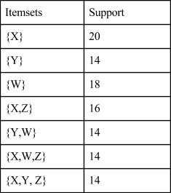
- Consider a market-basket transaction data that only has 4 items: X, Y, Z, and W. The table on the right shows the support of some itemsets, but the supports of other itemsets are unknown. Label each itemset listed below with the following letter(s):
• C if it is a closed itemset,
• N if it is not a closed itemset, and
• I if the information is not enough to judge whether or not it is closed.
- {Z}
- {Y}
- {X}
- {X, Z}

- I
- N
- C
- C

- Consider a dataset with 6 items: U,V,W,X,Y,Z and 50 transactions. You are given partial information about the support count of some itemsets as follows:
{U,V,W}: support count = 35
{U,V,W,X}: support count = 15
{U,V,W,X,Y}: support count = 15
The information about the support counts of other itemsets are unknown. Based on this, specify whether the following statements are:
(a) True, (b) False, or (c) Cannot decide based on the given partial information.
If you choose (a) or (b), then provide a brief explanation.
If you choose (c), give one example when the statement is correct, and another example when the statement is wrong.
(i) {U,V} is a closed itemset
Choice (a/b/c): c
Explanation (if a/b) or examples (if c): This is because the support of {U,V} is unknown. If it happens that the support of {U,V} is equal to 35, then the statement is wrong since {U,V,W} has the same support. Otherwise, if the support {U,V} is strictly higher than 35, and none of its immediate supersets has the same support, then the statement is correct.

(ii) {U,V,W} is a closed itemset
Choice (a/b/c): c
Explanation (if a/b) or examples (if c): There may exist another itemset, say {U,V,W,Y} that has a support count less than or equal to the one of {U,V,W}.

(iii) {U,V,W,X} is a closed itemset
Choice (a/b/c): b
Explanation (if a/b) or examples (if c): {U,V,W,X,Y} has the same support as {U,V,W,X}

- If all the transactions that contain {B,C,D} also contain {D,E, F}, which of the following itemsets are not closed.

a. {B,C,D}
b. {D,E,F}
c. {B,C,D,E}
d. {B,C,D,F}
e. {B,C,D,E,F}
Answer: a, b, c, d

Compact Itemsets in Market Basket Tables

- The dataset below contains 10 items and 100 transactions. Dark cells indicate the presence of items, while white (and grey) cells indicate the absence of items. We will apply the Apriori algorithm to extract frequent itemsets with minsup = 20% (i.e., itemsets must contain at least 20 transactions). Determine whether or not the following statements are true or false with a brief explanation.
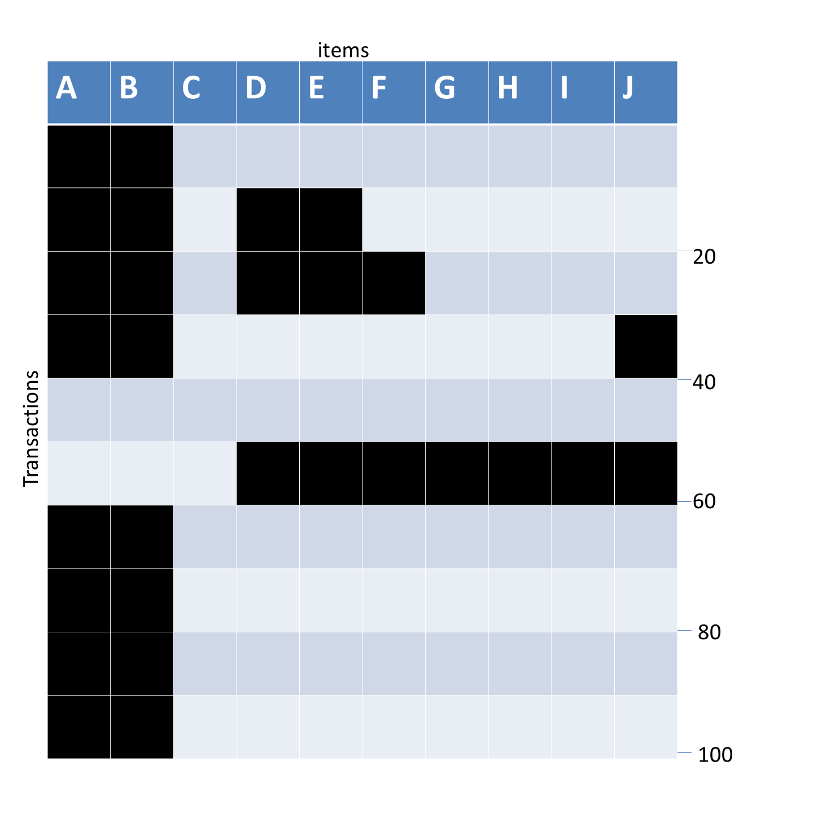
Statement | True/False. Explanation if false
{A, B} is a maximal frequent itemset | False. {A,B,D} is frequent.
{A, B} is a closed frequent itemset | True. None of its supersets has support of 0.8.
{D,E,F} is a frequent itemset | True. The support of {D,E,F} is 20 % >= minsup
Confidence of rule {A} → {J} is 100 % | False. Confidence of rule {A} → {J} = 10/80 = 0.125 = 12.5 %.
All subsets of {A,B,D,E} are frequent. | True, by the fact that {A, B, D, E} is a frequent itemset and apriori principle.
{A,B,D} is a maximal frequent itemset | False. {A,B,D,E} is frequent.

- The dataset below contains 10 items and 100 transactions. Dark cells indicate the presence of items, while white (and grey) cells indicate the absence of items. We will apply the Apriori algorithm to extract frequent itemsets with minsup = 20% (i.e., itemsets must contain at least 20 transactions).
Judge whether or not the following statements are correct. Give an explanation if you believe any statement is incorrect. For example,

Statement
{A} is a closed itemset | True/False: False
{A} is a closed itemset | Explanation if false: {A,B} has the same support as {A}.
{A} is a maximal itemset | True/False: False
{A} is a maximal itemset | Explanation if false: {A, B} is frequent.

Statement
All subsets of {A,B,D,E,J} are frequent | True/False:  False
All subsets of {A,B,D,E,J} are frequent | Explanation if false:  {E,J} is infrequent
All frequent itemsets are a subset of {A,B,D,E,F,J} | True/False:  True
All frequent itemsets are a subset of {A,B,D,E,F,J} | Explanation if false:
{A, B, E} is a closed itemset | True/False:  False
{A, B, E} is a closed itemset | Explanation if false:  {A,B,D,E} has the same support as {A,B,E}
{D, E} is a maximal frequent itemset | True/False:  False
{D, E} is a maximal frequent itemset | Explanation if false:  {D,E,F} is also frequent

- The dataset below contains 10 items and 100 transactions. Dark cells indicate the pres ence of items, and white (and grey) cells indicate the absence of items. We will apply the Apriori algorithm to extract frequent itemsets with minsup = 20% (i.e., itemsets must contain at least 20 transactions).

Statement
{A} is a closed itemset | True/False: False
{A} is a closed itemset | Explanation if false: {A,B} has the same support as {A}.
{A} is a maximal itemset | True/False: False
{A} is a maximal itemset | Explanation if false: {A, B} is frequent.
Judge whether or not the following questions are correct. Give the explanation if you believe any statement is incorrect. For example,

Statement
All subsets of {A,B,D,E,J} are frequent | True/False:  False
All subsets of {A,B,D,E,J} are frequent | Explanation if false:  {E,J} is infrequent
All frequent itemsets are a subset of {A,B,D,E,F,J} | True/False:  True
All frequent itemsets are a subset of {A,B,D,E,F,J} | Explanation if false:
{A, B, E} is a closed itemset | True/False:  False
{A, B, E} is a closed itemset | Explanation if false:  {A,B,D,E} has the same support as {A,B,E}
{D,E} is a maximal frequent itemset | True/False:  False
{D,E} is a maximal frequent itemset | Explanation if false:  {D,E,F} is also frequent

- The dataset below contains 8 items and 80 transactions. Dark-colored cells indicate the presence of items, and lightly shaded cells indicate the absence of items. We apply the Apriori algorithm to extract frequent itemsets with minsup = 25% (i.e., itemsets must contain at least 20 transactions). Indicate whether the following statements are “true” or “false.” Give an explanation if your answer is “false.” An example of two statements with their corresponding answers is shown below.
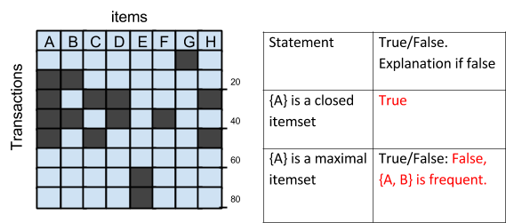
Statement | True/False. Explanation if false
{A} is a closed frequent itemset | True
{A,C} is a closed itemset | False {A,C,H} has same support as {A,C}
{A,B,D} is a frequent itemset | False The support count of {A,B,D} is 10.
{A,D} is a maximal itemset | True

- The figure below depicts a transaction matrix
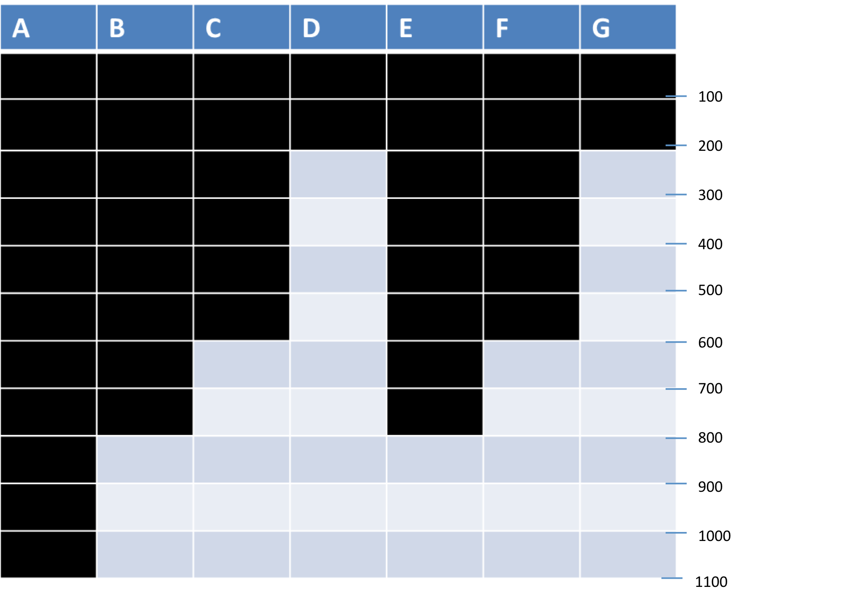

- List all the closed frequent itemsets for the following support threshold:
i) 950
Answer - Closed frequent – A

ii) 700
Answer - Closed frequent – A,ABE

- List all the maximal frequent itemsets for the following support threshold:
- 95
Answer : Maximal frequent – ABCDEFG

- The figure below depicts a transaction matrix with 10 items and 20 transactions. Dark cells indicate the presence of items, and white (or grey) cells indicate the absence of items. We apply the Apriori algorithm to extract frequent itemsets with minsup=20% (i.e., itemsets must be contained in at least 4 transactions). Answer the following questions:
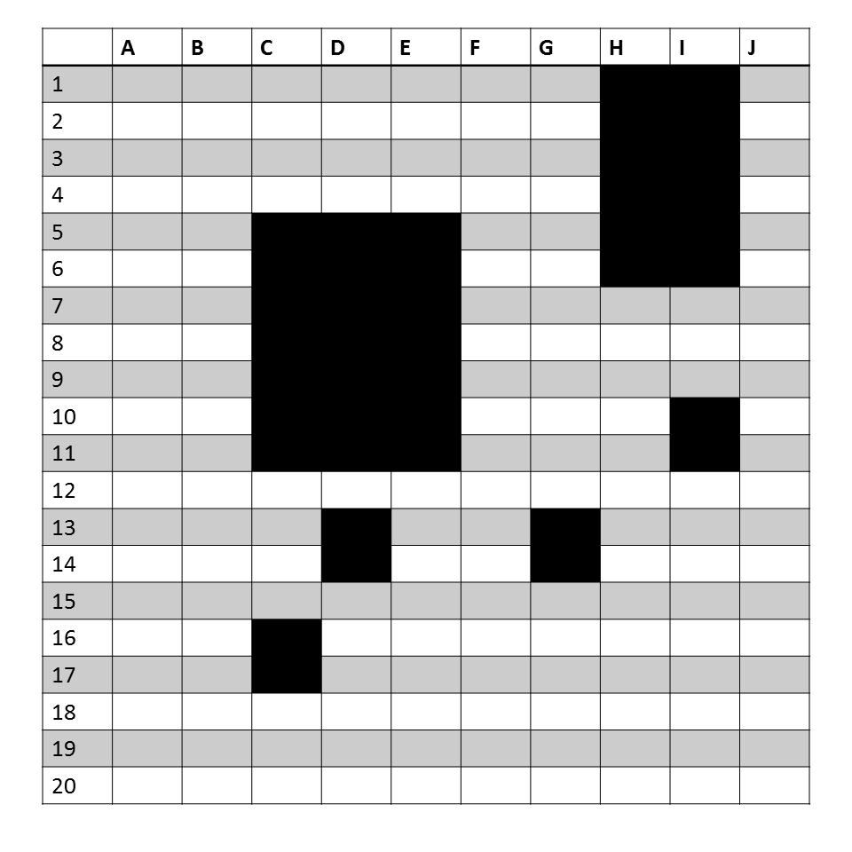

- List all the maximal itemsets in the dataset.
Answer: {C,D,E,I}, {H,I}

- List all the frequent itemsets in the dataset.
Answer: All subsets of {C,D,E,I} and {H,I}

- List all the closed frequent itemsets in the dataset.
Answer: {C},{D},{I},{C,D,E}, {H,I}, {C,D,E,I}
- The figure below depicts a transaction matrix with 10 items and 20 transactions. Dark cells indicate the presence of items, and white (or grey) cells indicate the absence of items. We apply the Apriori algorithm to extract frequent itemsets with minsup=20% (i.e., itemsets must be contained in at least 4 transactions). Answer the following questions.
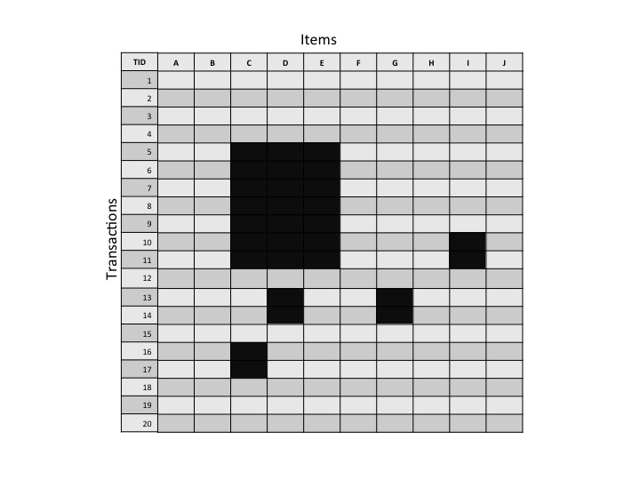
- Which are the maximal itemsets in the dataset?
Answer: {CDE}
- How many frequent itemsets are there in the dataset.
Answer: 7
- Which are the closed frequent itemsets in the dataset?
Answer: {CDE}

- Itemset properties
3
5
8
A | B | C | D | E | F | G
1 | 1 | 1
1 | 1 | 1
1 | 1 | 1
1 | 1 | 1
1 | 1 | 1
1 | 1 | 1
1 | 1 | 1
1 | 1 | 1
 |  |  | 1 | 1
 |  |  | 1 | 1
 |  |  | 1 | 1
 |  |  | 1 | 1
 |  |  | 1 | 1
 |  |  |  |  | 1 | 1
 |  |  |  |  | 1 | 1
 |  |  |  |  | 1 | 1

The table shows a transaction matrix for items A-G. Each row is a transaction. Given the following itemsets and a support threshold of 5, complete the table with a Yes or No. The first example is solved for you.
Itemset | Frequent | Closed | Maximal frequent | Closed frequent
{A,B,C} | Yes | Yes | Yes | Yes
{A,B} | Yes | No | No | No
{F} | No | Yes | No | No

Comparing Compact Itemsets across Market Basket Tables

- Answer the following questions based on the data sets shown in the figure below. Note that each data set contains 1000 items and 10000 transactions. Dark cells indicate the presence of items, and white cells indicate the absence of items. We will apply the Apriori algorithm to extract frequent itemsets with minsup = 10% (i.e., itemsets must contain at least 1000 transactions). For ease of comparison, you can assume that the vertical bars in data set B are approximately of width 10 items each, and the square block centered around item 800 is of the same size as each of the 5 square blocks in data set A.
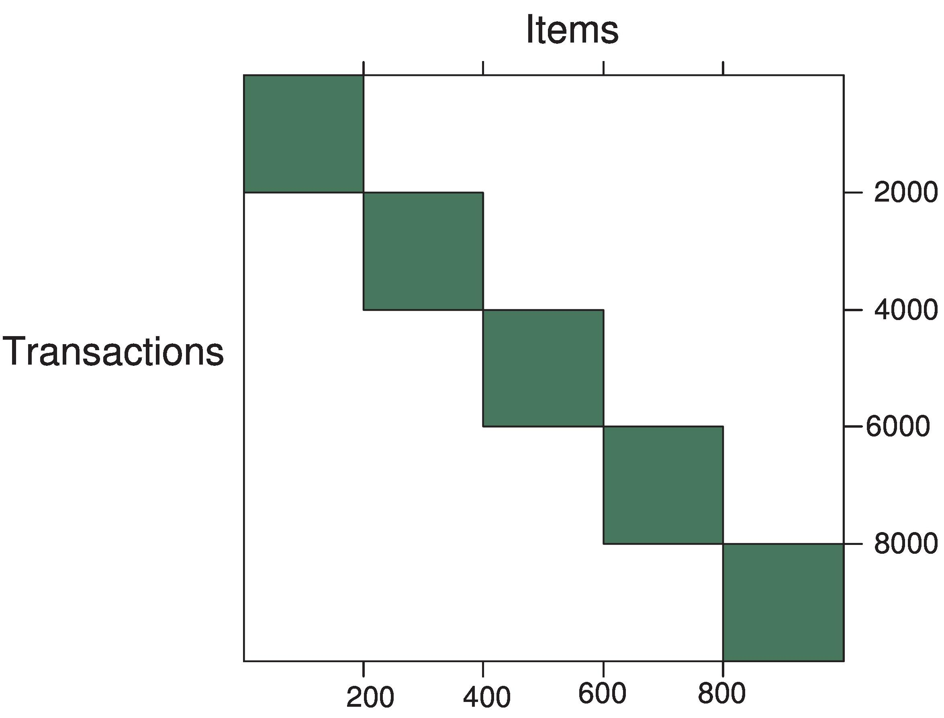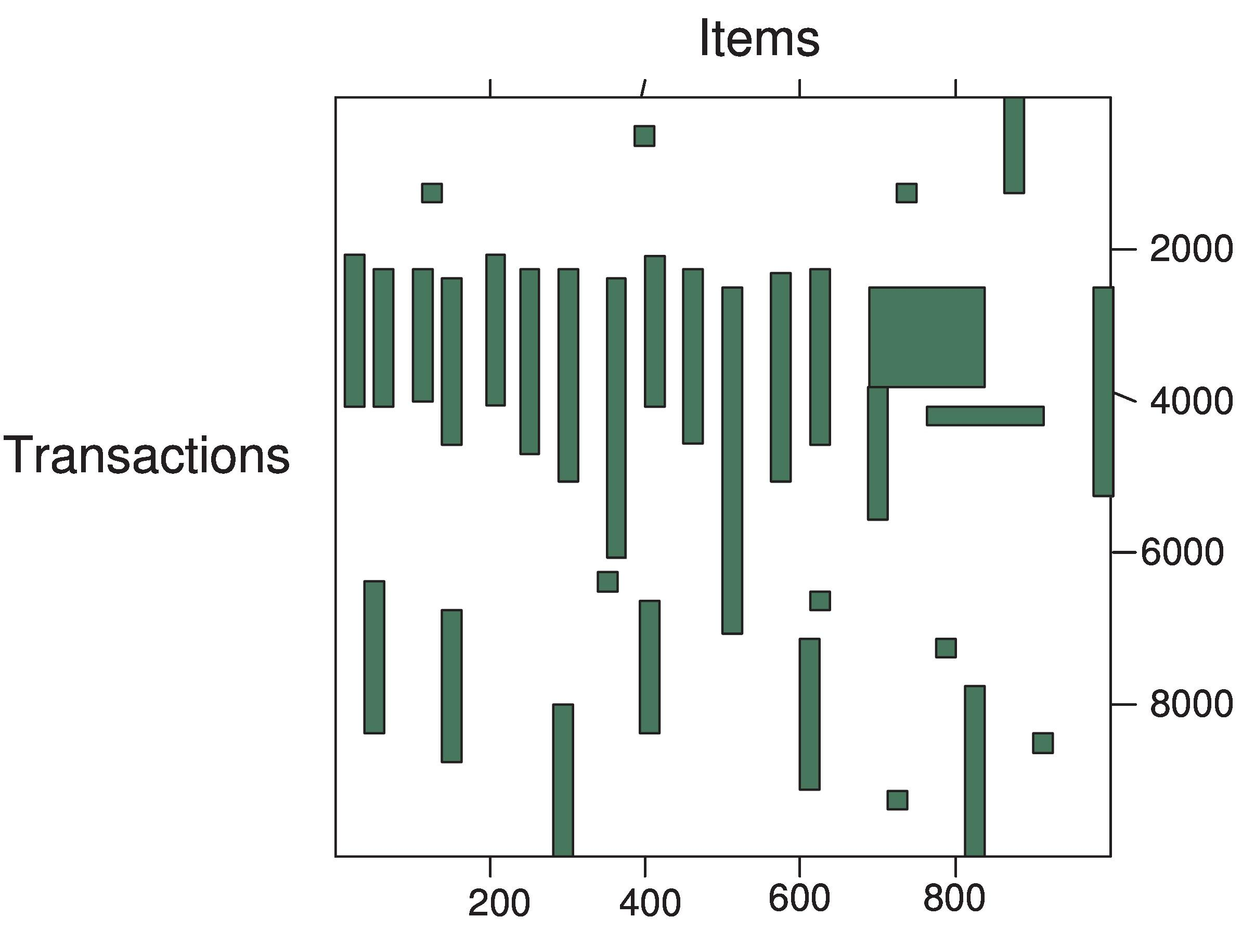
Data set A Data set B

- Which data set will produce the greatest number of frequent itemsets?
Graph (b). Graph (a) will produce 5 × (2²⁰⁰ – 1) frequent itemsets. On the other hand, there are at least 340 items that are supported by transactions 2000-4000 and have support greater than 10% in the data set of Graph (b). So, in the latter case, (2³⁴⁰ – 1) frequent itemsets can be produced, which is much larger than the number produced from Graph (a).
- Assume that the minimum support threshold is equal to 10%. How many closed frequent itemsets will be discovered from data set 1?
5, since each of the diagonal blocks will be produced as a closed itemset. Each
of their constituent itemsets will have the same support as the diagonal block of which they are
a part.
- Which data set will produce the longest frequent itemset?
Graph (b), which can produce a frequent itemset that has more than 200 items (which is the longest frequent itemset produced by graph (a)).
- Which data set will produce frequent itemset with the highest support?
Graph (b), which has an itemset composed of items in the range 400-600 and has a support count of over 4000 (40%). This is larger than the maximum support of 20% that an itemset in Graph (a) can have. Thus, Graph (b) will produce itemsets of higher support.
- Which data set will produce the most closed frequent itemsets?
Graph (b), since Graph (a) will produce 5 closed frequent itemsets. On the
other hand, since Graph (b) will produce many more frequent itemsets of different sizes
and supports, it will also produce more closed frequent itemsets.

- The figures below depict 4 transaction data sets, each having 1000 items and 10,000 transactions. Dark cells indicate the presence of items, and white cells indicate the absence of items. We apply the Apriori algorithm to extract frequent itemsets with minsup=10% (i.e., itemsets must be contained in at least 1000 transactions). Answer the following questions (give the label of the corresponding figure).

(a)
(b)

(d)
(c)

- Which data set will produce the most frequent itemsets?
D, since it produces the longest itemset by far and the number number of subsets, which will also be frequent itemsets, is 2^{L}, where L is the length of that itemset.

- Which data set will produce the smallest number of closed frequent itemsets?
B since it has only 3, and all others have at least 5.

- Which data set will produce the longest (size) frequent itemset?
D since it will produce a frequent itemset of length somewhere between 400 and 700, which is supported by transactions 2000-4000.

- Which data set will produce the frequent itemset with the highest support?
B since it has an itemset with support of roughly 8000 and none of the other 3 data sets have an itemset with nearly as much support.

- Which data set(s) will produce the most closed frequent itemsets, excluding (D)?

A and C, since they will produce 5 closed frequent itemsets. B has 3? closed frequent itemsets.

- Which data set will produce the longest (size) closed itemset?
B since the longest frequent itemset (if it exists) is also the longest closed itemset.

- Answer the following questions using the data sets shown in the following Figure. Note that each data set contains 1000 items and 10000 transactions. Dark cells indicate the presence of items, and white cells indicate the absence of items. We will apply the Apriori algorithm to extract frequent itemsets with minsup = 10% (i.e., itemsets must contain at least 1000 transactions).
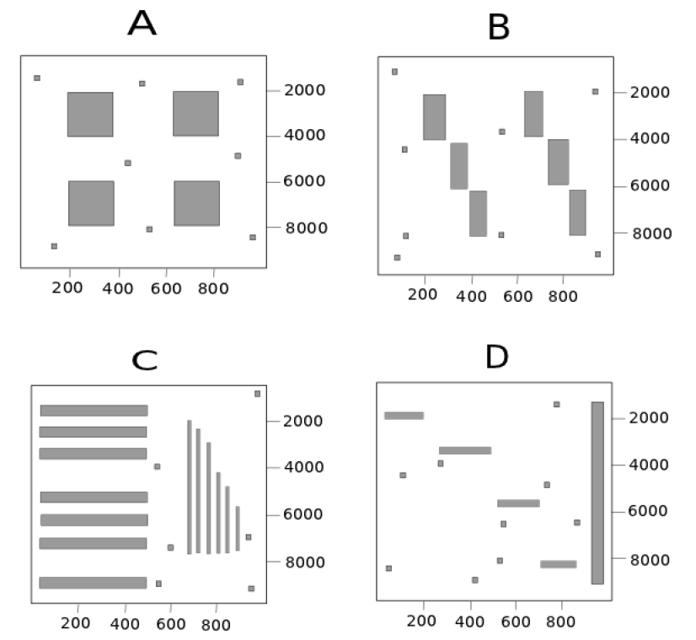

- Which data set will produce the most frequent itemsets?
C
- Which data set will produce the longest (size) frequent itemset?
C
- Which data set will produce the frequent itemset with the highest support?
D
- Which data set will produce the most closed frequent itemsets?
C
- Which data set will produce the most maximal frequent itemsets?
B

- Answer the following questions using the data sets shown in the following Figure. Note that each data set contains 1000 items and 10000 transactions. Dark cells indicate the presence of items, and white cells indicate the absence of items. We will apply the Apriori algorithm to extract frequent itemsets with minsup = 10% (i.e., itemsets must contain at least 1000 transactions).

(a) Which data set will produce the most frequent itemsets?
Answer: C

(b) Which data set will produce the longest (size) frequent itemset?
Answer: C

(c) Which data set will produce the frequent itemset with the highest support?
Answer: D

(d) Which data set will produce the most closed frequent itemsets?
Answer: C

(e) Which data set will produce the most maximal items?
Answer: B

- Answer the following questions using the data sets shown in the following Figure. Note that each data set contains 1000 items and 10000 transactions. Dark cells indicate the presence of items, and white cells indicate the absence of items. We will apply the Apriori algorithm to extract frequent itemsets with minsup = 10% (i.e., itemsets must contain at least 1000 transactions).
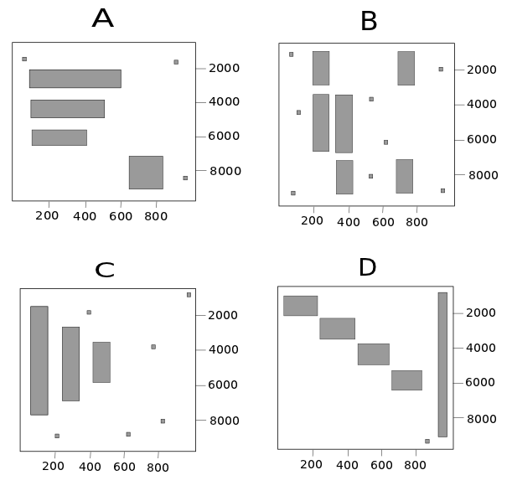
(a) How many maximal itemsets are present in data matrix A?
2
(b) How many closed frequent itemsets are present in data matrix B?
4
(c) How many closed frequent itemsets are present in data matrix C?
5
(d) How many maximal itemsets are present in data matrix D?
5

- Answer the following questions using the data sets shown in the following Figure. Note that each data set contains 1000 items and 10000 transactions. Dark cells indicate the presence of items, and white cells indicate the absence of items. We will apply the Apriori algorithm to extract frequent itemsets with minsup = 10% (i.e., itemsets must contain at least 1000 transactions).

a) Which data set will produce the most number of frequent itemsets?
Answer: A
b) Which data set will produce the least number of frequent itemsets?
Answer: B
If we order all the four datasets decreasingly based on the number of frequent itemsets, the results are A, C, D, B. In detail, frequent itemsets in A are all the subsets of item 150-600 + all the subsets of item 650-800. Thus, there are more than 2450 frequent itemsets. Frequent itemsets in C are all the subsets of items in the range 50-150, 200-300, and 450-550). Thus, there are around 2300 frequent itemsets. Frequent itemsets in B are all the subsets of items in three unions. They are the union of items 200-300 and 680-780, the union of items 680-780 and 320-420, and the union of item 200-300 and 320-420 (item labels are approximate, but each column has approximately 100 items). Frequent itemsets in D are the subsets of four unions. Each union contains a small block and the bar on the right side of the image.
c) Which data set will produce the least number of maximal itemsets?
Answer: C
The number of maximal itemset of each dataset is as follows,
A: 2 (One itemset contains items labeled within 150-600, and the other itemset contains items labeled within 625- 800)
B: 3 (They are the union of item 200-300 and 680-780, the union of item 680-780 and 320-420 and the union of item 200-300 and 320-420.)
C: 1 (Items corresponding to the three large columns).
D: 4 (Items corresponding to each small block plus the bar on the right side of the image is a maximal itemset)

d) Which data set will produce the most closed frequent itemsets?
Answer: D
It is easy to see that B contains 6 closed frequent itemsets, C contains 3 closed frequent itemsets. A contains 4 blocks. Each of them is a closed frequent itemset. Besides, some other itemsets, e.g., the items covered by the blue line in A, are also closed frequent itemset because of the “small dots” (adding any other item to such itemsets will make the support decrease). Thus, there are 4 additional closed frequent itemsets in dataset A. In total, dataset A contains 8 closed frequent itemsets. Similarly, D contains 5+8=13 closed frequent itemsets.

e) Which data set will produce the most maximal itemsets?
Answer: D

- The template below is for future use in creating problems like those below.
10000
8000
6000
4000
2000
Itemscv
Transactions
A | B | C | D | E | F | G | H | I | J

- Each dataset below contains 10 items and 10000 transactions. Dark cells indicate the presence of items, and white (and grey) cells indicate the absence of items. We will apply the Apriori algorithm to extract frequent itemsets with minsup = 20% (i.e., itemsets must contain at least 2000 transactions).
(a) (b) (c)
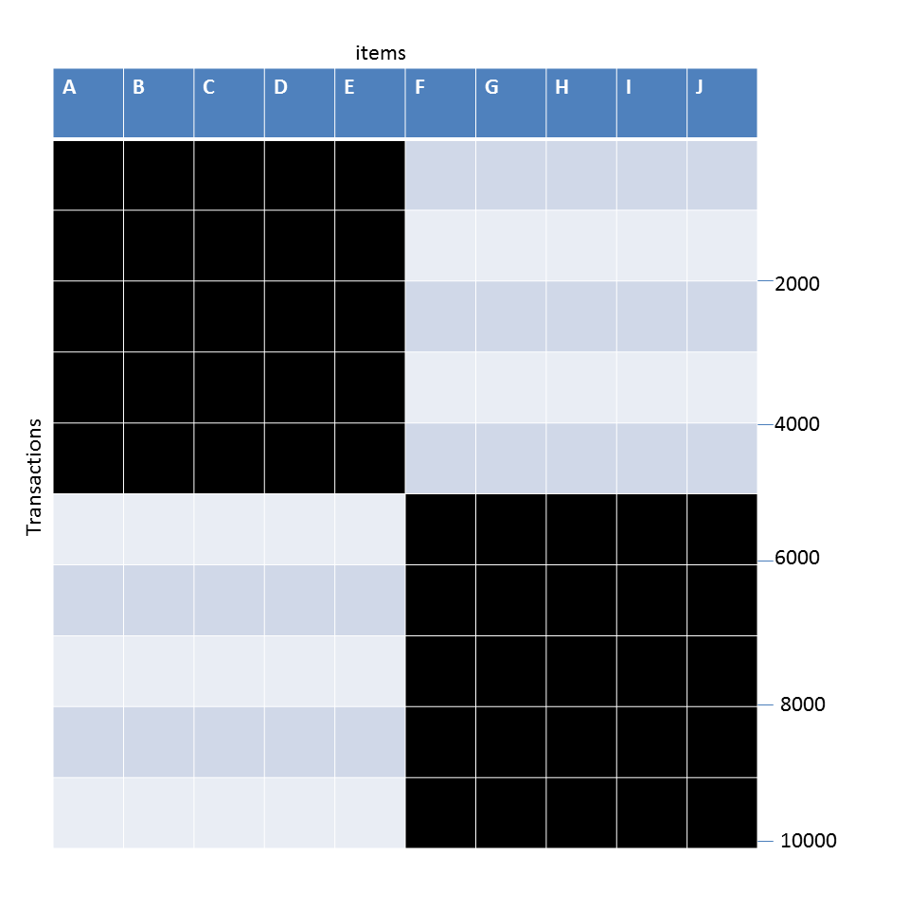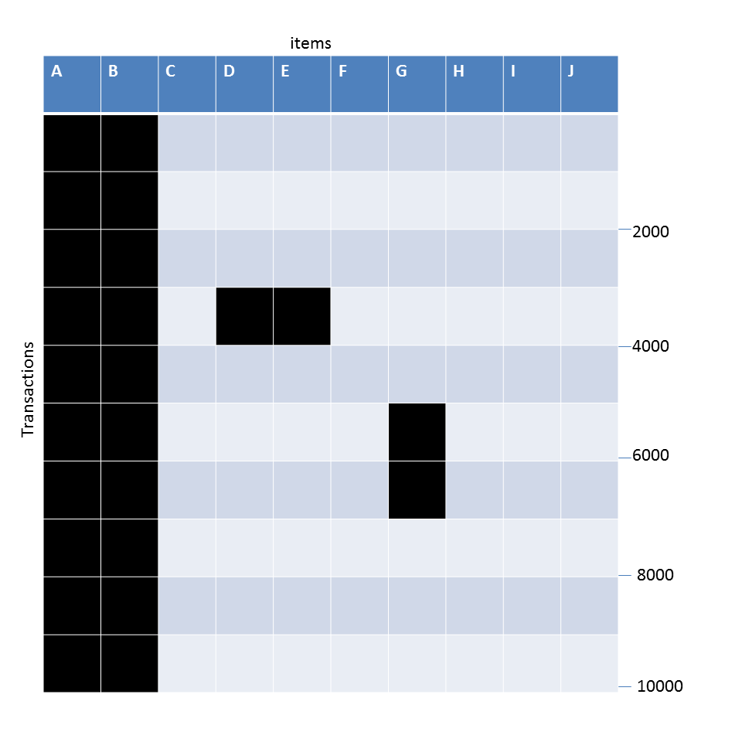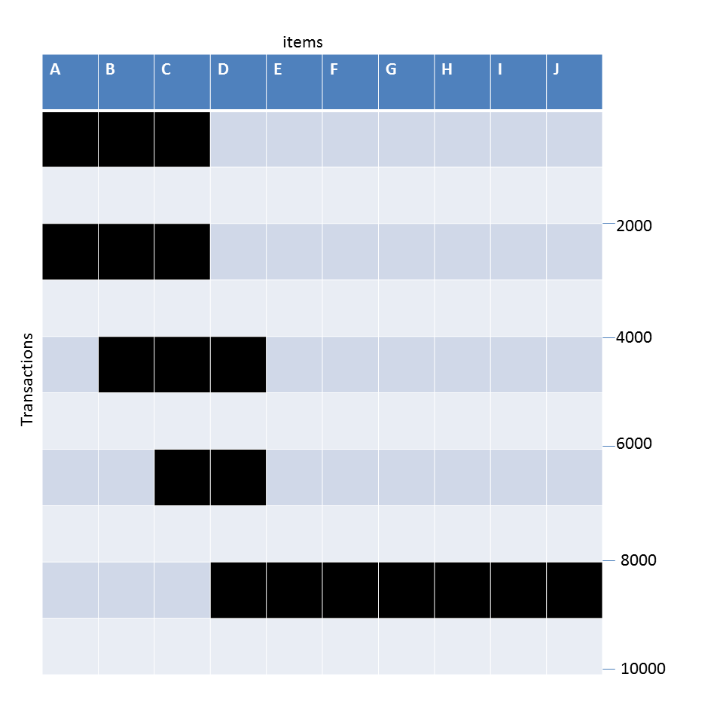

- What is the number of frequent itemsets for each dataset? Which dataset will produce the most number of frequent itemsets?
- Which dataset will produce the longest frequent itemset?
- Which dataset will produce frequent itemsets with the highest maximum support?
- Which dataset will produce frequent itemsets containing items with widely varying support levels (i.e., itemsets containing items with mixed support, ranging from 20% to more than 70%)?
- What is the number of maximal frequent itemsets for each dataset? Which dataset will produce the most number of maximal frequent itemsets?
- What is the number of closed frequent itemsets for each dataset? Which dataset will produce the most number of closed frequent itemsets?
Solution:
- A - 62, B- 7, C- 9.
- A
- B
- B
- A: 2. B:1 C:2
A and C
- A:2 B:2 C:5
C
- Each dataset below contains 10 items and 10000 transactions. Dark cells indicate the presence of items, and white (and grey) cells indicate the absence of items. We will apply the Apriori algorithm to extract frequent itemsets with minsup = 30% (i.e., itemsets must contain at least 2000 transactions).
(A) (B) (C)

- Which dataset will produce the most number of frequent itemsets?
- Which dataset will produce the longest frequent itemset?
- Which dataset will produce frequent itemsets with the highest support?
- Which dataset will produce the least number of maximal frequent itemsets?
Solution:
- A - 62, B- 3, C- 4. Hence A
- A
- B
- B

- Each dataset below contains 10 items and 10000 transactions. Dark cells indicate the presence of items and white (and grey) cells indicate the absence of items. We will apply the Apriori algorithm to extract frequent itemsets with minsup = 20% (i.e. Itemsets must contain at least 2000 transactions).
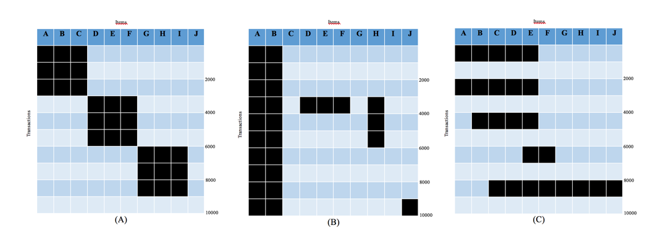
(i) Which dataset will produce the largest number of frequent itemsets?
Answer (A/B/C): C

(ii) Which dataset will produce the longest frequent itemset?
Answer (A/B/C): C

(iii) Which dataset will produce frequent itemsets with highest support?
Answer (A/B/C): B

(iv) Which dataset will produce the least number of maximal frequent itemsets?
Answer (A/B/C): B

(iv) Which dataset will produce the least number of closed itemsets?
Answer (A/B/C): A

- Consider the three datasets below that contain 7 items and 1000 transactions. Each row represents 100 transactions. Dark cells indicate the presence of items and white (and grey) cells indicate the absence of items. We will apply the Apriori algorithm to extract frequent itemsets with minsup = 50% (i.e., itemsets must contain at least 500 transactions).
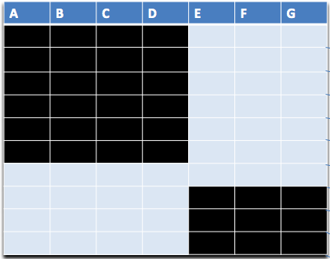
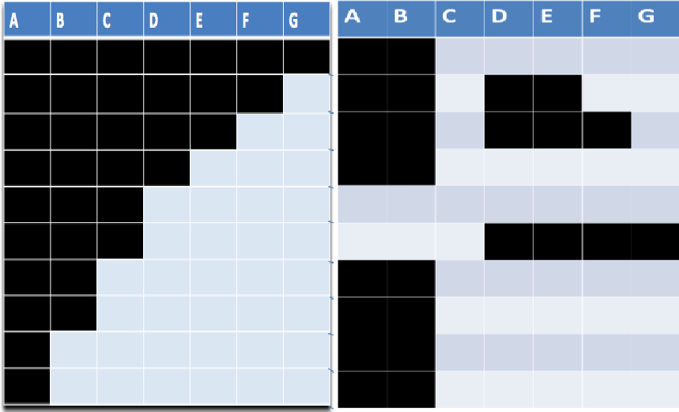

Dataset 1 Dataset 2 Dataset 3

  - What is the number of frequent itemsets for each dataset? Which dataset will produce the greatest number of frequent itemsets?

Dataset 1: {ABCD} and all its subset = 1 + 4C3 + 4C2 + 4C1 = 1+4+6+4 = 15
Dataset 2: {ABC} and all its subsets = 1 + 3C2 + 3C1 = 1+3+3 = 7
Dataset 3: {AB} and all its subsets = 3
Dataset 1 has the largest number of frequent itemset.

  - Which dataset will produce the longest frequent itemset?

Dataset 1

  - Which dataset will produce frequent itemsets with highest maximum support?

Dataset 2

  - Which dataset will produce frequent itemsets containing items with widely varying support levels (i.e., itemsets containing items with mixed support, ranging from 20% to more than 70%)?

Dataset 2

  - What is the number of maximal frequent itemsets for each dataset? Which dataset will produce the greatest number of maximal frequent itemsets?
Dataset 1: 1 ({ABCD})
Dataset 2: 1 ({ABC})
Dataset 3: 1 ({AB})
All Datasets produce the same number of maximal frequent itemsets.

  - What is the number of closed frequent itemsets for each dataset? Which dataset will produce the greatest number of closed frequent itemsets?

Dataset 1: 1 ({ABCD})
Dataset 2: 3 ({A}, {A,B}, {A,B,C})
Dataset 3: 1 ({A,B})
Dataset 2 has the most number of closed frequent itemset.

- Consider the two datasets below that contain 7 items and 1000 transactions. Dark cells indicate the presence of items, and white (and grey) cells indicate the absence of items. We will apply the Apriori algorithm to extract frequent itemsets with minsup = 50% (i.e., itemsets must contain at least 500 transactions).
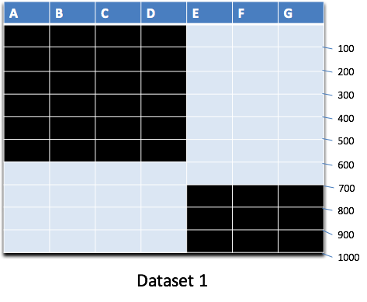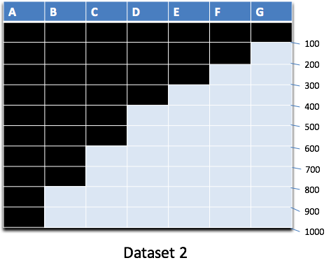
State which dataset has the highest number of a given type of itemsets. No explanation needed.
- Number of frequent itemsets?
Dataset 1
- Number of closed itemsets?
Dataset 2
- Number of closed frequent itemsets?
Dataset 2
- Number of maximal frequent itemsets?
Both have exactly one maximal frequent itemset.

- The figure below depicts a transaction matrix with 11 items and 20 transactions. Dark cells indicate the presence of items, and white cells indicate the absence of items. We apply the Apriori algorithm to extract frequent itemsets with minsup=20% (i.e., itemsets must be contained in at least 4 transactions). Answer the following questions:
- List all the frequent itemsets in the dataset.
- List all the closed frequent itemsets in the dataset.
- List all the maximal frequent itemsets in the dataset.

 | A | B | C | D | E | F | G | H | I | J | K
1
2
3
4
5
6
7
8
9
10
11
12
13
14
15
16
17
18
19
20

- Frequent itemsets -
Size 1: {B}, {C}, {D}, {E}, {H}, {I}, {K}
Size 2: {B,C}, {B,D}, {B,E}, {B,K}, {C,D}, {C,E}, {D,E}, {E,I}, {E,K}, {H,I}
Size 3: {B,C,D}, {B,C,E}, {B,D,E}, {B,E,K}, {C,D,E}
Size 4: {B,C,D,E}
- Closed frequent itemsets -
Size 1: {B}, {E}, {H}, {I}
Size 2: {B,E}, {E,I}, {H,I}
Size 3: {B,E,K}
Size 4: {B, C, D, E}
- Maximal frequent itemsets - {E,I}, {H,I}, {B,E,K}, {B,C,D,E}

- The figure below depicts a transaction matrix with 10 items and 20 transactions. Dark cells indicate the presence of items, and white (or grey) cells indicate the absence of items. We apply the Apriori algorithm to extract frequent itemsets with minsup=20% (i.e., itemsets must be contained in at least 4 transactions). Answer the following questions:
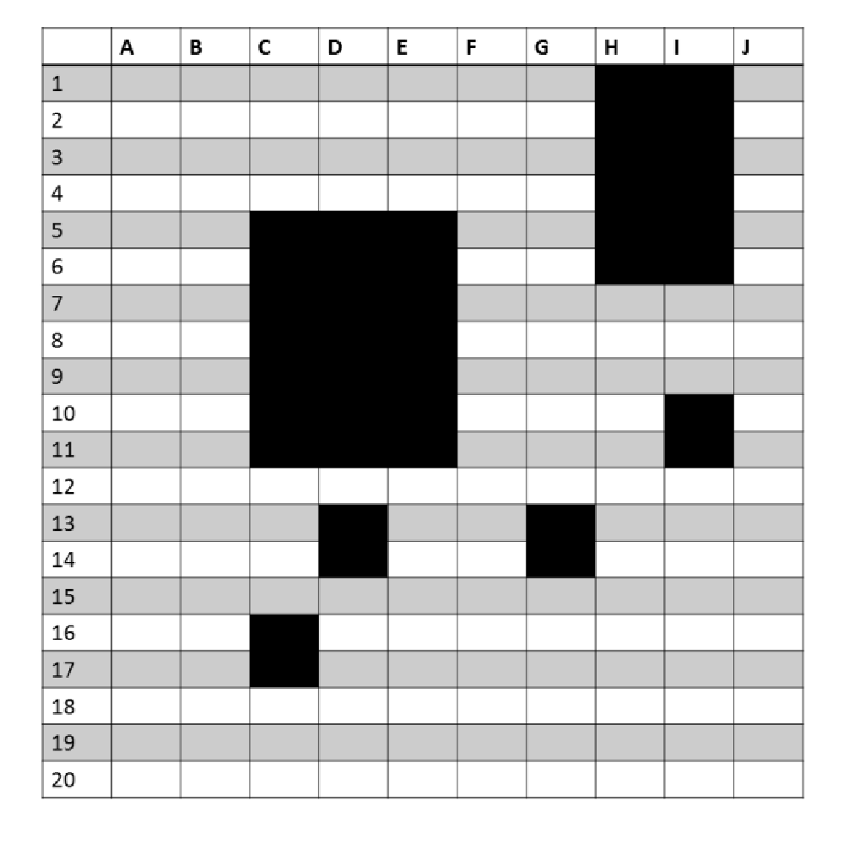

a) List all the maximal itemsets in the dataset.
{C,D,E,I}, {H,I}
b) List all the frequent itemsets in the dataset.
All subsets of {C,D,E,I} and {H,I}
c) List all the closed frequent itemsets in the dataset.
{C},{D},{I},{C,D,E}, {H,I}, {C,D,E,I}

- Each dataset below contains 10 items and 10000 transactions. Dark cells indicate the presence of items, and white (and grey) cells indicate the absence of items. We will apply the Apriori algorithm to extract frequent itemsets with minsup = 20% (i.e., itemsets must contain at least 2000 transactions).

(a) (b)
( C)
- What is the number of frequent itemsets for each dataset? Which dataset will produce the most number of frequent itemsets?
Answer:
A. 62. B. 7. C 9.
A.
- Which dataset will produce the longest frequent itemset?
Answer: A
- Which dataset will produce frequent itemsets with the highest maximum support?
Answer: B
- Which dataset will produce frequent itemsets containing items with widely varying support levels (i.e., itemsets containing items with mixed support, ranging from 20% to more than 70%)?
Answer: B
- What is the number of maximal frequent itemsets for each dataset? Which dataset will produce the most number of maximal frequent itemsets?
Answer:
A: 2. B:1 C:2
A and C
- What is the number of closed frequent itemsets for each dataset? Which dataset will produce the most number of closed frequent itemsets?
Answer:
A:2 B:2 C:5
C

- The figures below depict 4 transaction data sets, each having 1000 items and 10,000 transactions. Dark cells indicate the presence of items, and white cells indicate the absence of items.
We apply the Apriori algorithm to extract frequent itemsets with minsup=10.
Note that, the minsup is 10, as stated clearly, not 10 percent:

(a) Which data set will produce the highest number of frequent itemsets?
Answer: C, mainly because the long horizontal bar between transaction 8000-10000 and items 200-1000.
(b) Which data set will produce the smallest number of closed frequent itemsets?
Answer: A, just five.
(c) Which data set will produce the longest (size) frequent itemset?
Answer: C, longest size greater than 800.
(d) Which data set will produce the itemset with the highest support?
Answer: B, more than 8000.
(e) Which data set will produce the longest (size) closed itemset?
Answer: C

- The figures below depict 4 transaction data sets, each having 1000 items and 10,000 transactions. Dark cells indicate the presence of items, and white cells indicate the absence of items. We apply the Apriori algorithm to extract frequent itemsets with minsup=10% (i.e., itemsets must be contained in at least 1000 transactions). Answer the following questions (give the label of the corresponding figure).

(b)
(a)

(d)
(c)

  - Which data set will produce the highest number of frequent itemsets?
Answer: D
  - Which data set will produce the longest frequent itemset?
Answer: D
  - Which data set will produce the itemset with the highest maximum support?
Answer: B

- The figures below depict 4 transaction data sets, each having 1000 items and 10,000 transactions. Dark cells indicate the presence of items, and white cells indicate the absence of items. We apply the Apriori algorithm to extract frequent itemsets with minsup=10% (i.e., itemsets must be contained in at least 1000 transactions). Answer the following questions (give the label of the corresponding figure).

(b)
(a)

(d)
(c)

  - For which data set will the same set of closed and maximal frequent itemsets be produced?
Answer: A
  - Which data set will produce the itemset with the highest support?
Answer: B
  - Which data set will produce the longest (size) closed itemset?
Answer: C

- Answer the following questions based on the data sets shown in the figure below. Note that each data set contains 1000 items and 10000 transactions. Dark cells indicate the presence of items, and white cells indicate the absence of items. We will apply the Apriori algorithm to extract frequent itemsets with minsup = 10% (i.e., itemsets must be contain at least 1000 transactions).

          - Synthetic Data set 1 (b) Synthetic data set 2.
Figure: Data sets for this question.
(a) Which data set will produce the most number of frequent itemsets?
Answer: Graph (b). Graph (a) will produce 5 x 2200 frequent itemsets. On the other hand, there are at least 400 items that are supported by transactions 2000-4000, and have a support greater than 10% in the data set of Graph (b). So, in the latter case, 2400 frequent itemsets can be produced, which is much larger than those produced from Graph (a).
(b) Assume that the minimum support threshold is equal to 10%. How many closed frequent itemsets will be discovered from data set 1?
Answer: 5, since each of the diagonal blocks will be produced as a closed itemset. Each of their constituent itemsets will have the same support as the diagonal block they are a part of.
(c) Which data set will produce the longest frequent itemset?
Answer: Graph (b), since it will produce a frequent itemset of length 400 or more that is supported by transactions 2000-4000. On the other hand, graph (a) will produce a frequent itemset of length at most 200.
(d) Which data set will produce frequent itemset with high support?
Answer: Graph (b), which has an itemset constituted by items in the range 400-600 and has a support of over 4000 (40%). This is larger than the maximum support of 20% that an itemset in Graph (a) can have. Thus, Graph (b) will produce itemsets of higher support.
(e) Which data set will produced the most number of closed frequent itemsets?
Answer: Graph (b), since Graph (a) will produce 5 closed frequent itemsets. On the other hand, since Graph (b) will produce many more frequent itemsets of different sizes and supports, it will also produce more closed frequent itemsets.

Evaluation of Association Patterns

      - A survey was conducted to study the preferences of two beverages, namely tea and coffee, among the 1000 students of a university. It was found out that 80 % of coffee drinkers do not drink tea, suggesting that tea was highly unpopular among those who drink coffee. In which of the following scenarios would tea be necessarily more popular among those who do not drink coffee, i.e., P(Tea| Not Coffee) > P(Not Tea| Not Coffee)? Justify with a brief explanation.

- 90 % of the total population are coffee-drinkers.
- 90 % of the total population are tea-drinkers.
- 90 % of the total population do not drink coffee.
- Cannot say with certainty due to a lack of information.

B. If it is known that tea is overall a popular beverage, it has to be popular among either coffee-drinkers or non-coffee drinkers or both. Since only 20 % of coffee-drinkers drink tea, it has to be compensated by a high fraction of non-coffee drinkers that drink tea. The mathematical proof is the following.
Consider the contingency table for the situation described above:
 | Coffee | Not Coffee
Tea | a | b
Not Tea | 4a | d

For scenario B, a + b = 900 and 4a+ d = 100. Therefore, 4(900-b) + d = 100, which implies 3500 = 4b - d. Since a, b, d>0, 0<= d <100. Therefore, b lies in [775,800).

      - Consider the bond measure for an itemset, X = {A, B}, containing two items, A and B given by

P(A,B)/P(A˅ B)
where P(A, B) is the support of the itemset and P(A˅B) is the fraction of transactions that contain either A or B (or both).
    - What is the minimum value for bond and under what condition does Bond(X) attain its minimum value?
0 when P(A,B) = 0.
    - What is the maximum value for bond and under what condition does Bond(X) attain its maximum value?
1 when P(A,B) = P(A) = P(B).

    - How does Bond(X) behave when P(A) is increased while P(A, B) and P(B) remain unchanged?
Decreases because P(A˅B) = P(A) + P(B) - P(A,B) increases
    - If A and B are independent and have identical support, P (A ) = P (B ), write a simplified expression for Bond ({A,B}).
P(A)/[2−P(A)]
      - Consider the interestingness measure, M = [P(B|A)−P(B)] / [1−P(B)] , for an association rule:
A → B, assuming P(B) ≠ 1.

(a) What is the range of this measure? When does the measure attain its maximum and minimum values?
Range of the measure: -∞<M≤1
Since M = [P(B|A)−P(B)] / [1−P(B)] maximum value occurs when P(A,B) = P(A):
At this value, M = [1−P(B)]/[1−P(B)] = 1
Minimum Value occurs when P(A,B)/P(A) = 0:
At this value M = −P(B)/[1−P(B)]
This value decreases with increasing P(B).
(b) How does M behave when P(A,B) is increased while P(A) and P(B) remain unchanged?
M increases.
(c) How does M behave when P(A) is increased while P(A, B) and P(B) remain unchanged?
M decreases.
(d) How does M behave when P(B) is increased while P(A, B) and P(A) remain unchanged?
Let a = P(A,B)/P(A) and y = P(B). Since P(A, B) and P(A) remain unchanged, then a is a constant.
However, the measure M can be shown as a function
f(y) = (a−y)/(1−y) .
The derivative of f is: df(y)/dy = (a−1)/(1−y)^2
Since a <= 1, M decreases while y = P(B) increases.
(e) Is the measure symmetric under the variable permutation?
No.

      - Consider the following two contingency tables for rules {B} -> {C} (left) and {A} -> {D} (right)
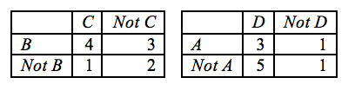
The interestingness measure Odds Ratio (OR) for a pair of items (A,B) is defined as:

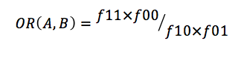
(i) Calculate the confidence and Odds Ratio for {B} -> {C} and {A} -> {D}
1. Rule {B} -> {C}
Confidence: 4/7 (0.57)
Odds Ratio: 2.67

2. Rule {A} -> {D}
Confidence: 3/4 (0.75)
Odds Ratio: 0.6

(ii) Which rule do you think is more interesting? Explain.
Rule: {B} -> {C}
Explanation: It is more interesting according to OR (more extreme OR value compared to 1). Confidence can be misleading, because it does not take into account statistical dependence (whether Confidence(X -> Y) > support(Y))

      - The interestingness measure I for a pair of items (A, B) is defined as:
Consider the following pairs of items: (A, B) and (C, D), characterized by the following contingency tables:
 | A | Not A |  |  | C | Not C
B | 2 | 398 |  | D | 240 | 60
Not B | 498 | 102 |  | Not D | 160 | 540
 | I(A,B)=.01 |  |  |  | I(C,D)=2

Which of these pairs of items: (A, B) or (C, D), is more interesting (strongly associated)? Why?

I(x,y)=1 indicates that items x and y occur independently. Hence they are uninteresting. I(x,y)<1 suggests a negative association, while I(x,y)>1 suggests a positive association. The more extreme I(.), the stronger the association. The stronger the association, the more interesting the pattern. I(A,B) = .01 is more extreme than I(C,D) = 2 since I(A,B) differs from 1 by a factor of 100, while I(C,D) differs only by a factor of 2, and hence the pattern (A,B) is more interesting.
      - The interestingness measure I for a pair of items (A, B) is defined as:
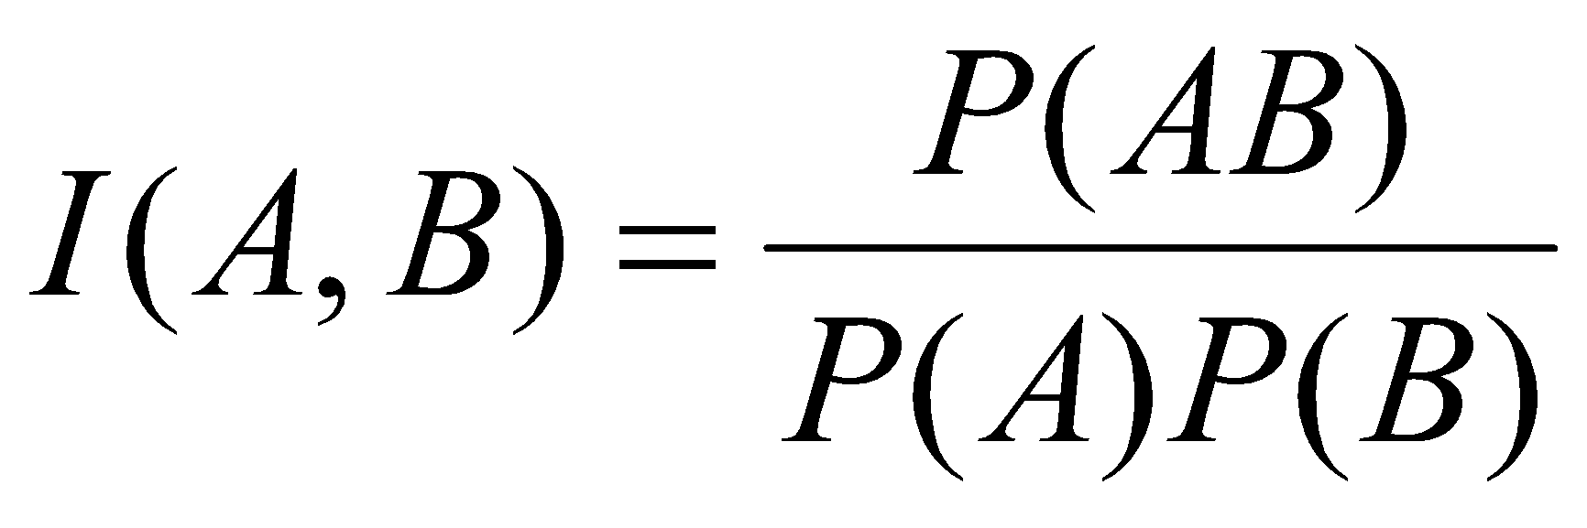
Consider the following pairs of items: (A, B) and (C, D), characterized by the following contingency tables:
 | A | Not A |  |  | C | Not C
B | 1 | 399 |  | D | 800 | 400
Not B | 499 | 101 |  | Not D | 400 | 400
 | I(A,B)=.005 |  |  |  | I(C,D)=10

Which of these pairs of items: (A, B) or (C, D), is more interesting (strongly associated)? Why?
I(x,y)=1 indicates that items x and y occur independently. Hence they are uninteresting. I(x,y)<1 suggests a negative association, while I(x,y)>1 suggests a positive association. The more extreme I(.), the stronger the association. The stronger the association, the more interesting the pattern. I(A,B) = .005 is more extreme than I(C,D) = 10 since I(A,B) differs from 1 by a factor of 5000, while I(C,D) differs only by a factor of 10, and hence the pattern (A,B) is more interesting.

      - The interestingness measure Odds Ratio (OR) for a pair of items (A, B) is defined as mentioned in the textbook. Consider the following two pairs of items (A, B) and (C, D) characterized by their contingency tables:

   | A | $$\overline{A}$$
  B | 20 | 400
  $$\overline{B}$$ | 50 | 10
   | C | $$\overline{C}$$
  D | 100 | 50
  $$\overline{D}$$ | 40 | 200

Calculate the value of the OR measure for the pairs (A, B) and (C, D). Based on these values, comment on which of these pairs is more interesting? Why?
Hint: The more extreme the value of OR(.) relative to 1 in either direction, the stronger the association.
OR(A,B)=0.01, OR(C,D)=10
OR(x,y)=1 indicates that items x is present or absent in the same proportions among the observations in which y is present or absent.
OR(x,y)<1 suggests a negative association, while OR(x,y)>1 suggests a positive association.
The more extreme the value of OR(.), the stronger the association, and the stronger the association, the more interesting the pattern. OR(A, B)=.01 is more extreme than OR(C, D)=10 (OR(A, B) differs from 1 by a factor of 100, while OR(C, D) differs only by a factor of 10), and hence the pattern (A, B) is more interesting.
      - Consider a binary data set representing user movie rating in which the columns are users, and the rows are for different movies that are available online, and the entry corresponding to the ith row (movie) and jth column (user) is a 1 if the movie is viewed by the user. An interestingness measure needs to be designed, which can be useful for evaluating whether a pair of users are strongly similar in their tastes of movies.
 | User 1 | User 2 | User 3 | …
Movie 1 | 1 | 1 | 0 | …
Movie 2 | 0 | 0 | 1 | …
Movie 3 | 1 | 0 | 1 | …
… | … | … | … | …

  - Circle yes or no to indicate which of the following properties the interestingness measure should possess and also write a very brief justification for your choice.
- Symmetry Yes No
Yes, because similarity measure between (User A, User B) and (User B, User A) should be the same and not order dependent.
- Invariant under inversion Yes No
No, because ideally, the similarity of the two users should only be governed by the number of movies that both of them have watched and not by the number of movies that none of them watched, which would be typically a high number for any two users, assuming that the online collection of movies is too large to be watched by a single user.
- Invariant under null addition Yes No
Yes, because if more movies are added to the dictionary such that they haven’t been watched by either of the two users, that should not affect their similarity in movie preferences.

  - Based on your answers above, would you prefer the odds ratio, Jaccard measure, or correlation (Ф-coefficient) for this task? Briefly justify your answer.
Jaccard measure, because none of the other measures satisfy the properties mentioned in the part (a) as required.

      - Consider a binary data set representing the words that are contained in a document. The rows are the documents, the columns are the words, and the entry corresponding to the ith row (document) and jth column (word) is a 1 if the word is present in the document and 0 if it is not.

- Circle yes or no to indicate which of the following properties an interestingness measure should possess to be useful for evaluating whether a pair of words in this data set are strongly related, i.e., if the two words co-occur in many documents.

 | word1 | word2 | word3 | ...
document1 | 1 | 1 | 0 | ...
document2 | 0 | 0 | 1 | ...
document3 | 1 | 0 | 1 | ...
... | ... | ... | ... | ...

      - Invariant under scaling Yes No

      - Invariant under inversion Yes No

      - Invariant under null addition Yes No

No, no, yes

b. Based on your answers above, would you prefer the cosine measure or correlation for this task? Briefly justify your answer.

cosine measure is appropriate for documents since it ignores 0-0 matches, which requires property iii but not i and ii.

      - Consider a binary data set representing the answers that a class of students gave on a true/false test. The rows are students, the columns are questions, and the entry corresponding to the ith row (student) and jth column (question) is a 1 if the student answered true and 0 if the student answered false.

 | Question 1 | Question 2 | Question 3 | …
Student 1 | 1 | 1 | 0 | …
Student 2 | 0 | 0 | 1 | …
Student 3 | 1 | 0 | 1 | …
… | … | … | … | …

  - Circle yes or no to indicate which of the following properties an interestingness measure should possess to be useful for evaluating whether a set of two attributes (questions) in this data set are strongly related, i.e., if students tend to answer the two questions in a similar way.
- Symmetry Yes No
Yes, because similarity measure between (User A, User B) and (User B, User A) should be same and not order dependent.
- Invariant under inversion Yes No
Yes, because 0 values (false) count as much as 1 values (true).
- Invariant under null addition Yes No
No, once again, because 0 values (false) count as much as 1 values (true).
  - Based on your answers above, would you prefer confidence, the cosine measure, or correlation for this task? Briefly justify your answer.
Correlation because it has the desired properties, while confidence and cosine are not invariant under inversion, they are invariant under null addition.

      - Consider a binary data set. Each row is a basket (set of items a customer purchased), the columns are items, and the entry corresponding to the ith row (basket) and jth column (item) is a 1 if the item is present in the basket and 0 if it is not.

Circle yes or no to indicate which of the following properties an interestingness measure should possess to be useful for evaluating whether a pair of items in this data set are strongly related, i.e., if two items are likely to co-occur in many baskets.

 | item 1 | item 2 | item 3 | ...
basket 1 | 1 | 1 | 0 | ...
basket 2 | 0 | 0 | 1 | ...
basket 3 | 1 | 0 | 1 | ...
... | ... | ... | ... | ...

- Invariant under Scaling Yes No

- Invariant under inversion Yes No

- Invariant under null addition Yes No

No, no, yes

b. Based on your answers above, would you prefer the cosine measure or correlation for this task? Briefly justify your answer.

cosine measure

      - Assume that a committee of ten professors evaluated the performance of a set of students in a given exam. Each professor judged the performance of every student independently, and gave a binary evaluation of 0 or 1, denoting fail or pass. Consider a binary dataset representation of these results, where the rows correspond to professors and the columns correspond to the students, as shown in the table below.
 | Student 1 | Student 2 | Student 3 | …
Professor 1 | 1 | 1 | 0 | …
Professor 2 | 0 | 0 | 1 | …
Professor 3 | 1 | 0 | 1 | …
… | … | … | … | …

- Which of the following properties should an interestingness measure possess in order to be useful for evaluating whether two rows in this dataset are strongly related, i.e., if two professors tend to judge students in a similar way? Give a one-sentence justification of the appropriateness of each one of them for this task.

    - Symmetry
Answer: True. If professor 1 is similar to professor 2, then professor 2 is also similar to professor 1, and hence is symmetric. Note: students who mention that similarity (student 1, student 2) or similarity (student 1, professor 1) should not change based on order have lost 1 point. Students who mention changing rows and columns will not change similarity scores have lost 1 point.

    - Invariant under inversion

Answer: True. Two professors should be considered similar if both of them tend to pass or fail students similarly. Hence, if we flip 1s (pass) and 0s (fail) for judgments from all professors, the similarity measure should not be changed.

    - Invariant under null addition

Answer: False. Adding a set of zeros (meaning adding several students who fail the experiments according to all professors) should change the similar measure. Hence, it is not invariant under null addition.
- Based on your answers above, would you prefer confidence, cosine measure, or correlation for this task? Briefly justify your answer.
Answer: Correlation. It is the only one that satisfies all the three requirements above.
      - Consider a binary data set representing word document matrix in which the columns are documents and the rows are for different words that come from a dictionary, and the entry corresponding to the i^{th} row (word) and j^{th} column (document) is a 1 if the word is present in that document. An interestingness measure needs to be designed, which can be useful for evaluating whether a pair of documents are strongly related, i.e., if two documents are quite similar.

 | Document 1 | Document 2 | Document 3 | …
Word 1 | 1 | 1 | 0 | …
Word 2 | 0 | 0 | 1 | …
Word 3 | 1 | 0 | 1 | …
… | … | … | … | …

(a) Circle yes or no to indicate which of the following properties the interestingness measure should possess and also write a very brief justification for your choice.
- Symmetry Yes No
Answer: Yes, because similarity measure between (Document A, Document B) and (Document B, Document A) should be the same and not order dependent.

- Invariant under inversion Yes No
Answer: No, because ideally, the similarity of the two documents should only be governed by the number of words that occur in both the documents and not by the number of words that don’t appear in either of the two documents. In general, for any two documents, the number of words that don’t appear in either of them would always be large because of the large size of a dictionary from which the words come.
- Invariant under null addition Yes No
Answer: Yes, because if more words are added to the dictionary such that they don’t occur in either of the documents, that should not affect the similarity of the two documents.
(b) Based on your answers above, would you prefer support, confidence, the cosine measure, or correlation (Ф-coefficient) for this task? Briefly justify your answer.

Answer: cosine measure, because none of the other measures satisfy the properties mentioned in the part (a) as required.

      - Consider the contingency tables shown below:

 | p | Not p
q | 880 | 50 | 930
Not q | 50 | 20 | 70
 | 930 | 70 | 1000

 | r | Not r
s | 20 | 50 | 70
Not s | 50 | 880 | 930
 | 70 | 930 | 1000

- Consider the rule {p} -> {q} and {r}->{s}. Compute the IS (cosine) and Interest factor for both the rules.

Solution:
{p}->{q }: IS =0.95 Interest factor = 1.02
{r} ->{s}: IS= 0.287. Interest factor = 4.08

- Given that these tables belong to the text domain and the items {p},{q},{r},{s} represent some words, which measures above would you prefer. Justify.

Solution:
IS should be the preferred measure. Interest factor shows value close to 1 for {p} ->{q} which suggests that {p}->{q} are almost independent. However, there is a very high co-occurrence of p and q in the large number of documents. On the other hand, the co-occurrence of r and s is lower, but its Interest factor is higher.

- Consider another measure M = supp({x,y})/ supp(y) for rule {x}->{y}. Compute this measure for the above rules. Which of the above measures (IS and Interest factor) do the values look similar to? Would this similarity always hold? If yes, explain otherwise explain when both would be different.

Solution:
{p}->{q}: M = 0.95
{r} ->{s}: M = 0.287
The values of measure M looks exactly similar to that of IS. However, this similarity does not always hold. This would be different when there is a large difference between the support count of antecedent and consequent.

      - Consider a binary data set representing the movie preference of N Netflix users of K movies. In the tabular representation of this data set, the rows are users, and the columns are movies. The entry corresponding to the ith row (user) and jth column (movie) is a 1 if the user likes the movie and 0 if the user dislikes it.

(a) Which of these properties should an interestingness measure possess to be useful for evaluating if users have similar likes or dislike for movies? Briefly justify your answer.
i. Symmetry
ii. Invariant under null addition
iii. Invariant under inversion
Answer: i and iii. Because both like and dislike matter in this case.
(b) Based on your answers above, would you prefer confidence, the cosine measure, or correlation for this task? Briefly justify your answer.
Answer: Correlation, because it possesses i and iii.
(c) Repeat the above two parts (a and b) if a 1 is assigned only if a user likes a movie. A zero in the rest of the entries means that the user does not know about the movie
Answer: i and ii, because only ”like” matters. Cosine should be used. Note that confidence is not symmetric.

      - The interestingness measure Odds Ratio (OR) for a pair of items (A, B) is defined in the book. Consider the following two pairs of items (A, B) and (C, D) characterized by their contingency tables:

   | A | $$\overline{A}$$
  B | 2 | 40
  $$\overline{B}$$ | 50 | 10
   | C | $$\overline{C}$$
  D | 100 | 50
  $$\overline{D}$$ | 40 | 200

Calculate the value of the OR measure for the pairs (A,B) and (C,D). Based on these values, comment on which of these pairs is more interesting? Why?
Answer:
OR(A,B)=0.01, OR(C,D)=10
OR(x,y)=1 indicates that items x is present or absent in the same proportions among the observations in which y is present or absent.
OR(x,y)<1 suggests a negative association, while OR(x,y)>1 suggests a positive association.
The more extreme the value of OR(.), the stronger the association, and the stronger the association, the more interesting the pattern. OR(A,B)=.01 is more extreme than OR(C,D)=10 (OR(A,B) differs from 1 by a factor of 100, while OR(C,D) differs only by a factor of 10), and hence the pattern (A,B) is more interesting.

      - If conf(A→B)=1 and conf(B→A)=1, then what is the value of correlation(A,B)?

Solution: correlation(A,B)=1.

      - Consider the data set given in the table below.

Transaction ID | Items Bought
1 | {B, C, D}
2 | {A, B, C, D, E, F}
3 | {B, C, D, F}
4 | {A, B, C, F}
5 | {A, D, E}
6 | {B, D, F}

(a) Compute the support counts for itemsets {E}, {B, F}, {B, E, F}.
Solution: Support({E}) = 2
Support({B, F}) = 4
Support({B, E, F}) = 1
(b) Use the results in part (1) to compute the confidence for the association rules {B, F } → {E} and {E} → {B, F }. Is confidence a symmetric measure?
Solution: Conf({B, F } → {E}) = Support({B,E,F})/Support({B,F}) = ¼=0.25
Conf({E} → {B, F }) = Support({B,E,F})/Support({E})= ½=0.5
Therefore, the confidence measure is not symmetric.

      - You are given a medical database in Table 2 containing instances of sudden deaths (SD) among infants and adults. You are asked to analyze if the injection of polio vaccine (PV) has any influence on sudden death.

Table 1: A hypothetical medical database.
Infant | Adult | Polio Vaccine PV | Sudden Death SD | Support Count
1 | 0 | 1 | 1 | 26
1 | 0 | 1 | 0 | 24
1 | 0 | 0 | 1 | 49
1 | 0 | 0 | 0 | 1
0 | 1 | 1 | 1 | 20
0 | 1 | 1 | 0 | 130
0 | 1 | 0 | 1 | 240
0 | 1 | 0 | 0 | 510

(a) Compute support, confidence and the Interest Measure for the rule PV → SD.
Solution: s(PV → SD) = 0.046, c(PV → SD) = 0.23, I(PV → SD) = 0.687
(b) Intuitively, what can you say about rule PV → SD? Does this conform to the results of part(a)?
Solution: Since conf(PV = 1 → SD = 1) = 23%, there does not appear to be any notable relationship between Polio vaccine and sudden death.
(c) Compute support, confidence and the Interest Measure for the rule PV → SD for infants and adults separately.
Solution:
For infants: s(PV → SD) = 0.26, c(PV → SD) = 0.52, I(PV → SD) = 0.693.
For Adults: s(PV → SD) = 0.022, c(PV → SD) = 0.133, I(PV → SD) = 0.462.
(d) What interesting conclusions can you draw from the results of part (c)?
Solution: For infant, since conf(PV = 1 → SD = 1) = 52%, there appears to be quite a strong relationship between Polio vaccine and sudden death in infants.

      - The original association rule mining formulation uses the support and confidence measures to prune uninteresting rules.

(a) Draw a contingency table for each of the following rules using the transactions shown in Table 2.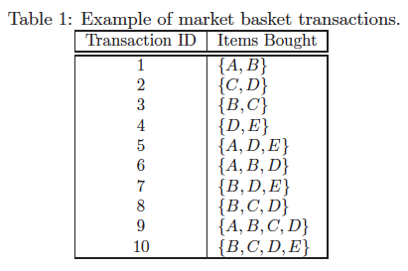
Rules: {b} => {c}, {a} => {d}, {b} => {d}, {e} => {c}, {c} => {a}.
Solution:

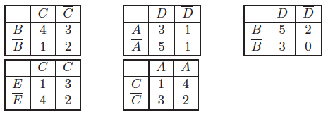
(b) Use the contingency tables in part (a) to compute and rank the rules in decreasing order according to the following measures.
i. Support.
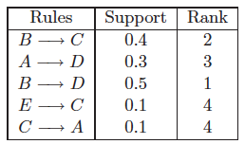
ii. Confidence.
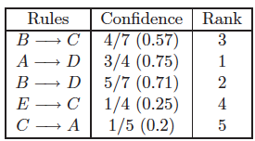
- Interest (X → Y) = P(X,Y) / P(X)P(Y)
Rules | Interest | Rank
B → C  A → D B → D E → C C → A | 1.14  0.93  0.89  0.5  0.5 | 1  2  3  4  4

- IS (X → Y) = P(X,Y)/ [P(X)P(Y)]1/2
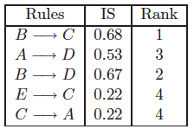
- Klosgen (X → Y) = P(X, Y) 1/2 * (P(Y|X) − P(Y)), where P(Y |X) = P(X,Y)/P(X) .
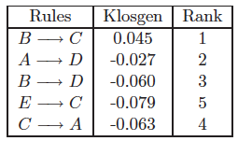
vi. Odds ratio (X → Y) = [P(X, Y) P(XC, YC)] / [P (X, YC) P(X, YC)]
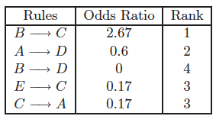

(c) Given the rankings you had obtained in part (b) above, compute the correlation between the rankings of confidence and the other five measures. Which measure gives rankings that are most highly similar to those given by confidence? Which measure is least similar to confidence?

(a) Using the transactions given in the table above, draw the contingency table for X and Y, where X and Y are the respective antecedents and consequents in the rule X ->Y, for each of the following rules:
{B}->{C}, {A}->{D}, {B}->{D}, {E}->{C}, {C}->{A}, {A}->{E}

(b) Use the contingency tables in part (a) to fill the scoring table given below, for each of the following measures:
- Support.
- Confidence.
- IS (X -> Y) = P(X,Y)/ [P(X)P(Y)]1/2
- Odds ratio (X -> Y) = [P(X, Y) P(XC, YC)] / [P (X, YC) P(XC, Y)]
- Interest measure = [P(X,Y)]/(P(X)P(Y))
- All-confidence = min(P(X,Y)/P(X),P(X,Y)/P(Y))
- Correlation
Scoring table
 | Support | Confidence | IS | Odds ratio | Interest measure | All confidence | Correlation
B->C
A->D
B->D
E->C
C->A
A->E

(c) Using the values in the scoring table computed in (b), for every choice of evaluation measure, rank the rules in decreasing order of their measure value, assigning rank 1 for the highest value, and 6 for the lowest value. What do you observe? Are they all different?
Ranking table
 | Support | Confidence | IS | Odds ratio | Interest measure | All confidence | Correlation
B->C
A->D
B->D
E->C
C->A
A->E

Solution:
a)
 | A | $$\overline{A}$$
E | 1 | 3
$$\overline{E}$$ | 3 | 3

b) and c)
 | All-confidence |  | Interest |  | Odds Ratio |  | IS |  | Confidence |  |  | Support |  |  | Correlation
RULES | Val | rank | Val | rank | Val | rank | Val | rank | Val | rank |  | Val |  | rank | Val | rank
B->C | 0.57 | 2 | 1.14 | 1 | 2.67 | 1 | 0.68 | 1 | 0.57 | 3 |  | 0.4 |  | 2 | 0.22 | 1
A->D | 0.38 | 3 | 0.94 | 2 | 0.6 | 2 | 0.53 | 3 | 0.75 | 1 |  | 0.3 |  | 3 | -0.1 | 2
B->D | 0.63 | 1 | 0.89 | 3 | 0 | 5 | 0.67 | 2 | 0.71 | 2 |  | 0.5 |  | 1 | -0.3 | 4
E->C | 0.2 | 5 | 0.5 | 5 | 0.17 | 4 | 0.22 | 5 | 0.25 | 4 |  | 0.1 |  | 4 | -0.4 | 5
C->A | 0.2 | 5 | 0.5 | 5 | 0.17 | 4 | 0.22 | 5 | 0.2 | 5 |  | 0.1 |  | 4 | -0.4 | 5
A->E | 0.25 | 4 | 0.63 | 4 | 0.33 | 3 | 0.25 | 4 | 0.25 | 4 | 0.1 |  | 4 |  | -0.25 | 3

(a) What is the importance of support having the anti-monotone property?
Solution: The property helps us to substantially prune the search space in order to speed up frequent itemset generation.
(b) The support of an itemset is the fraction of the transactions that contain all the items of the itemset. Consider redefining support so that the support of an itemset is the fraction of the transactions that contain any of the items in an itemset. Is this new support measure monotone, anti-monotone, or non-monotone? Briefly explain your answer.
Solution: Monotone.

Simpson’s Paradox

A pharmaceutical company has manufactured two drugs for the cure of a disease. A survey was conducted to compare the performances of the two drugs. The details of the survey are as follows:
- Drug A was given to 1000 patients, out of which 100 were in critical condition. The drug successfully cured 810 patients, out of which 10 were in critical condition.
- Drug B was given to 1500 patients, out of which 500 were in critical condition. The drug successfully cured 1000 patients, out of which 100 were in critical condition.

- Which drug has an overall higher success rate?
Drug A has a higher overall success rate (81 %) than Drug B (66.67 %).
- Which drug would you recommend to a patient? Does your recommendation differ for a critical and non-critical patient? Justify.
Answer: If the data for patients in critical and non-critical conditions are analyzed separately, then Drug B has a higher success rate (20 % for critical patients, 90 % for non-critical patients) than Drug A (10 % for critical patients, 80 % for non-critical patients). Therefore, Drug B clearly outperforms Drug A on both categories of patients and should be recommended to all the patients irrespective of their illness condition.

Patients suffering from a certain disease are known to be either in the normal stage or the critical stage of the disease. Hospital A has a 75% success rate of treatment on a sample of 1000 patients, which included a mix of both normal and critical stage patients. Hospital B has a 50% success rate of treatment on a different sample of 1000 patients, which included a different mix of normal and critical stage patients. It is further known that the success rate of treating critical stage patients is 10 % for both the hospitals, A and B. Based on this information, would you consider hospital A to have a better success rate on normal stage patients than hospital B? Justify.

Answer: No. Based on the above information, one can’t say that Hospital A is better than Hospital B for normal patients. There could be a possibility of the occurrence of Simpson’s paradox here. It could be possible that Hospital B is treating more critical patients than normal patients, and hence, its overall performance goes down in comparison with Hospital A, which might be treating very few critical patients.

Effect of Skewed Support (H-confidence and Hypercliques)

The dataset below contains 10 items and 100 transactions. Dark cells indicate the presence of items, and white (and grey) cells indicate the absence of items.
Compute h-confidence for the following itemsets.
- {A,B,D}
For any given itemset, h-confidence is defined as the minimum confidence among all the possible rules that can be generated using the items of the itemset. Clearly, the rule with minimum confidence would have most frequent item as its antecedent and rest of all other items in its consequent. Therefore,
h-confidence ({A,B,D}) = conf({A} -> {B,D}) = σ{A,B, D} / σ{A} = 20 / 80 = 0.25 = 25 %

- {D,E,F}
Similarly, h-confidence ({D,E,F}) = conf({D} -> {E,F}) = σ{D,E,F} / σ{D} = 20/ 30 = 0.67. = 66.67 %

Answer the following questions:

i) What advantages do hyperclique patterns provide over the traditional frequent patterns, and how?
Answer: Hyperclique patterns avoid the cross-support problem by the use of h-confidence as an additional constraint over the standard support constraint for finding frequent patterns. Due to this additional constraint, hyperclique patterns do not include items that have very different support levels. This further provides guarantees on the pairwise proximities of the items included in a hyperclique.
ii) If conf(A→B) = 1 and conf(B→A) = 1 then what value(s) could correlation(A, B) be?
Answer: correlation(A, B) = 1
iii) If the h-confidence of an itemset is 0.2, what’s the range of the support ratio (the larger one divided by the smaller one) between any pairs of items in the itemset? Explain clearly.
Answer: [1,5]. Say the support of the pattern is 2x, then, the most frequent item has a support of 10x, the least frequent item has a support of 2x. The other items’ support range from 2x to 10x. Thus, the support ratio between any pairs of items in the itemset (the larger one divided by the smaller one) will be between [2x/2x 10x/2x], i.e.,[1, 5].

Given a transaction dataset A and an itemset α, the H-Confidence of α is defined as below

$$HConf(α)=\frac{\sup_{A}(α)}{\max_{i∈α}{(sup}_{A}(i))}$$

where the $\sup_{A}$ denotes the support of an itemset in dataset A, relative to the total number of transactions, i.e.,$\sup_{A}$ is in the range [0, 1].

    - What’s the range of $HConf(α)$?

Answer: [0,1]

    - If we modify the above definition of H-Confidence slightly as below, what’s the range of $HConf'(α)$?
$${HConf'(α)=\sup_{A}\left(α\right)-max}_{i∈α}{(sup}_{A}(i))$$

Answer: [-1,0]

    - Given a transaction dataset with three items {a,b,c} and the support of all the size-1, size-2 and size-3 itemsets in the table below. Compute HConf' and fill in the table below. Then, based on your computation, do you think $HConf(α)$ is monotonic or antimonotonic? Provide a brief explanation (No formal proof needed)
 | {a} | {b} | {c} | {a,b} | {a,c} | {b,c} | {a,b,c}
Support | 0.6 | 0.6 | 0.4 | 0.4 | 0.2 | 0.3 | 0.2
$$HConf'$$ | 0 | 0 | 0 |  | -0.4

Answer: {a,b}: -0.2 {b,c}: -0.3 {a,b,c}: -0.4

Antimonotonic.

    - Given two datasets A and B, whose transactions are disjoint yet share the same set of items, an interesting data mining problem is to discover itemsets with very different support between the two datasets (called discriminative patterns), e.g., an itemset can have a support of 0.6 in dataset A but only has a support of 0.05 in dataset B.
To efficiently discover discriminative patterns, a variety of monotonic or antimonotonic measures have been designed and can be used in the Apriori framework taught in class. For example, one such measure was designed by modifying the $HConf'(α)$ into $HConf''(α)$ as defined below.
$${HConf''(α)=\sup_{A}\left(α\right)-max}_{i∈α}{(sup}_{B}(i))$$

Is $HConf''(α)$ monotonic or antimonotonic? Explain clearly.

Given a data set, let S be the set of patterns with support ≥ a, and T be the set of hypercliques with support ≥ b and h-confidence ≥ c.

(a) What’s the relationship between S and T, if a = b, and Why?
Answer: T is a subset of S.
(b) What’s the relationship between S and T, if a < b, and Why?
Answer: T is still a subset of S, since T is a subset of the set of patterns with support ≥ b, which is a subset of S.
(c) What’s the relationship between S and T, if a > b, and Why?
Answer: If we consider size-1 itemset, then S and T is guaranteed to be overlapping (those size-1 itemset with support _ a). If we only consider itemsets of size greater than 1, then, S and T could be either overlapping or disjoint, depending on specific transaction data.

How do itemsets which satisfy hconf ≥ h_{c} are different from those which satisfy hconf ≤ h_{c}.

Answer- The former can produce more cohesive itemsets, i.e., if an itemset has high h-conf, then if one of the items appear in a transaction, there is a high probability the rest of the items in the itemset also appear in the same transaction.

Handling Categorical and Continuous Attributes

Consider the data set shown in Table 2. Suppose we are interested in extracting the following association rule:

{α1 ≤ Age ≤ α2, Play Piano = Yes} −→ {Enjoy Classical Music = Yes}
Age | Play piano | Enjoy classical music
9 | Yes | Yes
11 | Yes | Yes
14 | Yes | No
17 | Yes | No
19 | Yes | Yes
21 | No | No
25 | No | No
29 | Yes | Yes
33 | No | No
39 | No | Yes
41 | No | No
47 | No | Yes

To handle the continuous attribute, we apply the equal-frequency approach with 3, 4, and 6 intervals. Categorical attributes are handled by introducing as many new asymmetric binary attributes as the number of categorical values. Assume that the support threshold is 10% and the confidence threshold is 70%.
- Suppose we discretize the Age attribute into 3 equal-frequency intervals. Find a pair of values for α1 and α2 that satisfy the minimum support and minimum confidence requirements.
- (α1 = 19,α2 = 29): s = 16.7%,c = 100%.

- Repeat part (a) by discretizing the Age attribute into 4 equal-frequency intervals. Compare the extracted rules against the ones you had obtained in part a.
- No rule satisfies the support and confidence thresholds.
- Repeat part (a) by discretizing the Age attribute into 6 equal-frequency intervals. Compare the extracted rules against the ones you had obtained in part a.
- (α1 = 9,α2 = 11): s = 16.7%,c = 100%.
- From the results in part (a), (b), and (c), discuss how the choice of discretization intervals will affect the rules extracted by association rule mining algorithms.
If the discretization interval is too narrow, the rule in part (a) will be lost and sometimes spurious rules are being discovered. So, the rules found are sensitive to the choice of the width of the discretization interval.

Consider the data set shown in Table 1. Suppose we are interested in extracting the following association rule:
{α1 <= Age < α2,Play Chess = Yes} implies {Enjoy Solving Puzzles = Yes}
Table 1: Data set

Age | Plays Chess | Enjoys Solving Puzzles
10 | Yes | Yes
12 | Yes | Yes
15 | Yes | No
18 | Yes | No
20 | Yes | Yes
22 | No | No
26 | No | No
28 | Yes | Yes
36 | No | No
39 | No | Yes
41 | No | No
47 | No | Yes

To handle the continuous attribute, we apply the equal-frequency approach with 3, 4, and 6 intervals. Categorical attributes are handled by introducing as many new asymmetric binary attributes as the number of categorical values. Assume that the support threshold is 10% and the confidence threshold is 70%.

(a) Suppose we discretize the Age attribute into 3 equal-frequency intervals. Find a pair of values for α1 and α2 that satisfy the minimum support and minimum confidence requirements.
(α11 = 20, α2 = 29): s = 16.7%, c = 100%
(b) Repeat part (a) by discretizing the Age attribute into 4 equal-frequency intervals. Compare the extracted rules against the ones you had obtained in part (a).
No rules satisfy both the support and confidence thresholds.
(c) Repeat part (a) by discretizing the Age attribute into 6 equal-frequency intervals. Compare the extracted rules against the ones you had obtained in part (a).
(α1 = 10, α2 = 13): s = 16.7%, c = 100%
(d) From the results in part (a), (b), and (c), discuss how the choice of discretization intervals will affect the rules extracted by association rule mining algorithms.
If the discretization interval is too narrow as in part (c), the rule in part (a) was lost due to low support and if the discretization is too wide, then some rules are lost (e.g., the rule obtained in part (a) was lost when wider intervals were used in part(b). Also the rule obtained in part (c) was lost in part(a)). This illustrates that the rules found are sensitive to the choice of the width of the discretization interval and no single choice is perfect.

Association rules for continuous and categorical data.

Age | Plays Piano | Enjoys Classical Music
9 | Yes | Yes
11 | Yes | No
14 | No | No
17 | Yes | No
19 | Yes | Yes
21 | No | Yes
25 | No | Yes
29 | Yes | Yes
33 | Yes | No
39 | No | No
41 | Yes | No
43 | Yes | Yes

You are asked to analyze the table above using association analysis. Minsup = 15 %. Minconf = 75 %. The goal is to predict whether a person enjoys classical music or not. However, first, you need to convert these attributes to asymmetric binary attributes to perform this analysis.
(a) Assume that you can discretize the Age attribute into 2, 3, 6, or 12 categories (bins). Assume equal frequency discretization is being used.
- How many asymmetric binary attributes would each of the four discretizations produce?
For n categories, n asymmetric binary attributes would be produced, i.e., 2, 3, 6, 12.
- Briefly, what is the disadvantage of using many categories (bins)?
Using too many categories would produce rules that are too specific and may not satisfy the minsup = 15 % condition.
For example, if we use 12 categories, then each category would have at most one observation and therefore, support would be at most 1/12 = 8.33 %.
iii. Briefly, what is the disadvantage of using very few categories (bins)?
If we use very few categories, then the confidence of some rules may be reduced because of increased heterogeneity within each category. And instead, we would miss some other interesting rules which could have been obtained if the number of categories was reduced.
- Consider the confidence of association rules of the form

Age{some range}, Plays Piano = Yes → Enjoys Classical Music = Yes
When breaking Age into 2 categories and 3 categories. Which discretization would you prefer?
If we just use 2 categories, then the rules formed would be
R₁: Age {9-21}, Plays Piano = Yes-> Enjoys classical Music = Yes
Confidence = 50 %. Support = 16.67 %
R₂: Age {25-43}, Plays Piano = Yes -> Enjoys classical Music = Yes
Confidence = 50 %. Support = 16.67 %
Both R₁ and R₂ would be discarded because of low confidence.
However, if we use discretize the Age attribute into three categories, then the rules formed would be,
R₃: Age {9-17}, Plays Piano = Yes-> Enjoys classical Music = Yes
Confidence = 33 %. Support = 8.33 %
R₄: Age {19-29}, Plays Piano = Yes-> Enjoys classical Music = Yes
Confidence = 100%. Support = 16.67 %
R₅: Age {33-43}, Plays Piano = Yes-> Enjoys classical Music = Yes
Confidence = 33 %. Support = 8.33 %
R₃ and R₅ would be discarded because of low support and confidence. However, R₄would satisfy both minconf and minsup thresholds and, therefore, would be an interesting rule. However, this rule couldn’t be extracted if only 2 categories of Age attributes were used.
Thus, we would prefer 3 categories.
(b) Would you need to convert the Plays Piano or Enjoys Classical Music attributes, or are they already asymmetric binary attributes? Briefly justify your answer.
Answer: Both Plays Piano and Enjoys Classical Music are binary attributes as they can be assigned only two values Yes or No. However, both of the values Yes and No are equally interesting. Therefore, the attributes are not asymmetric and therefore should be changed into following four asymmetric attributes -
Plays Piano = Yes
Plays Piano = No
Enjoys Classical Music = Yes
Enjoys Classical Music = No

Handling Categorical and Continuous attributes
Gender | Age | State | Buy Umbrella | Buy Sun Screen | Buy Snowshoes
Female | 24 | Minnesota | No | Yes | Yes
Male | 31 | Texas | No | Yes | No
Male | 25 | Minnesota | No | No | Yes
Female | 45 | Washington | Yes | No | No
Male | 35 | California | No | Yes | No
Female | 47 | Texas | No | Yes | No
Male | 40 | Washington | Yes | No | No
… | … | … | … | … | …

The above table shows the results of a survey conducted on a large population from 50 different states to gather information about some of their annual purchasing habits. The items being covered are umbrella, sunscreen, and snowshoes. We want to apply association analysis to learn useful patterns among different attributes. However, before that, we need to convert the attributes in each column into asymmetric binary attributes. Based on your general understanding of the data, answer the following questions:
- Is Buy Sunscreen an asymmetric binary attribute? Justify your answer.
No, whichever value is assigned to 0 will not appear in any association patterns. We need to convert it to two asymmetric binary variables unless we have no interest in people who don’t buy sunscreen.
- If in the given dataset, about 40 % of the people surveyed are from Minnesota, and none of the other states exceeds 5 % and the minsup for an interesting rule is set to 10 %, then how and why would you break the State attribute into asymmetric binary attributes? List all the new asymmetric binary attributes that you replace and provide a brief justification for your answer.
The frequency of the items (asymmetric binary variables) representing other states is less than minsup, and thus they would not appear in any association patterns. We could use two attributes:
State is Minnesota: (value = 1 If State is Minnesota)
State is not Minnesota: (value = 1 if State is not Minnesota)
- If, in the given data, about 99 % of the people surveyed are from Minnesota, and the minsup for an interesting rule is set to 10 %, then how would you handle State Attribute? Justify your answer.

We would ignore this attribute because the majority of the observations for this attribute have the same value. When converted to asymmetric binary attributes, the attribute representing State is Minnesota would appear in almost every pattern, while the other asymmetric binary attributes would not be frequent.
(i) True or false. For discretizing the Age attribute, it is always better to use a large number of smaller bins as opposed to a small number of larger bins
False. Discretizing the Age attribute into a very large number of small bins may lose some interesting patterns because of their lack of support.

Given a transaction dataset in which each entry is a continuous value, there can be two strategies to convert it into asymmetric data so that traditional association analysis techniques can be applied.
- For each attribute, use a threshold to convert it into one asymmetric attribute, such that the values are above the threshold, the new asymmetric attribute is assigned a value of 1.

- For each attribute, first divide the range of values into k intervals, then create k asymmetric attributes, such that each of these attributes (corresponding to an interval) is assigned a value of 1 when the original value falls in the interval.

List one advantage and one disadvantage for each strategy.

Advantage for A: It is a simple strategy and the rules with the new asymmetric attribute are likely to have sufficient support.
Disadvantage for A:
Since the new asymmetric attribute covers only those transactions that have higher values for the original attribute, interesting patterns with smaller continuous values (i.e., below threshold) would get lost.

Advantage for B:
The entire range of the original attribute is covered. Therefore, all the interesting rules covering a different range of attribute is covered.
Disadvantage for B:
Discretizing the original attribute into a large number of small intervals may lose some interesting patterns because of their lack of support.

List two disadvantages of choosing wider intervals for discretizing a continuous attribute in order to use it for performing association analysis.

Answer:
- Several disparate patterns may get merged.
- Wider intervals tend to reduce the confidence of a rule due to which several interesting patterns may get lost.

Consider the time series data shown in Table 2.

Time | Sensor A | Sensor B | Sensor C | Sensor D
1 | 0.588 | -0.588 | 0.951 | 0.705
2 | 0.951 | -0.951 | 0.809 | 1.141
3 | 0.951 | -0.951 | 0.588 | 1.141
4 | 0.588 | -0.588 | 0.309 | 0.705
5 | 0 | 0 | 0 | 0
6 | -0.588 | 0.588 | -0.309 | -0.705
7 | -0.951 | 0.951 | -0.588 | -1.141
8 | -0.951 | 0.951 | -0.809 | -1.141
9 | -0.588 | 0.588 | -0.951 | -0.705
10 | 0 | 0 | -1 | 0
11 | 0.588 | -0.588 | -0.951 | 0.705
12 | 0.951 | -0.951 | -0.809 | 1.141
13 | 0.951 | -0.951 | -0.588 | 1.141
14 | 0.588 | -0.588 | -0.309 | 0.705
15 | 0 | 0 | 0 | 0
16 | -0.588 | 0.588 | 0.309 | -0.705
17 | -0.951 | 0.951 | 0.588 | -1.141
18 | -0.951 | 0.951 | 0.809 | -1.141
19 | -0.588 | 0.588 | 0.951 | -0.705
20 | 0 | 0 | 1 | 0

Table 2: Time series data

(a) Plot the time series for all the sensors.
Answer: See Figure 2.
Figure 2: Time series for sensors A, B, C and D
(b) Visually estimate the correlations between sensors A and B, A and C, and A and D. You only need to mention whether the correlation is high, medium or low (’+’ or ’-’).
Answer:
Correlation between sensor A and B: High negative correlation
Correlation between sensor A and C: Low (almost no) correlation
Correlation between sensor A and D: High positive correlation
(c). Create a binary transaction file, where each transaction corresponds to a time step. The items are obtained by binarizing each sensor measurements: if sensor X > 0.75, then create an item called X-
High. If sensor X < -0.75, then create an item called X-Lo. Note that some transactions may be empty.
Use the transaction database to identify all the frequent 2-itemsets, assuming the support threshold is
20% (i.e., all itemsets whose support is greater than or equal to 20% are frequent).
Answer: All frequent 2-itemsets: [A-High, B-Low]; [A-Low, B-High]; [B-High D-Low]; [B-Low, D-high]; [A-Low, D-Low]; [A-high, D-High]
(d). Compare the estimates of correlations you had observed in part (2) to the frequent itemsets found in part (3). Can we use the frequent itemsets to explain the correlations observed in part (2)?
Answer: Yes, the frequent itemsets obtained in part (3) can be used to explain the correlations observed in part (2). For example, frequent itemsets [A-High, B-Low] and [A-Low, B-High] explains the high negative correlation between A and B. Similarly, frequent itemsets [A-Low, D-Low] and [A- high, D-High] explains the high positive correlation between A and D, as observed in part (b).
However, it is important to note that frequent itemsets may not always explain the correlations among the items or vice-versa. This is because correlation is a linear measure and discretization may not preserve the linear relationship.

Suppose you are given the data in the form of the following table from a survey conducted over a population of Minneapolis.

Gender | Age | No. of email accounts | Privacy Concern
Female | 26 | 4 | Yes
Male | 51 | 2 | No
Male | 29 | 3 | Yes
… | … | … | …

Every row in the table shows the information about a person in terms of the following attributes:
Gender: Male / Female
Age: A natural number in the range 1-100
Number of email accounts: A non-negative number
Privacy Concern: Yes / No
If you are interested in finding association patterns between different attributes, you would need to discretize the continuous attributes as well as convert the categorical attributes into asymmetric binary attributes.
State True / False with an explanation.

- It is always beneficial to discretize the Age attribute into a larger number of bins.
Answer:
False. Discretizing the Age attribute into a very large number of bins may lose some interesting patterns because of their lack of support.

- The categorical attribute, Privacy Concern, can be represented as an asymmetric binary attribute with 1 representing YES and 0 representing NO.
Answer:
False. Both of the values of the categorical attribute Privacy Concern “YES” and “NO” are equally interesting in the given context and thus, the attribute Privacy Concern needs to be converted into a pair of asymmetric binary attributes. Otherwise, no patterns with NO can be found.

The table below shows the results of a survey conducted on a large population from 50 different states to gather information about some of their annual purchasing habits. The items being covered are umbrella, sunscreen and snowshoes. We want to apply association analysis to learn useful patterns among different attributes. However, before that, we need to convert the attributes in each column into asymmetric binary attributes. Based on your general understanding of the data, answer the following questions

Gender | Age | State | Buy Umbrella | Buy Sunscreen | Buy Snowshoes
Female | 24 | Minnesota | No | Yes | Yes
Male | 31 | Texas | No | Yes | No
Male | 25 | Minnesota | No | No | Yes
Female | 45 | Washington | Yes | No | No
Male | 35 | California | No | Yes | No
Female | 47 | Texas | No | Yes | No
Male | 40 | Washington | Yes | No | No
… | … | … | … | … | …

- Is Buy Sun Screen an asymmetric binary attribute? Justify your answer.
Answer: If one is interested only in finding rules that involve people who buy sunscreen, then Buy Sun Screen is an asymmetric binary attribute. However, there can be scenarios in which one may also want to study rules that involve people who don’t buy sunscreen. For instance, People from Alaska never buy sunscreen. For such cases, Buy Sunscreen can be broken into two asymmetric binary attributes –
- Buy Sunscreen: present only if a person buys sunscreen
- Don’t Buy Sunscreen: present only if a person doesn’t buy sunscreen

- Is Gender an asymmetric binary attribute? Justify your answer.
Answer: No. Both Gender = Male and Gender = Female are important.

- If in the given dataset, about 40 % of the people surveyed are from Minnesota, and none of the other states exceeds 5 % and the minsup for an interesting rule is set to 10 %, then how and why would you break the State attribute into asymmetric binary attributes? List all the new asymmetric binary attributes that you replace, and provide a brief justification for your answer.
Answer: We would need two attributes –
State is Minnesota : (value = 1 If State is Minnesota)
State is not Minnesota : (value = 1 if State is not Minnesota)

- If in the given data, about 99 % of the people surveyed are from Minnesota, and the minsup for an interesting rule is set to 10 %, then how would you handle State Attribute? Justify your answer.
Answer: We would not consider this attribute because the majority of the observations have the same value for this attribute, which doesn’t make it an interesting attribute anymore.

- Suppose we also want to find patterns associated with people belonging to one or more states. For instance, there can be an interesting pattern such as People not from Minnesota and not from Wisconsin generally don’t buy snowshoes. To capture such kind of patterns, how many asymmetric binary attributes would you use to replace the State attribute?

Answer: For every possible state, both presence and absence need to be considered important. Therefore, to know about a person being non-Minnesotan is as equally important as about a person being Minnesotan. As this would hold for all states, one needs two attributes for each state, and therefore, 100 asymmetric binary attributes would be required in total to replace State attribute.

Handling a Concept Hierarchy

1. Discuss one advantage and one disadvantage of taking an item taxonomy/hierarchy/ontology into account when finding frequent association patterns from a market basket data set.
Advantage: Sometimes, novel patterns can be discovered by treating an ancestor of two or more items as individual items, since the individual items may not be frequent enough. This also may make the results of frequent pattern mining easier to interpret.
Disadvantage: The computation time of the pattern mining algorithm increases, since it has to take additional information in the taxonomy into account.

Sequential Patterns

- Here are four 4-sequences involving events A, B, C, and D:
<{A,B}, {C,D}>
<{A}, {B}, {C}, {D}>
<{A,B}, {C}, {D}>
<{A}, {B,C}, {D}>
And here are four 4-sequences involving events B, C, D, and E:
<{B,C}, {D,E}>
<{B}, {C}, {D}, {E}>
<{B}, {C,D}, {E}>
<{B}, {C,D,E}>

Consider what happens if you try to merge each sequence in the first group with each sequence in the second group. Does the attempted merge yield a candidate 5-sequence? If so, what is that sequence? Identify the true statement from the list below.

- <{A,B}, {C,D}> merges with <{B}, {C,D}, {E}> to produce <{A,B}, {C,D}, {E}>
T
- <{A}, {B}, {C}, {D}> merges with <{B}, {C}, {D}, {E}> to produce <{A}, {B}, {C}, {D}, {E}> T
- <{A}, {B,C}, {D}> merges with <{B}, {C,D}, {E}> to produce <{A}, {B,C,D}, {E}>
F (When you remove A (the first event) from the first sequence and remove E (the last event) from the second sequence, you do not get the same sequence. Therefore, no merger is possible.)
- <{A,B}, {C}, {D}> does not merge with <{B}, {C}, {D}, {E}>
F(When you remove A (the first event) from the first sequence and remove E (the last event) from the second sequence, you do get the same sequence. Therefore, these two sequences merge.)

- Here is a table of the events associated with four objects A, B, C, and D, at five timestamps, 1 through 5. Which of the following sequences has support 3/4?
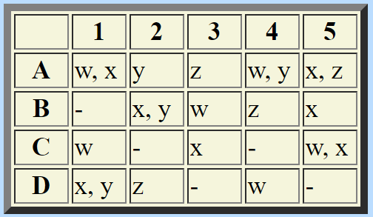
<{w}, {x}> Correct. This sequence is a subsequence of the sequences for A, B, and C.
<{y}, {z}>Correct. This sequence is a subsequence of the sequences for A, B, and D.
<{x}, {y}>This sequence is a subsequence of the sequence for A only. Thus, its support is 1/4.
<{z}, {z}>This sequence is a subsequence of the sequence for A only. Thus, its support is 1/4.

- The following is a table of the events associated with four objects A, B, C, and D, at five timestamps,
1 through 5.

 | 1 | 2 | 3 | 4 | 5
A | w, x | y | z | w, y | x, z
B | - | x, y | w | z | x
C | w | - | x | - | w, x
D | x, y | z | - | w | -

For each of the following sequences, write their support.
Sequence | Support
<{w},{x}> | 3/4
<{w}, {y}> | 1/4
<{x}, {w}> | 1
<{y}, {x}> | 1/2
<{x}, {z}> | 3/4

- Find all the frequent subsequences with support ≥ 50% given the sequence database shown in Table 3. Assume that there are no timing constraints imposed on the sequences. List the candidate and frequent subsequences at each level.

Sensor | Timestamp | Events
S1 | 1  2  3  4 | A, B  C  D, E  C
S2 | 1  2  3 | A, B  C, D  E
S3 | 1  2  3  4 | B  A  B  D, E
S4 | 1  2  3  4 | C  D, E  C  E
S5 | 1  2  3  4 | B  A  B, C  A, D

Table: Example of event sequences generated by various sensors.

The events in the given data set are A, B, C, D and E. So, the candidate level-1 subsequences are: <{A}>, <{B}>, <{C}>, <{D}>, <{E}>
Since the support of each of these level-1 subsequences is 80% and is greater than the support threshold 50%, the level-1 frequent subsequences are: < {A} >, < {B} >, < {C} >, <{D}>, < {E} >.

The candidate level-2 subsequences are: (enumerated as discussed in section 6.4.2 of the book)
< {{A,B} > (0.4), < {A,C} > (0), < {A,D} > (0.2), < {A,E} > (0),
< {B, C} > (0.2), < {B, D} > (0), < {B, E} > (0),
< {C, D} > (0.2), < {C, E} > (0), < {D, E} > (0.6),
<{A}{A}> (0.2), <{A}{B}> (0.4), <{A}{C}> (0.6), <{A}{D}> (0.8), < {A}{E} > (0.6),
<{B}{A}> (0.4), <{B}{B}> (0.4), <{B}{C}> (0.6), <{B}{D}> (0.8), <{B}{E}> (0.6),
<{C}{A}> (0.2), <{C}{B}> (0.0), <{C}{C}> (0.4), <{C}{D}> (0.6), <{C}{E}> (0.6),
<{D}{A}> (0), <{D}{B}> (0), <{D}{C}> (0.4), <{D}{D}> (0), <{D}{E}> (0.4),
<{E}{A}> (0.0), <{E}{B}> (0.0), <{E}{C}> (0.2), <{E}{D}>(0.0), <{E}{E}>(0.2)

The level-2 frequent subsequences are:
< {A} {C} >, < {A} {D} >, < {A} {E} >, < {B} {C} >,
< {B} {D} >, < {B} {E} >, < {C} {D} >, < {C} {E} >, < {D, E} >

The candidate level-3 subsequences are:
< {A} {C} {D} > (0.4), < {A} {C} {E} > (0.4), <{A} {D, E}> (0.4)
<{B}{C}{D}> (0.4), <{B}{C}{E}> (0.4), <{B} {D, E}> (0.4)
<{C}{D}{E}> (0.2), <{C} {D, E}> (0.4)

Since there are no candidate level-3 subsequences with support greater than 50%, there are no level-3 frequent subsequences.

- The following frequent 4-sequences were the only frequent 4-sequences generated by a candidate generation step:

<{1}{2}{3}{4}>
<{1}{2}{4}{5}>
<{1,2}{3,4}>
<{1,2}{3}{4}>
<{1,2}{4}{5}>
<{1,3}{4}{5}>
<{2}{3,4}{5}>
<{2}{3}{4}{5}>

- Is it possible to merge <{1,2}{3,4}> and <{2}{3,4}{5}> and generate a 5-sequence?
ANSWER: (YES/NO):
If yes, write down that sequence. If no, explain briefly.

Yes. <{1,2}{3,4}{5}>

- Is it possible to merge <{1}{2}{3}{4}> and <{2}{3,4}{5}> and generate a 5-sequence? If yes, write down that sequence. If no, explain briefly.

No, because <{2}{3}{4}> is not the same as <{2}{3,4}>.

- We generate <{1}{2}{3}{4}{5}> by merging <{1}{2}{3}{4}> and <{2}{3}{4}{5}>. Will this candidate survive the pruning step? Explain briefly.

No, because <{1}{3}{4}{5}> is not frequent.

- Assume that the following 4-sequences are the only frequent 4-sequences generated by the Apriori algorithm in a sequence data set:

<{A,B}, {C,D}>
<{A}, {B}, {C}, {D}>
<{A,B}, {C}, {D}>
<{A}, {B,C}, {D}>
<{A}, {C,D}, {E}>
<{A,B}, {D},{E}>
<{A},{C,D,E}>
<{A,B}, {D}, {E}>
<{A},{C},{D},{E}>
<{B,C}, {D,E}>
<{B}, {C}, {D}, {E}>
<{B}, {C,D}, {E}>
<{B}, {C,D,E}>
<{A}, {C,D}, {E}>

Using the sequence merging procedure described in section 6.4.2 (page 470), what candidate 5-sequences are generated? Which of the generated sequences survive the pruning step?

Candidate sequences:
<{A,B}, {C,D}, {E}> generated by merging <{A,B}, {C,D}> and <{B}, {C,D}, {E}>

<{A,B}, {C,D,E}> generated by merging <{B}, {C,D,E}> and <{A,B}, {C,D}>

<{A},{B},{C},{D},{E}> generated by merging <{B},{C},{D},{E}> and <{A},{B},{C},{D}>

<{A,B},{C},{D},{E}>generated by merging <{B},{C},{D},{E}> and <{A,B},{C},{D}>

<{A},{B,C},{D,E}> generated by merging <{B,C},{D,E}> and <{A},{B,C},{D}>

Sequences post-pruning: None

- Determine which sequence t is a valid subsequence of the corresponding sequence s:

Sequence s Sequence t
<{1,2,3} {2,4} {6}> <{2,4}>
<{1,2,3} {2,4} {6}> <{1}{2}{4}>
<{1}{3}{1,3}> <{1,3}{1}>
<{1,2} {1,2} {1}{2}> <{1}{1,2}{2}>
<{1,2,4}{1,4}{1}{2,3}> <{2}{3}>
<{1} {1,2} {1} > <{1,2} {1} {1}>
<{1,2}{2}{1}> <{1}{2}{1,2}>
<{1,2,4}{1,4}{2,3}{1,2,3}> <{1}{2}{3}>
<{1,2,4}{1,4}{2,3}{1,2,3}> <{1}{2,4}{3}>
Solution
Sequence s | Sequence t | Answer
<{1,2,3} {2,4} {6}> | <{2,4}> | Yes
<{1,2,3} {2,4} {6}> | <{1}{2}{4}> | No
<{1}{3}{1,3}> | <{1,3}{1}> | No
<{1,2} {1,2} {1}{2}> | <{1}{1,2}{2}> | Yes
<{1,2,4}{1,4}{1}{2,3}> | <{2}{3}> | Yes
<{1} {1,2} {1} > | <{1,2} {1} {1}> | No
<{1,2}{2}{1}> | <{1}{2}{1,2}> | No
<{1,2,4}{1,4}{2,3}{1,2,3}> | <{1}{2}{3}> | Yes
<{1,2,4}{1,4}{2,3}{1,2,3}> | <{1}{2,4}{3}> | No

- For each sequence shown in parts (i), (ii), and (iii) indicate whether it is a subsequence of the sequence <{b c}{a}{e d}>.
If a sequence is not a subsequence, give a one sentence explanation of why this is so.

(i) <{a}{c}>
No. Event a cannot occur before event c since it occurs in a later element of the original sequence.

(ii) <{a b c}>
No. Events a, b, and c do not occur in the same element of the original sequence.

(iii) <{e}{d}>
No. Events e and d occur only in the same element of the original sequence.

- For each sequence shown in parts a-c, indicate whether it is a subsequence of the sequence <{b,c,e}{b,d}{e,f}{a}>. If the sequence given is not a subsequence, give a one sentence explanation of why it is not.

- <{d,f}>
Answer: (YES/NO)
Explanation if NO:

No. We could have <{d}{f}>, but events d and f do not occur in the same element in the original sequence so we cannot have <{d,f}>

- <{b,c,d}{a}>
Answer: (YES/NO)
Explanation if NO:

No. d cannot be added to element {b,c}, though we could have <{b,c}{d}{a}>

- <{b}{d}{e}>
Answer: (YES/NO)
Explanation if NO:

Yes

- <{e}{f}>
Answer: (YES/NO)
Explanation if NO:

Yes

- <{c}{d}{e}{f}>
Answer: (YES/NO)
Explanation if NO:

No. We cannot split {e,f} to make {e}{f}

- The table below shows the browsing history of five different users on a given day. We wish to interpret the above table as a sequential dataset.

Users | Time (on a given day) | Webpages
A | 1-1:15 am | 1,2
A | 3 -3:15am | 5,6
A | 10-10:15am | 1,2
A | 6 -6:15pm | 7,9
A | 9 -9:15pm | 1,2,3
B | 2:30- 2:45 am | 1,2
B | 5:30-5:45 am | 1,2,4
B | 11 -11:15am | 1,6,8
B | 7 -7:15pm | 2,7,9
C | 11 -11:15am | 3
C | 8 -8:15pm | 6,9
D | 8 -8:15pm | 1
E | 7 -7:15pm | 1,3
E  E | 8 -8:15pm  9 -9:15pm | 2,6  1,9

- How many sequences are present in the above table? List out all of them.
There are 5 sequences, each corresponding to a user. The sequences are as follows –
A – {1,2}{5,6}{1,2}{7.9}{1,2,3}
B-{1,2}{1,2,4}{1,6,8}{2,7,9}
C-{3}{6,9}
D-{1}
E-{1,3}{2,6}{1,9}

- Write the support count of the following subsequences and mention whether they are frequent or not if the minsup is set to 60 % –
(i) {1} (ii) {1} {2} (iii) {1,2} (iv) {6}{9} (v) {1}{2}{9} (vi) {3}{6,9}

- {1} – 4, YES
- {1}{2} –3, YES
- {1,2} – 2, NO
- {6}{9} –3, YES
- {1}{2}{9} – 3, YES
- {3} {6,9} – 1, NO

- Suppose there were 100 users of type A, 100 of type B, 1200 of type C, 500 of type D and 100 of type E. Repeat part a) and b) for this scenario. For part a), skip listing the sequences.
Answer:
The total no. of sequences is 100 +100+1200+500+100 = 2000.
- {1} – 800, NO
- {1}{2} –300, NO
- {1,2} – 200, NO
- {6}{9} –300, NO
- {1}{2}{9} – 300, NO
- {3} {6,9} – 1200, YES

- Consider the following dataset

Customers | Dates (from a month) | Items
A | 1 | 1,2
A | 4 | 1,2,3
A | 10 | 1,2
A | 18 | 3
A | 20 | 2,4,5
B | 2 | 1,3
B | 5 | 2,3
B | 11 | 4
B | 18 | 2,4,5
C | 11 | 1
C | 19 | 2
D | 20 | 2,5
E | 19 | 2
E | 20 | 5
Minconf = 60 %.
- Write the support count of the following subsequences –
- {1,2}
- {1} {2}
- {2} {5}
- {2} {4,5}
- {1} {2,5}

- {1,2} – 1
- {1}{2} –3
- {2}{5} – 3
- {2} {4,5} –2
- {1} {2,5} – 2

- Which of the following rules satisfy the minconf = 60% requirement?
- {1} → {2}
- {2} → {5}
- {3} → {5}
Answer :
- {1}→ {2} Confidence = 60/60 = 100 %
- {2} → {5} Confidence = 60/100 = 60 %
- {3} → {5} Confidence = 40/40 = 100 %
All are satisfied.
- Suppose there are 100 customers similar to A, 200 customers similar to B, 50 customers similar to C, and 500 customers similar to D and E each. Repeat parts a) and b) for this scenario.
Answer : Support count of the subsequences -
- {1,2} – 100
- {1}{2} – 100 + 200 + 50 = 350
- {2}{5} – 100 + 200 + 500 = 800
- {2} {4,5} – 200 + 100 = 300
- {1} {2,5} – 200 + 100 = 300

Confidence of the rules –
- {1} →{2} Confidence = (350/1350)/(350/1350) = 100 %
- {2} → {5} Confidence = (800/1350)/(1350/1350) = 59.26%
- {3} → {5} Confidence = (300/1350)/(300/1350) = 100 %
Only i) and iii) satisfy minconf

- Do the rules {2}→ {5} and {2} → {2,5} have the same confidence? Give a brief justification.

Confidence of rule {2} → {5} would be ((|A|+|B|+|E|)/(|A| + |B| +|C| + |D| + |E|)) *(100) % = 59.26 %
Confidence of rule {2} → {2,5} would be supported only by the sequences where the subsequence
< {2} {2,5}> is present and therefore, the confidence of this rule would be equal to
((|A|+|B|) / (|A| + |B| +|C| + |D| + |E|)) *(100) % = 22.22 %
The confidence is not the same.

- Consider the following frequent 3-sequences:
  - <{a,b}{b}>
  - <{b}{b}{b}>
  - <{a}{b}{b}>
  - <{a}{a,b}>
  - <{b}{c,d}>
  - <{a,b}{c}>
  - <{b,c}{d}>
  - <{a,b,c}>
  - <{b,c,d}>

- Generate all the candidate 4-sequences from the given frequent 3-sequences, using the method for candidate generation described in the Book (page 470). For every 4-sequence generated, also write down the corresponding 3-sequences that were merged to generate the 4-sequence. [Note: Given n (k-1)-sequences, you will need to consider all n² pairs of (k-1)-sequences during candidate generation step].
- Find out the candidate 4-sequence that would survive the candidate pruning.

Solution :
Candidate generated :
<{a,b}{b}{b}> by merging <{a,b}{b}> and <{b}{b}{b}>
<{a}{a,b}{b}> by merging <{a}{a,b}> and <{a,b}{b}>
<{a}{b}{b}{b}> by merging <{a}{b}{b}> and <{b}{b}{b}>
<{a}{a,b}{c}> by merging <{a}{a,b}> and <{a,b}{c}>
<{a}{a,b,c}> by merging <{a}{a,b}> and <{a,b,c}>
<{a,b}{c,d}> by merging <{a,b}{c}> and <{b}{c,d}>
<{a,b,c}{d}> by merging <{a,b,c}> and <{b,c}{d}>
<{a,b,c,d}> by merging <{a,b,c}> and <{b,c,d}>
<{b}{b}{b}{b}> by merging <{b}{b}{b}> with itself.
Candidate that survives pruning :
<{a,b}{b}{b}>
<{a}{b}{b}{b}>
<{b}{b}{b}{b}>

- Consider the following frequent 3-sequences:
<{r}, {s, t}>
<{p}, {s, t}>
<{p}, {r}, {s}>
<{p}, {r}, {t}>
<{p},{r,t}>
<{s, t}, {w}>
<{p,r,s}>
<{r,s,t}>
- Generate all the candidate 4-sequences from the given frequent 3-sequences, using the method for candidate generation described in the Book (page 470). For every 4-sequence generated, also write down the corresponding 3-sequences that were merged to generate the 4-sequence.
- Find out the candidate 4-sequence that would survive the candidate pruning.
Solution :
Candidate generated :
<{r},{s,t},{w}> by merging <{r},{s,t}> and <{s,t},{w}>
<{p},{s,t},{w}> by merging <{p},{s,t}> and <{s,t},{w}>
<{p},{r},{s,t}> by merging <{p},{r},{s}> and <{r},{s,t}>
<{p,r,s,t}> by merging <{p,r,s}> and <{r,s,t}>
<{r,s,t},{w}> by merging <{r,s,t}> and <{s,t},{w}>
Candidate that survives pruning : <{p},{r},{s,t}>

- For some sequential dataset, the number of frequent 3-sequences was found out to be three. Is it safe to assume that there cannot be any frequent 4-sequence? If no, come up with an example. If yes, justify your answer.
Answer : No, consider the following frequent 3-sequences.
{a,b}{b}
{a}{b}{b}
{b}{b}{b}
We can generate {a,b}{b}{b} by merging 1st and 3rd. All of its subsequences of size 3 are frequent. Therefore, it can be possible that {a,b}{b}{b} is frequent.

- Consider the following seven frequent 3-sequences:
<{p}, {q, r}>
<{p}, {p, q}>
< {p, q}, {q}>
< {p, q}, {r}>
<{q}, {q, r}>
< {q, r}, {q}>
< {q}, {q}, {q}>

Answer (Yes or No) whether the following 4-sequences will be generated as candidates for frequent 4-sequences or not, using the method for candidate generation described in the book and in class.
If a candidate is generated, then further answer (Yes or No) whether the sequence would survive candidate pruning or not. If no candidate was generated, specify NA.
 | Does it get generated? | Would it survive after pruning?
<{p}{q,r}{q}> | Yes | No
<{p,q}{q}{r}> | No | NA
<{q} {q} {q} {q}> | Yes (a sequence can be merged with itself) | Yes

- Consider the following frequent 3-sequences:

<{p},{q,r}> <{q} ,{q,r}> <{p,q}, {q}> <{q},{q},{q}>
Answer whether the following 4-sequences will be generated as candidates for frequent 4-sequences or not, using the method for candidate generation described in the class. If the answer is yes, then further answer whether the sequence would survive candidate pruning or not. Place a Y (Yes), N (No), or NA (Not Applicable) at appropriate places in the table below to answer this question.
 | Does it get generated? | Would it survive after pruning?
<{p}{q}{q,r}> | No | NA
<{p,q}{q}{q}> | Yes | No
<{q} {q} {q} {q}> | Yes (a sequence can be merged with itself) | Yes

- Following is the list of all frequent 3-sequences found for a certain dataset.
<{r}, {s, t}>,
<{p}, {s, t}>,
<{p}, {r}, {s}>,
<{p}, {r}, {t}>,
<{s, t}, {w}>
Answer whether the given pairs of 3-sequences can be merged to create candidates for frequent 4-sequences, using the method for candidate generation described in the Book. If the sequence can be generated, list the candidate 4-sequence otherwise write None. If the candidate sequence can be generated, further answer whether it would be eliminated by the candidate pruning step or not. Write NA (Not Applicable) if you write None in the column of Candidate Sequence.

Merging Sequences | Candidate Sequence | Candidate Pruned (Y/N/NA)
<{p}, {r}, {s}> <{p}, {r}, {t}> | None | NA
<{r}, {s, t}> <{s, t}, {w}> | <{r}, {s,t}, {w}> | Y
<{p}, {r}, {s}> <{r}, {s, t}> | <{p}, {r}, {s,t}> | N

- Consider the following seven frequent 3-sequences:
<{p},{q,r}> <{q} ,{q,r}> <{p,q}, {q}>
<{q,r},{q}> <{p,q},{r}> <{q},{q},{q}> <{p},{p,q}>
Answer whether the following 4-sequences will be generated as candidates for frequent 4-sequences or not, using the method for candidate generation described in the Book. If the answer is yes, then further answer whether the sequence would survive candidate pruning or not. Place a Y (Yes), an N (No), or an NA (Not Applicable) at appropriate places in the table below to answer this question.
 | Does it get generated? | Would it survive after pruning?
<{p}{q,r}{q}> | Yes | No
<{p,q}{q}{r}> | No | NA
<{q} {q} {q} {q}> | Yes (a sequence can be merged with itself) | Yes

- Following is the list of all frequent 3-sequences found from a dataset:
<{p},{q,r}>,
<{q},{q,r}>,
<{p,q},{q}>,
<{q},{q},{q}>
<{p},{q},{q}>
Answer whether the given pairs of 3-sequences can be merged to create candidates for frequent 4-sequences or not, using the method for candidate generation described in the Book. If the sequence could be generated, list the candidate 4-sequence; otherwise, write None. If the candidate sequence can be generated, further answer whether it would be eliminated by the candidate pruning step or not. Write NA (Not Applicable) if you write None in the column of Candidate Sequence.
Merging Sequences | Candidate Sequence | Candidate Pruned (Y/N/NA)
<{p},{q,r}> <{q} ,{q,r}> | None | NA
<{p, q},{q}> <{q},{q, r}> | <{p,q}, {q,r}> | Y
<{p},{q},{q}> <{q} ,{q,r}> | <{p},{q}, {q,r}> | Y

- Following is a list of all the frequent sequences of size 3 found for a certain database.

<{p}, {r, t}> <{r,t}, {t}> <{p}, {r}, {t}>
<{p, t}, {r}> <{p, t}, {t}> <{t}, {r}, {t}> <{t}, {r, t}>

Using the standard Fk-1 x Fk-1 method described in the book, which of the candidate 4-sequences below will be generated? If it is generated, specify from which two 3-sequences it is generated? Write None if it won’t get generated. Finally, answer whether it will get pruned or not or write NA if it is not generated.

Candidate 4-sequence | Generated? (T/F) | Generated From? | Pruned? (T/F/NA)
<{p,t}, {r}, {t}> | T | <{p,t},{r}>, <{t},{r},{t}> | F
<{p}, {t}, {r,t}> | F | None | NA
<{p}, {r, t}, {t}> | T | <{p}, {r,t}>, <{r,t}, {t}> | T

- The following is the set of frequent 4-sequences involving events P, Q, R and S
<{P,Q}, {R,S}>
<{P}, {Q,R}, {S}>
<{Q}, {R,S}, {T}>
<{Q}, {R,S,T}>
Generate candidate 5-sequences using Algorithm 7.1 (p. 434), wherein a sequence s1 is merged with another sequence s2 only if the subsequence obtained by dropping the first event in s1 is identical to the subsequence obtained by dropping the last event in s2. For each pair of 4-sequences, answer the following questions in the table given below:
- Does the attempted merge yield a candidate 5-sequence? (Yes/No)
- If so, what is that sequence?
- Does the generated 5-sequence survive the pruning step?
 | <{P,Q}, {R,S}> | <{P}, {Q,R}, {S}> | <{Q}, {R,S}, {T}> | <{Q}, {R,S,T}>
<{P,Q}, {R,S}> | Not generated | Not generated | Generated,  <{P,Q}, {R,S}, {T}>,  Pruned | Generated,  <{P,Q}, {R,S,T}>,  Pruned
<{P}, {Q,R}, {S}> | Not generated | Not generated | Not generated | Not generated
<{Q}, {R,S}, {T}> | Generated,  <{P,Q}, {R,S}, {T}>,  Pruned | Not generated | Not generated | Not generated
<{Q}, {R,S,T}> | Generated,  <{P,Q}, {R,S,T}>,  Pruned | Not generated | Not generated | Not generated

- Given the following frequent 5-sequences (i.e., sequences of size 5)
<{2,4} {2,4} {6}>
<{3,4} {2,3} {1}>
<{5} {1,2} {4,1}>
<{3} {2,3} {1,2}>
Assume that there are no other frequent 5-sequences. Which of the following statements are correct and which are wrong? For each case, provide a brief explanation.
- There would be no frequent sequence of size 6.
True. Such a sequence can only exist if there are 6 frequent 5-sequences.
- There would be at most five frequent sequences of size 4.
False. Each 5-sequence must have at least 5 frequent 4-sequences and they cannot all be the same since the 5-sequences are different.
- There would be at least five frequent sequences of size 4.
True. The existence of any one frequent 5-sequence implies at least five frequent 4-sequences.

- Consider the following frequent 3-sequences:

  - <{a,b}{b}>
  - <{b}{b}{b}>
  - <{a}{b}{b}>
  - <{a}{a,b}>
  - <{b}{c,d}>
  - <{a,b}{c}>
  - <{b,c}{d}>
  - <{a,b,c}>
  - <{b,c,d}>
(a) Generate all the candidate 4-sequences from the given frequent 3-sequences, using the method for candidate generation described in the Book (page 433). For every 4-sequence generated, also write down the corresponding 3-sequences that were merged to generate the 4-sequence. [Note: Given n (k-1)-sequences, you will need to consider all n² pairs of (k-1)-sequences during candidate generation step].
(b) Find out the candidate 4-sequence that would survive the candidate pruning.
Answer :
Candidate generated :
<{a,b}{b}{b}> by merging <{a,b}{b}> and <{b}{b}{b}>
<{a}{a,b}{b}> by merging <{a}{a,b}> and <{a,b}{b}>
<{a}{b}{b}{b}> by merging <{a}{b}{b}> and <{b}{b}{b}>
<{a}{a,b}{c}> by merging <{a}{a,b}> and <{a,b}{c}>
<{a}{a,b,c}> by merging <{a}{a,b}> and <{a,b,c}>
<{a,b}{c,d}> by merging <{a,b}{c}> and <{b}{c,d}>
<{a,b,c}{d}> by merging <{a,b,c}> and <{b,c}{d}>
<{a,b,c,d}> by merging <{a,b,c}> and <{b,c,d}>
Candidate that survives pruning : <{a,b}{b}{b}>

- For some sequential datasets, the number of frequent 3-sequences was found out to be three. Is it safe to assume that there cannot be any frequent 4-sequence? If no, come up with an example. If yes, justify your answer.

Answer : No, consider the following frequent 3-sequences.
{a,b}{b}
{a}{b}{b}
{b}{b}{b}
We can generate {a,b}{b}{b} by merging 1st and 3rd. All of its subsequences of size 3 are frequent. Therefore, it can be possible that {a,b}{b}{b} is frequent.

- Determine which of the following sequence t is a valid subsequence of the corresponding sequence s:

Sequence s Sequence t
<{1,2,3} {2,4} {6}> <{2,4}>
<{1,2,3} {2,4} {6}> <{1}{2}{4}>
<{1}{3}{1,3}> <{1,3}{1}>
<{1,2} {1,2} {1}{2}> <{1}{1,2}{2}>
<{1,2,4}{1,4}{1}{2,3}> <{2}{3}>
<{1} {1,2} {1} > <{1,2} {1} {1}>
<{1,2}{2}{1}> <{1}{2}{1,2}>
<{1,2,4}{1,4}{2,3}{1,2,3}> <{1}{2}{3}>
<{1,2,4}{1,4}{2,3}{1,2,3}> <{1}{2,4}{3}>
Answer:
Sequence s Sequence t Answer
<{1,2,3} {2,4} {6}> <{2,4}> YES
<{1,2,3} {2,4} {6}> <{1}{2}{4}> NO
<{1}{3}{1,3}> <{1,3}{1}> NO
<{1,2} {1,2} {1}{2}> <{1}{1,2}{2}> YES
<{1,2,4}{1,4}{1}{2,3}> <{2}{3}> YES
<{1} {1,2} {1} > <{1,2} {1} {1}> NO
<{1,2}{2}{1}> <{1}{2}{1,2}> NO
<{1,2,4}{1,4}{2,3}{1,2,3}> <{1}{2}{3}> YES
<{1,2,4}{1,4}{2,3}{1,2,3}> <{1}{2,4}{3}> NO

- Consider the following seven frequent 3-sequences:
<{p},{q,r}> <{q} ,{q,r}> <{p,q}, {q}>
<{q,r},{q}> <{p,q},{r}> <{q},{q},{q}> <{p},{p,q}>
Answer whether the following 4-sequences will be generated as candidates for frequent 4-sequences or not, using the method for candidate generation described in the Book (Section 7.4.2, Page 433). If the answer is yes, then further answer whether the sequence would survive candidate pruning or not. Place a Y (Yes), an N (No), or an NA (Not Applicable) at appropriate places in the table below to answer this question.
 | Does it get generated? | Would it survive after pruning?
<{p}{q,r}{q}> | Yes | No
<{p,q}{q}{r}> | No | NA
<{q} {q} {q} {q}> | Yes (a sequence can be merged with itself) | Yes

- Consider the following seven frequent 3-sequences:
<{p},{r,t}> <{r,t} ,{t}> <{p}, {r}, {t}>
<{p,t},{r}> <{p,t},{t}> <{t},{r},{t}> <{t},{r,t}>
Answer whether the following 4-sequences will be generated as candidates for frequent 4-sequences or not, using the method for candidate generation described in the Book (Section 7.4.2, Page 433). If the answer is yes, then further answer whether the sequence would survive candidate pruning or not. Place a Y (Yes), an N (No), or an NA (Not Applicable) at appropriate places in the table below to answer this question.
 | Candidate Generated | Candidate Pruned
<{p,t},{r},{t}>

<{p},{t},{r,t}>

<{p},{r,t},{t}>

Answer:
 | Candidate Generated | Candidate Pruned
<{p,t},{r},{t}> | Yes | No
<{p},{t},{r,t}> | No | NA
<{p},{r,t},{t}> | Yes | Yes (because <{p},{t},{t}> is not present)

Sequence id | TIMESTAMPS | Transactions
1 | 5 | {A,B]
1 | 7 | {A}
1 | 10 | {B,C}
1 | 11 | {B}
2 | 1 | {A}
2 | 4 | {A}
2 | 6 | {A,B,C}
2 | 8 | {A}
3 | 1 | {A,B}
3 | 4 | {A}
4 | 9 | {A,B}

- Find the support count of the following subsequences :
- {A}
Answer:
Support count = 4.

- {A}{B}
Answer:
Support count = 2

- Find the confidence of the rule {A} → {B}.
Answer:
conf({A}→ {B}) = σ ({A}{B}) / σ{A} = 0.5

Customers | Dates (from a month) | Items
A | 1 | 1,2
A | 4 | 1,2,3
A | 10 | 1,2
A | 18 | 3
A | 20 | 2,4,5
B | 2 | 1,3
B | 5 | 2,3
B | 11 | 4
B | 18 | 2,4,5
C | 11 | 1
C | 19 | 2
D | 20 | 2,5
E | 19 | 2
E | 20 | 5

Assume minconf = 60 %.

- Write the support count of the following subsequences:
(i) {1,2} (ii) {1} {2} (iii) {2} {5} (iv) {2}{4,5} (v) {1}{2,5}

Answer:
(i) {1,2} – 1
(ii) {1}{2} –3
(iii) {2}{5} – 3
- {2}{4,5} –2
- {1}{2,5} – 2

- Which of the following rules satisfy the minconf requirement?
- {1} -> {2}
- {2} -> {5}
- {3} ->{5}
Answer :
- {1} - > {2} Confidence = 60/60 = 100 %
- {2} -> {5} Confidence = 60/100 = 60 %
- {3} -> {5} Confidence = 40/40 = 100 %
All the rules satisfied the minconf requirement.

- Suppose there were 100 customers similar to A, 200 customers similar to B, 50 customers similar to C, and 500 customers similar to D and E each. Repeat part a) and b) for this scenario.
Answer : Support count of the subsequences -
- {1,2} – 100
- {1}{2} – 100 + 200 + 50 = 350
- {2}{5} – 100 + 200 + 500 = 800
- {2}{4,5} – 100 + 200 = 300
- {1}{2,5} – 100 + 200 = 300

Confidence of the rules –
- {1} - > {2} Confidence = (350/1350)/(350/1350) = 100 %
- {2} -> {5} Confidence = (800/1350)/(1350/1350) = 59.26%
- {3} -> {5} Confidence = (300/1350)/(300/1350) = 100 %
Only i) and ii) are satisfied.

- Do the rules {2} ->{5} and {2} ->{2,5} have the same confidence? Give a brief justification.
Answer:
Confidence of rule {2} - >{5} would be ((|A|+|B| + |E|)/(|A| + |B| +|C| + |D| + |E|)) *(100) % = 59.26 %
Confidence of rule {2} -> {2,5} would be supported only by the sequences where there is a subsequence <{2} {2,5}> present. Therefore confidence of this rule would be ((|A|+|B|)/(|A| + |B| +|C| + |D| + |E|)) *(100) % = 22.22 %
The confidence is not the same.

- Consider the following frequent 3-sequences:
<{r}, {s, t}>
<{p}, {s, t}>
<{p}, {r}, {s}>
<{p}, {r}, {t}>
<{p},{r,t}>
<{s, t}, {w}>
<{p,r,s}>
<{r,s,t}>
(a) Generate all the candidate 4-sequences from the given frequent 3-sequences, using the method for candidate generation described in the Book (page 433). For every 4-sequence generated, also write down the corresponding 3-sequences that were merged to generate the 4-sequence.
Solution :
Candidate generated :
<{r},{s,t},{w}> by merging <{r},{s,t}> and <{s,t},{w}>
<{p},{s,t},{w}> by merging <{p},{s,t}> and <{s,t},{w}>
<{p},{r},{s,t}> by merging <{p},{r},{s}> and <{r},{s,t}>
<{p,r,s,t}> by merging <{p,r,s}> and <{r,s,t}>
<{r,s,t},{w}> by merging <{r,s,t}> and <{s,t},{w}>
<{r},{r,s,t}> by merging <{r},{s,t}> and <{r,s,t}>
<{p},{r,s,t} > by merging <{p},{r,t}> and <{r,s,t}>

(b) Find out the candidate 4-sequence that would survive the candidate pruning.
Solution :
Candidate that survives pruning : <{p},{r},{s,t}>

- Assume that the following four sequences are the only frequent 5-sequences (i.e., sequences with 5 events) found from a sequence data set.
<{2,8} {2,8} {9}>
<{7,8} {2,7} {1}>
<{5} {1,2} {1,8}>
<{7} {2,7} {1,2}>
- Which candidate 6-sequences can be generated from these four 5-sequences?
Answer: <{7,8} {2,7} {1,2}> is the only candidate 6-sequence that will be generated.
- How many of those generated in (a) would be frequent?
Answer: None.
- Is it possible to answer (b) without doing part (a)?
Answer: Yes, because if any 6-sequence is frequent, then there are five subsequences containing 5 events and each of them should be frequent. Since there are only four frequent 5-sequences in the question, no 6-sequence can be frequent.

- The following parts of this question assume that the sequence s is defined as follows:

s = {1, 3, 6} {3, 6, 8} {2, 7} {9} {5, 7}
a. Is t = {6, 7} {5, 7} a subsequence of s?
Answer: No
b. Is t = {1} {6} {7} a subsequence of s?
Answer: Yes
c. Is t = {1, 3} {2, 7} a contiguous subsequence of s?
Answer: No
d. Briefly discuss the impact on finding sequential patterns if maxspan is set too low or too high.
Answer: If maxspan is too low, interesting patterns that span a longer time period could be missed. If maxspan is too high, this increases computation time considerably.
e. Consider a sequential data set where each object is a sequence of elements, each element is the set of items purchased by a customer at a particular time, and elements occur at successive, but not necessarily equally spaced times. Briefly explain the benefit of maxgap in finding sequential patterns in such data.
Answer: The constraint ensures that items contained in successive elements of the pattern are purchased within the maxgap time period.

- Sequence mining without timing constraints.
For each sequence shown in parts (i), (ii), and (iii) indicate whether it is a subsequence of the sequence <{b c}{a}{e d}>.
If a sequence is not a subsequence, give a one sentence explanation of why this is so.

- <{a}{c}>
Answer: No. incorrect sequential order.
- <{a b c}>
Answer: No. no superset.
- <{e}{d}>
Answer: No, split.

- The maxspan parameter is used in sequence mining to constrain the patterns discovered. However, one can do sequence mining without specifying any of the constraining parameters (including maxspan). What do we gain or lose by specifying the maxspan parameter in terms of the considerations below? Briefly explain.

Answer:
- Computational efficiency: Can be used for pruning.
- Filtering out undesirable patterns: Can filter too long patterns.
- Missing desirable patterns: Can lose patterns if set too high.

- You are given data from a study of 1,000 children (500 males, 500 females) in five different cities. For each child, the data consists of measurements of height and weight taken when the children were between the ages of 7 and 18, as well as information about the children’s birthdate, sex, and city. Assume that, for the duration of the study, each child stayed with the same physician and remained in the same city. Finally, all children in the study had their weight and height recorded at least every two years and the dates of any measurement are always available. (Dates are recorded in terms of the month and year.) However, height and weight measurements were also taken whenever a child came in for a visit, and thus, the number of height and weight measurements can vary from one child to another.
Assume that medical professionals categorize the growth of every child in each of the six two-year periods as below normal, normal, or above normal, with respect to that child.
A growth spurt is a pattern of growth involving several years of above normal growth preceded and followed by at least one year of normal or below normal growth. Comment on the ability of sequential association patterns to capture growth spurt patterns.
Answer: A growth spurt is easily described as a regular expression – a below average or average growth event followed by one or more above average events followed by a below average or average growth event.
However, you need to specify several sequential patterns in order to model such behavior. For example, you would need to set maxgap to 1 and specify patterns of all possible lengths since sequential patterns cannot directly model the notion of one or more. Also, you would have to combine below average and average into one type of event or specify even more patterns.
Also, sequential patterns cannot distinguish when (in absolute time) a pattern begins or ends. For growth spurts, this would be interesting. For example, males experience their adolescent growth spurt later than females.

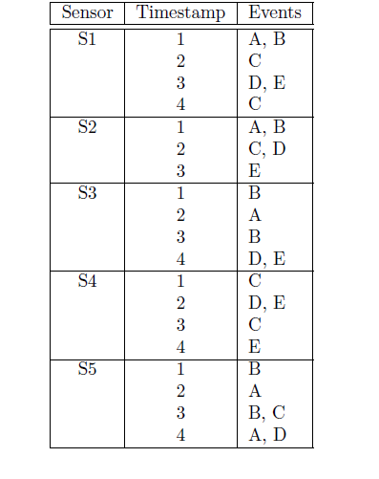
Find all the frequent subsequences with support >= 50% given the sequence database shown in the table above. Assume that there are no timing constraints imposed on the sequences. List the candidate and frequent subsequences at each level clearly.
Answer:
The events in the given data set are A, B, C, D and E. So, the candidate level-1 subsequences are:
< {A} >, < {B} >, < {C} >, < {D} >, < {E} >
Since the support of each of these level-1 subsequences is 80% and is greater than the support threshold 50%, the level-1 frequent subsequences are: < {A} >, < {B} >, < {C} >, < {D} >, < {E} >.
The candidate level-2 subsequences are: (enumerated as discussed in the book)
< {A,B} > (0.4), < {A,C} > (0), < {A,D} > (0.2), < {A,E} > (0),
< {B,C} > (0.2), < {B,D} > (0), < {B,E} > (0),
< {C,D} > (0.2), < {C,E} > (0), < {D,E} > (0.6),
< {A} {A} > (0.2), < {A} {B} > (0.4), < {A} {C} > (0.6), < {A} {D} > (0.8), < {A} {E} > (0.6),
<{B}{A}> (0.4), < {B} {B} > (0.4), < {B} {C} > (0.6), < {B} {D} > (0.8), < {B} {E} > (0.6),
<{C}{A}>(0.2), <{C}{B}>(0), < {C} {C} > (0.4), < {C} {D} > (0.6), < {C} {E} > (0.6),
<{D}{A}>(0), <{D}{B}>(0), <{D}{C}>(0.4), < {D} {D} > (0), < {D} {E} > (0.4),
<{E}{A}>(0), <{E}{B}>(0), <{E}{C}>(0.4), <{E}{D}>(0), < {E} {E} > (0.2)
The level-2 frequent subsequences are:
< {A} {C} >, < {A} {D} >, < {A} {E} >, < {B} {C} >,
< {B} {D} >, < {B} {E} >, < {C} {D} >, < {C} {E} >, < {D,E} >
The candidate level-3 subsequences are:
< {A} {C} {D} > (0.4), < {A} {C} {E} > (0.4),
<{A}{D,E}>(0.4), <{B}{D,E}>(0.4), <{C}{D,E}>(0.4),
< {B} {C} {D} > (0.4), < {B} {C} {E} > (0.4),
Since there are no candidate level-3 subsequences with support greater than 50%, there are no level-3 frequent subsequences.

(a) Determine which of the following sequence t is a valid subsequence of the corresponding sequence s:
Sequence s Sequence t Answer
<{2,4} {2,4} {6}> <{2} {4,6}>
<{3,4} {2,3} {1}> <{4}{1}>
<{5} {1,2} {4,1}> <{2}{5}>
<{3} {2,3} {1,2}> <{3}{2}>
<{1} {1} {1} > <{1,1}>
<{1,2} {1,2} {1} {2}> <{1} {2} {1,2}>
<{1} {1,2} {2} {1}> <{1} {2} {1}>
Solution:
Sequence s Sequence t Answer
<{2,4} {2,4} {6}> <{2} {4,6}> NO
<{3,4} {2,3} {1}> <{4}{1}> YES
<{5} {1,2} {4,1}> <{2}{5}> NO
<{3} {2,3} {1,2}> <{3}{2}> YES
<{1} {1} {1} > <{1,1}> NO
<{1,2} {1,2} {1} {2}> <{1} {2} {1,2}> NO
<{1} {1,2} {2} {1}> <{1} {2} {1}> YES

(a) Determine which of the following sequence t is a valid subsequence of the corresponding sequence s:
Sequence s Sequence t Answer
<{2,4} {2,4} {6}> <{2} {4,6}> NO
<{3,4} {2,3} {1}> <{4}{1}> YES
<{5} {1,2} {4,1}> <{2}{5}> NO
<{4} {2,3} {1,2}> <{3}{2}> YES
(b) Assume that the four sequences in the left column are the only frequent 5-sequences (i.e., sequences with 5 events) found from a sequence data set. Which candidate 6-sequences can be generated from these four 5-sequences?
Answer: <{3,4} {2,3} {1,2}> is the only candidate 6-sequence that will be generated by merging <{3,4} {2,3} {1}> with <{4} {2,3} {1,2}>.

(a) Consider the following data sequence:
< {A, B} {C, D} {E, F } {A, B} {D, E, F }>
State whether the following are subsequences of the above data sequence. Answer yes or no.

(i) <{A, F}>
Answer: No

(ii) <{E}, {F}>
Answer: Yes
(b) Using the candidate generation method discussed in the book, what candidate 4-sequence can be obtained by merging two frequent 3-sequences < {A, B } {C}> and < {B} {C, D}>
Answer: <{A,B}, {C,D}>

(c) Assume that the following six frequent 3-sequences are generated in the candidate generation step:
<{A} {B} {C}> <{A} {C} {B}>
<{A} {C} {D}> <{B} {C} {D}>
<{A} {C} {E}> <{C} {D, E}>

<{A} {C} {D, E}> is one of the candidate 4-sequence generated by merging <{A} {C} {D}> and <{C} {D, E}>. Will this be pruned in the candidate pruning step? Explain your answer.

Answer: Yes. A subsequence <{A} {D, E}> is not frequent.

- Assume that the following seven frequent 3-sequences are generated in the candidate generation step:
<{A} {C} {D}>
<{B} {C} {D}>
<{A} {C} {E}>
<{A} {D, E}>
< {A, B} {D}>
<{A} {C, D}>
<{C} {D, E}>

(a) Is it possible to merge <{A, B} {D}> and <{A} {C, D}>, and generate a 4-sequence? If yes, write down the sequence. If no, explain briefly.
Answer: No. removing first element of first sequence (<{B}{D}>) and last element of last sequence (<{A}{C}>) does not produce the same sequence. Hence cannot be merged.

(b) <{A} {C} {D, E}> is one of the candidate 4-sequence generated by merging <{A} {C} {D}> and <{C} {D, E}>. Will this be pruned in the candidate pruning step? Explain briefly.
Answer: No, it will not be pruned. All 3-subsequences (<{A}{C}{D}>, <{A}{C}{E}>, <{A}{D,E}>,<{C}{D,E}>) is present.

- Assume that the following seven frequent 3-sequences are generated in the candidate generation step:
<{A} {C} {D}>
<{B} {C} {D}>
<{A} {C} {E}>
<{A} {D, E}>
< {A, B} {E}>
<{A} {C, D}>
<{C} {D, E}>
(a) Is it possible to merge <{A, B} {E}> and <{A} {C} {E}>, and generate a 4-sequence? If yes, write down the sequence. If no, explain briefly.
Answer: No. removing first element of first sequence (<{B}{E}>) and last element of last sequence (<{A}{C}>) does not produce the same sequence. Hence cannot be merged.

(b) <{B} {C} {D, E}> is one of the candidate 4-sequence generated by merging <{B} {C} {D}> and <{C} {D, E}>. Will this be pruned in the candidate pruning step? Explain briefly.
Answer: Yes, it will be pruned. The 3-subsequences ( <{B}{C}{E}>, <{B}{D,E}>) are not present. (Sufficient to list one of these as not present)

- Consider the data sequence shown in following Figure:
(a) Determine whether the following sequential pattern is supported by the data sequence shown in Figure, subject to the following constraints:
mingap = 0, maxgap = 2, maxspan = 5, and window size (ws ) = 1.
w = <{a} {b, c} {d}>
Answer: True.
(b) Determine whether the sequence <{a} {b, c} {d}> is a contiguous subsequence of <{a, b, c} {b, c, d} {c, d, e} {d, e, f}>.
Answer: True.

- Consider the following data sequence:

< {A,B} {C,D} {E, F} {A,B} {D,E,F} {A,B} >

(a) State whether following subsequences are supported by the above data sequence subject to the following timing constraints:
mingap = 0, maxgap = 3, and window size = 1.
Answer yes or no.
• {A,B,C} {D,E, F}
Answer: No.
• {A,B,C} {A,B,E} {A,B,E}
Answer: Yes
(b) State whether the following sequences are contiguous subsequences of the above data sequence. Answer yes or no.
• {A,B} {D,E}
Answer: No
• {A,B} {A,B} {A,B}
Answer: No
(c) The Apriori principle states that if a pattern of length k is frequent, then all of its subpatterns of length k − 1 must also be frequent. For each of the sequential pattern mining problem below, state whether the Apriori principle holds (answer yes or no).
• Mingap and maxgap are the only timing constraints.
Answer: No, because of maxgap constraint.
• Window size is the only timing constraint.

Answer: Yes.

- Assume that the following six frequent 3-sequences are generated in the candidate generation step:

<{A} {B} {C}>
<{B} {C} {D}>
<{A} {B E}>
<{B E} {C}>
<{E} {C D}>
<{A} {B} {E}>
<{A} {E} {C}>
(a) List all the candidates 4-sequence generated from them.
Solution: <{A} {B} {C} {D}>, <{A} {B E} {C}>, <{B E} {C D}>, <{A}{E}{C D}>
(b) List all the 4-sequence left after pruning.
Solution: <{A} {B E} {C}>

- Answer True/False for the following with a very brief explanation

- There are four sequences in the data, each corresponding to a timestamp.
Answer: False. There are 5 sequences, each corresponding to a sensor.
- The longest sequence is of size 5.
Answer: False. The longest sequence is a 6-sequence, sequences of S1 and S5.
- The smallest sequence is of size 3.
Answer: False. The smallest sequence is a 5-sequence.
- The support count of {A}{B,C} is greater than {A}{C}.
Answer: False. By Apriori principle, support count of {A}{C} is greater than or equal to {A}{B,C}.

(a) Answer True/False for the following with a very brief explanation

- The support count of {A}{B} is 4.
Answer: False. The support count is 2 (present in S3 and S5).
- The support count of {A,B}{C}{D} is 3.
Answer: False. It is only present in S1.
- The support count of {A} is equal to 5.
Answer: False. The support count of {A} is 4.
(b) Answer the following - (no explanation required)
1) Which sequence(s) has(have) the highest support count? Write down the corresponding support count(s).
Answer: {D} , count = 5.
2) Which sequence has the lower support count – {A}{B} or {B}{A}?
Answer: Both have the same support count = 2.
- True / False with a brief explanation –
- In some sequential data, it was found out that sequences {A}{B} and {B}{A} were frequent. Then answer the following as True/False with a brief explanation –
- Sequence {A}{B}{A} would be necessarily frequent.
Answer: False. For example, when all the sequences are {B}{A}{B}.
- Sequence {B}{A}{B} would be necessarily frequent.
Answer: False. For example, when all the sequences are {A}{B}{A}.
- At least one of the sequences {B}{A}{B} and {A}{B}{A} is frequent.
Answer: False. For example, when half the sequences are {B}{A}{B} and the other hand are {A}{B}{A}, and s/2< minsup < s.
- Sequence {A} may not be frequent.
Answer: False. By the Apriori principle, {A} would be necessarily frequent.
- Now, if it is also known that {A}{B} and {B}{A} have the same support count (= s, s>1) and always occur together, then answer the following as True/False with a brief explanation –
- Sequence {A}{B}{A} would necessarily have the support count equal to s.
Answer: False. For example, when all the sequences are {B}{A}{B}, support count of {A}{B}{A} is 0.
- Sequence {B}{A}{B} would necessarily have the support count equal to s.
Answer: False. For example, when all the sequences are {A}{B}{A}, support count of {B}{A}{B} is 0.
- At least one of the sequences <{B}{A}{B}> or <{A}{B}{A}> would necessarily have the support count s.
Answer: False. For example, when half the sequences are {B}{A}{B} and the other half are {A}{B}{A}, then each of them has a support count equal to s/2.
- Sequences <{B}{A}{B}> and <{A}{B}{A}> may occur together.
Answer: True. For example, in a sequence <{A}{B}{A}{B}>, both of the given sequences occur together.
- The sum of the support counts of sequences <{B}{A}{B}> and <{A}{B}{A}> would be greater than or equal to s.

Answer: True. For each sequence where both {A}{B} and {B}{A} are present, at least one of the given sequences would be present. Hence the sump of their support counts would be greater than or equal to s.
- The sum of the support counts of sequences <{B}{A}{B}> and <{A}{B}{A}> would be less than 2s.
Answer: True. None of the given sequences can occur in any sequence where none of the <{A}{B}> and <{B}{A}>
- The support count of sequence {A} must be equal to s.
Answer: False. For example, There can be sequences that can have {A}, but not {A}{B} or {B}{A}.

Subgraph Patterns

- Draw all the candidate subgraphs obtained by merging the following subgraphs.
Assume that the core must be connected.

Solution:

